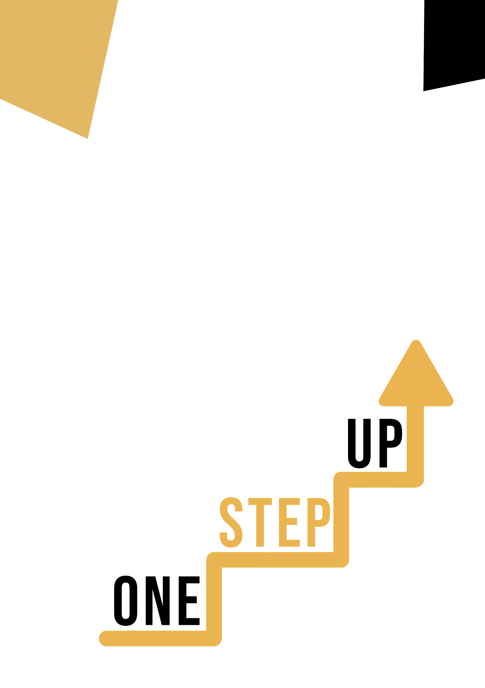
Sports and hobbies (MATHEMATICAL (STEM) COMPETENCE)
Adult educator manual

Micro-learning resources to re-engage low-skilled adult learners in education and training

Adult Educator Manual
The aim of this short handbook is to support you, as an experienced educator working with low-skilled and marginalised adult learners, with diverse needs, to use the video resources and the activity sheets provided in the Suite of Micro-Learning Resources to Re-Engage Low-Skilled Adult Learners in your centre and in your community. Through this short manual, we will provide you with some background information on the topic being discussed in the video resource and provide some guidance to support you to introduce and implement the accompanying activity with adult learners in your group. The activity developed to accompany the video resources aims to develop further their understanding of the topic outlined in the video resource. Finally, this manual will also present you with some de-briefing questions that you can use in your group of adult learners, to assess the user-friendliness and quality of the activity you have completed with them.

The topic of this manual relates to the video resources Building Mathematical Competences through Sports and Hobbies.

Introduction to the Topic
Playing sports and engaging in hobbies can help low-skilled adults develop their mathematical and subsequently, STEM skills. Throughout the ONE-STEP UP resources, low-skilled adults can explore how these learning materials can positively impact their ability to work with numbers and calculations. So, whether they are sports fanatics or a hobby enthusiast, they can be guided to discover how their favourite pastime can help them excel in maths and STEM.

Introduction to the Activity
In order to delve into the innovative "Learn through Sport" movement in Ireland and discover how it has helped adults enhance their mathematical skills. Learners also have the opportunity to engage in the fun and interactive 'Math in Motion' activity, where they'll discover how sports can improve their ability to work with numbers and calculations. With this, you can inspire learners to discover how even the most unlikely activities can lead to significant improvements in their mathematical and STEM skills.

Using this Resource with a Group
To use this resource with adult learners in your local group, we recommend that you begin by showing them the video resource to introduce the theme of Sports and Hobbies (Mathematical (STEM) Competence). This video will help learners to understand the topic before they begin the Learner Handout activity. Once they have gained a general knowledge of the theme, they will be able to begin the handout. For this, we recommend that you print one handout per learner to complete. All learners need for this resource is a pen to complete the learner handout and a computer to view the video. This resource will take one hour in total to complete. To assess learner knowledge, we suggest finishing the session with the quiz. This can help learners to evaluate what they have learned through the ONE-STEP UP resources.

De-Briefing Questions
Here are some potential debriefing questions for participants to reflect on after completing the case study and activity:
- What surprised you the most about the “Learn through Sport” programme in Ireland?
- In what ways did the “Learn through Sport” programme go beyond just teaching math and STEM skills?
- What is one key takeaway that you will bring with you from this case study and activity? How will you apply it to your own life or work?
- What was your experience like during the 'Math in Motion' activity? Did you find it helpful in improving your mathematical competence?
- How can sports and hobbies be incorporated into education or training programs for low-skilled adults to improve their math and STEM skills?

