Contents

What types of art can be used to improve literacy competences 3

Case study: Fighting Words - Empowering people through Creative Storytelling 5

Learning Activity 7

Additional Reading or Study Materials 9

# What types of art can be used to improve literacy competences



At first glance you might not think that art is a great tool to teach literacy, but in fact art is the perfect tool to do so.Using something like visual diaries or journals, where individuals combine words and visuals to record their thoughts and experiences, can strengthen both writing and artistic skills. Combining art and literacy improves the ability to express ideas effectively and encourages creative thinking.

Some of the first methods of communication was through art. Paintings depicting prehistoric times were found in the Chauvet caves of France that date back 30,000 years. These drawings showed stories of encountering mammoths, lions and rhinos and were some of the first known forms of communication and storytelling.

Another way to embed literacy into art is to encourage song writing. Engaging in creative writing, such as writing song lyrics, short stories, or poetry, provides individuals with an outlet to explore their thoughts and emotions. This form of artistic expression not only improves writing skills, deepens thinking, and encourages self-expression. But analysing and singing along to music and song lyrics can improve reading skills and the understanding of metaphors, similes, and poetic language. It fosters a love for language and helps individuals appreciate the beauty and power of words. The immense popularity of hip-hop and rap music has further cemented the writing of lyrics as a widely embraced and effective method for improving literacy. Listening to this genre and dissecting the meaning behind the lyrics can inspire participants to write their own verses, providing them with a means to express themselves uniquely. It can also help to listen to this music and break down the meaning behind the lyrics and then encourage participants to write their own lyrics to express themselves.

Another type of art which is good for exploring the theme of literacy is dance. Dance can be a fun and engaging way to improve literacy skills in a few different ways. One way is to get participants to use storytelling through movement. Participants can be encouraged to create and perform dances that tell stories. This promotes literacy by requiring participants to think critically about plot, characters, and how best to communicate a story to an audience. For example participants can be asked to express the meaning of certain words through body language and dance movements. By combining dance and literacy, you can engage participants’ creativity, promote critical thinking and improve their overall communication skills.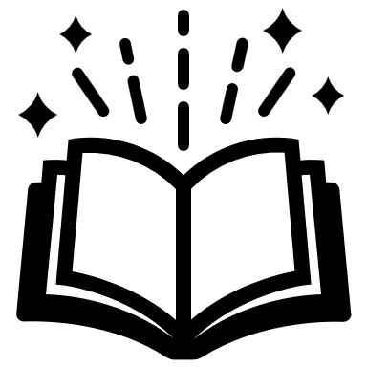





* Writing lyrics for your own song
* Listening to a song and trying to understand the lyrics
* Creating music to accompany a poem or story you've written
* Telling a story through dance
* Creating your own comic script

# Case study: Fighting Words - Empowering people through Creative Storytelling

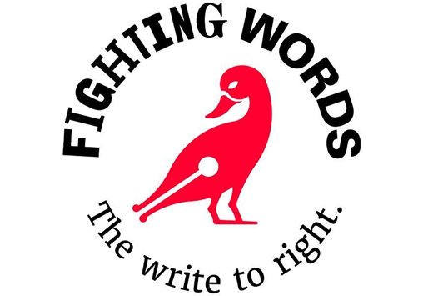

*Fighting Words* is an Irish-based organisation that aims to inspire and support people of all ages in developing their creative writing skills and improving their literacy. Established in 2009, the organisation provides free writing workshops and mentoring programmes, encouraging participants to explore their imagination and build confidence in their storytelling abilities. While *Fighting Words* primarily focuses on creative writing, they also incorporate songwriting and elements of literacy education.

*Fighting Words* was co-founded by Irish author Roddy Doyle, known for his acclaimed novels such as *Paddy Clarke Ha Ha Ha* (1993). The organisation was inspired by the success of *826 Valencia*, a renowned writing centre in San Francisco. Doyle, along with other authors and volunteers, wanted to establish a similar initiative in Ireland to nurture the creativity and literacy skills of young people. However, it has since branched out to work with people of all ages.

*Fighting Words* provides its programme of literacy and creative storytelling through workshops, storytelling events, school visits, summer camps and young adult programmes. 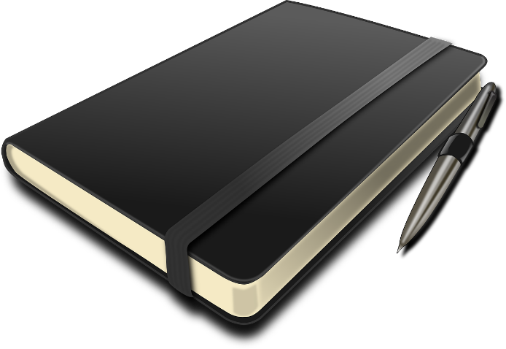

Through its storytelling events, it invites authors, actors, and musicians to share their experiences and engage with young writers. These events inspire participants and expose them to various storytelling mediums.

*Fighting Words* also collaborates with schools, colleges and youth groups to deliver workshops and mentoring programs. This outreach enables the organisation to reach a broader audience and instill a love for writing. Recognising the specific needs and interests of young adults, *Fighting Words* tailors programs to engage and empower this age group. These initiatives aim to foster self-expression, critical thinking, and storytelling skills.

Fighting Words has empowered thousands of young writers, providing them with a platform to express themselves creatively and explore their unique storytelling voices. Participants often report increased self-confidence in their writing abilities after attending workshops and receiving positive feedback from mentors and peers. This newfound confidence can have a profound impact on their overall academic performance and personal growth. *Fighting Words* has become a community hub for young writers, offering a supportive network where they can connect with like-minded individuals, receive encouragement, and celebrate their literary achievements.

Many participants of *Fighting Words* have continued their writing journeys beyond the workshops, pursuing further education in creative writing or actively engaging in writing communities. This long-term impact speaks to the lasting influence of Fighting Words on young writers' lives.

Fighting Words has emerged as a vital organisation in Ireland, inspiring and nurturing the next generation of writers. Through their workshops, events, and mentoring programs, they have created an engaging and inclusive space where people can explore their creativity, improve their literacy skills, and find their unique storytelling voices.

**Questions**

1. How does Fighting Words try to improve the literacy of participants in Ireland?

_________________________________________________________________________________________________________________________________________________________________________________________________________________________________________________________________________________________________________________________________________________________

1. What type of workshops do Fighting Words offer participants?

_________________________________________________________________________________________________________________________________________________________________________________________________________________________________________________________________________________________________________________________________________________________

1. How do you think you could improve your literacy using art?

____________________________________________________________________________________________________________________________________________________________________________________________________________________________________________________________________________________

_____________________________________________________________________

# Learning Activity

|  |  |  |  |
| --- | --- | --- | --- |
| **Transversal Theme** | Enhancing Literacy Competences Through Art | | |
| **Activity Title** | Artistic Word Collage | | |
| **Type of resource** | **Learning Activity** | | |
| **Photo** |  | | |
| **Duration of Activity**  **(in minutes)** | 60 minutes | **Learning Outcome** | * Apply various artistic techniques and processes to create original works of art that demonstrate personal expression, innovation, and aesthetic quality. |
| **Aim of activity** | The aim of this activity is to encourage you to use your creativity to improve your literacy skills through making a collage. | | |
| **Materials Required for Activity** | * Magazines, newspapers, or printouts with a variety of text and word options. * Scissors, glue sticks, and plain white paper or card. * Markers or coloured pencils. | | |
| **Step-by-step instructions** | * **Step 1:** For this activity, you are going to make a collage. First start to brainstorm what your collage will focus on and what it will represent. * **Step 2:** Collect magazines, newspapers, or printouts with a variety of text and word options. Browse through the materials and cut out words or phrases that catch your attention or resonate with you. Select words that are interesting, meaningful, or related to the specific topic of your choice. * **Step 3:** For this step, you will need paper or poster board, scissors, and glue sticks. Arrange the collected words and phrases on the paper, creating a visually appealing collage. Be creative in your arrangement! Why not experiment with varying colours, shapes, and patterns. * **Step 4:** Once the collage is complete, why not share your collage, explaining their choices and the meaning behind your selection of words. Think about the relationship between the chosen words, the visual representation, and any emotions or ideas evoked. Consider how the activity helped you explore vocabulary and express yourself creatively. | | |

# Additional Reading or Study Materials

Congratulations, you have reached this point and completed your self-reflection activities related to *‘Building Literacy Competences through Art’* What comes next? If you would like to learn more about the topics you have covered so far in this lesson, we have prepared the following additional reading materials for you. This section presents some links to extra materials and videos that we have found online that we think will help you to take the next step in developing your knowledge.

|  |  |
| --- | --- |
| **Resource Title:** | Fighting Words: Sean Love at TEDxDublin |
| **Topic Addresses:** | The Fighting Word Case Study |
| **Introduction to the resource:** | This is a TEDx Talk by Sean Love, the Co-founder of *Fighting Words* (The organisation from the case study). In this talk Sean talks about the power of creativity and how it can be used to support people of all ages to improve their literacy skills in a fun, empowering way. |
| **What will you get from using this resource?** | A better insight to the *Fighting Words Creative Writing Centre* we mentioned in the earlier case study. *Fighting Words* has been used as a case study for other creative writing centres around Europe and is held up as being a centre of excellence and best practice. |
| **Link to resource:** | <https://youtu.be/4ReiZIRF05s> |

|  |  |
| --- | --- |
| **Resource Title:** | Why hip-hop belongs in today’s classrooms |
| **Topic Addresses:** | Using creativity and music to enhance literacy skills |
| **Introduction to the resource:** | This article explores the relevance and educational value of incorporating hip-hop culture and music into the modern classroom. |
| **What will you get from using this resource?** | You will learn ways that music, in particular hip-hop music, is used in the classroom to enhance learning. Hip-hop is one of the most popular genres of music and is being used as a tool to teach literacy around the world. From learning to write their own lyrics, to studying song lyrics and what they mean, studying music is an accessible means to teaching literacy and can be a fun way to engage students from all backgrounds. |
| **Link to resource:** | <https://theconversation.com/why-hip-hop-belongs-in-todays-classrooms-128993> |

