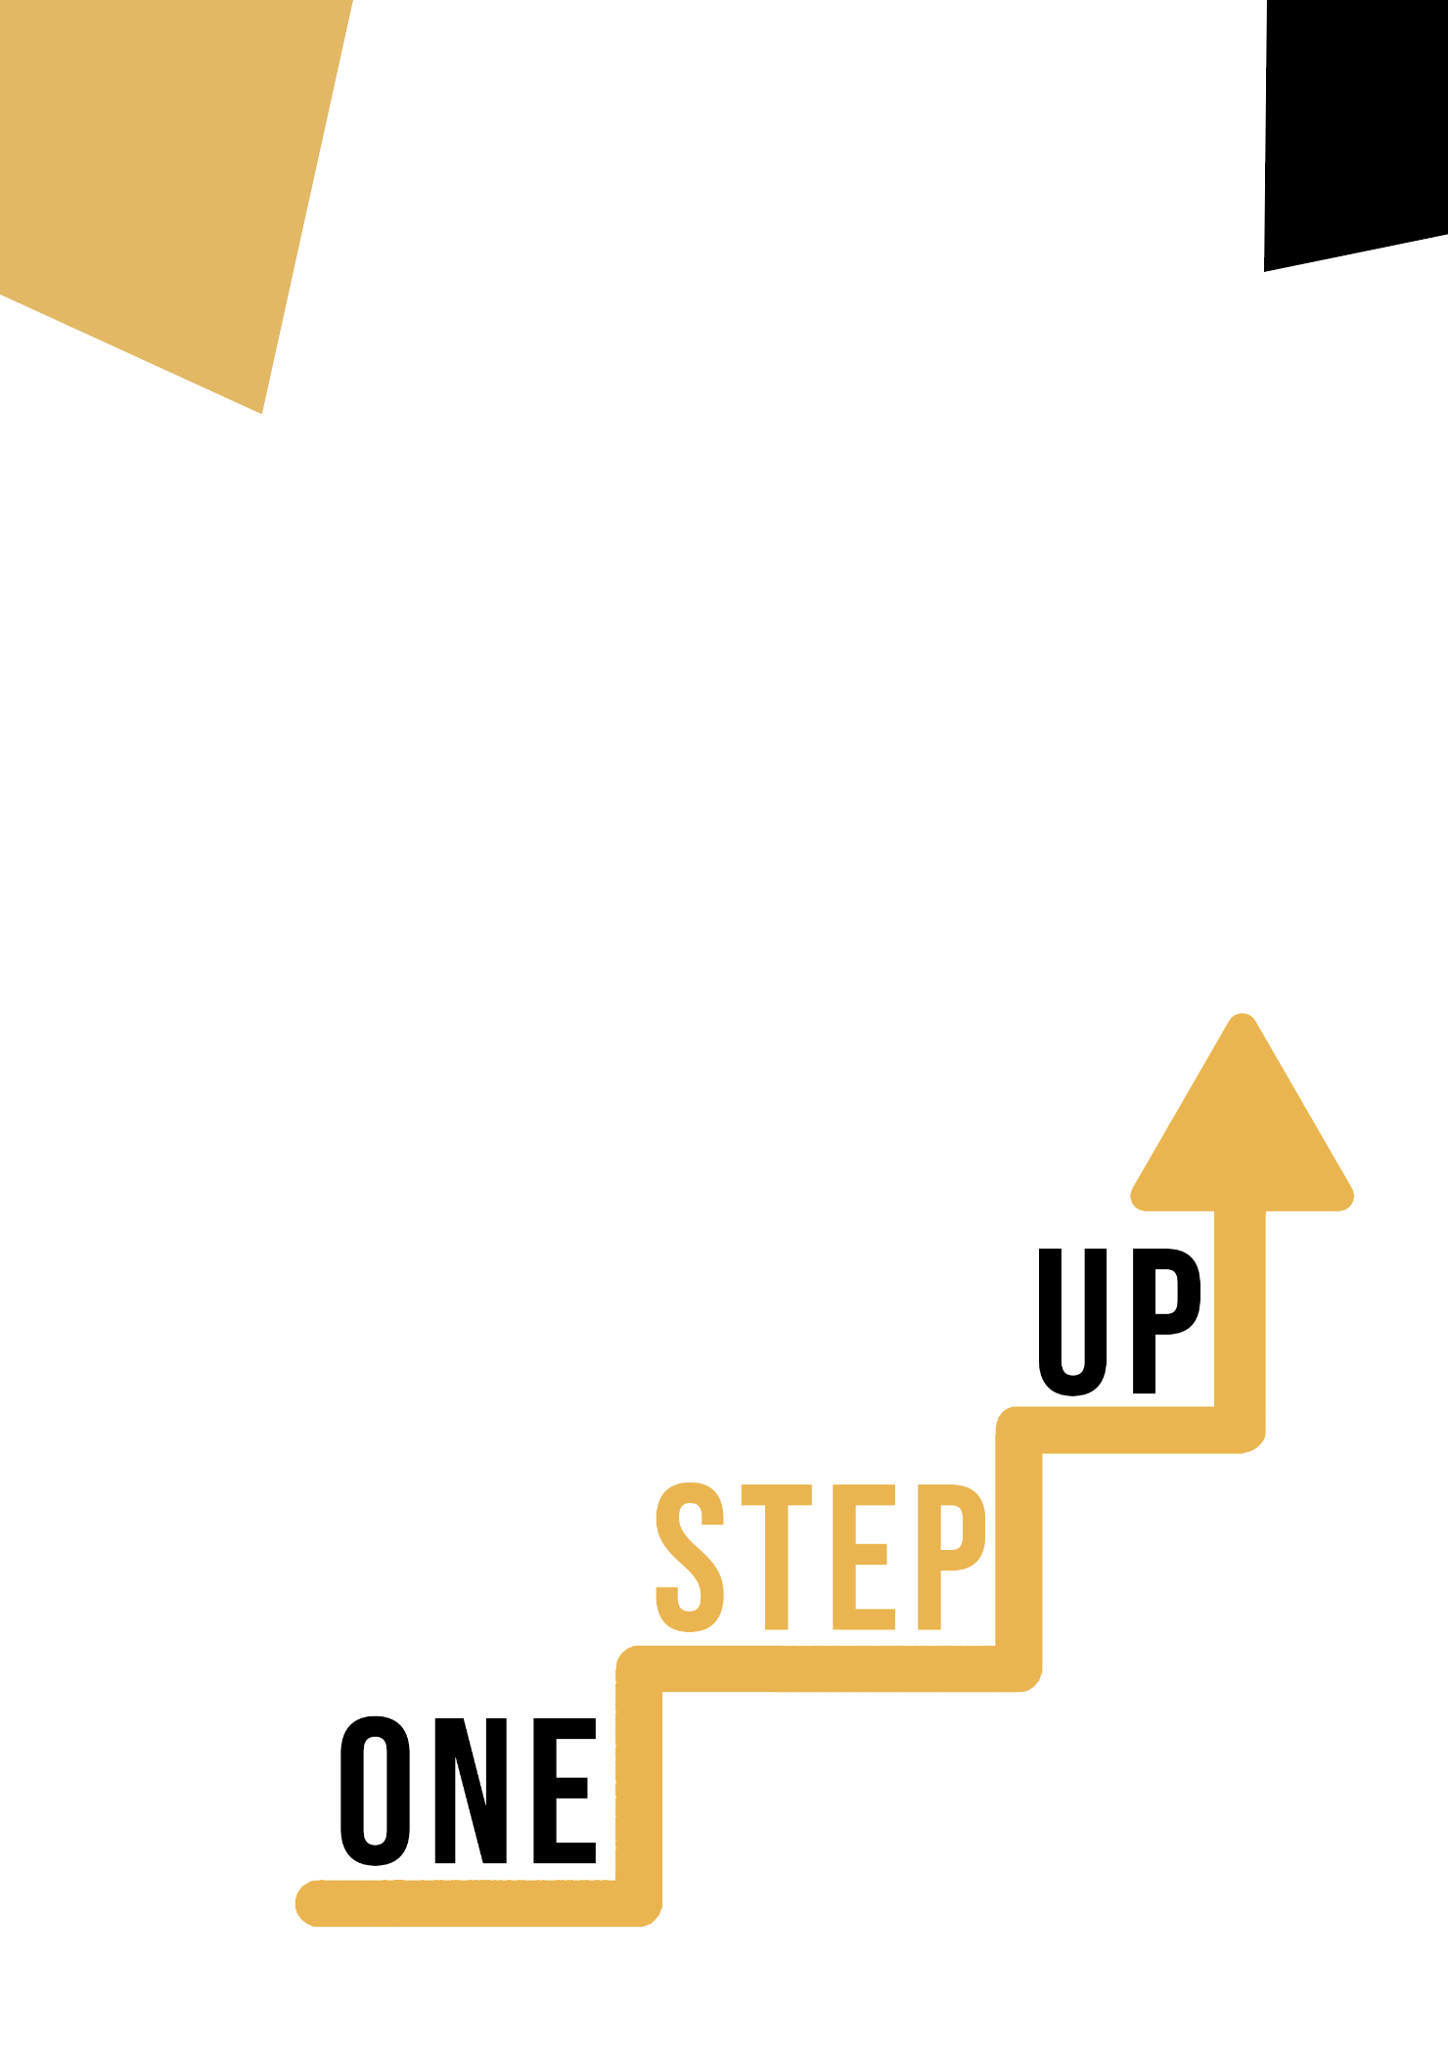
Building literacy competences through artistic discliplines
Adult educator manual

Micro-learning resources to re-engage low-skilled adult learners in education and training

Adult Educator Manual
Lesson Plan
The aim of this short handbook is to support you, as an experienced educator working with low-skilled and marginalised adult learners, with diverse needs, to use the video resources and the activity sheets provided in the Suite of Micro-Learning Resources to Re-Engage Low-Skilled Adult Learners in your centre and in your community. Through this short manual, we will provide you with some background information on the topic being discussed in the video resource and provide some guidance to support you to introduce and implement the accompanying activity with adult learners in your group. The activity that has been developed to accompany the video resource aims to further develop their understanding of the topic. Finally, this manual will also present you with some de-briefing questions that you can use in your group of adult learners, to assess the user-friendliness and quality of the activity you have completed with them. Finally, you can ask your adult learners to complete the quiz, as a self-assessment activity.

The topic of this manual relates to the video resources Building Literacy Competences through Artistic Disciplines.

Introduction to the Topic
Art is a fantastic medium to teach literacy, particularly to learners who may lack confidence in the area. Throughout the One-Step Up resources, learners can explore how these learning materials can positively impact their literacy skills and how they can use them to feel more confident in their abilities. So whether they are dance enthusiasts, music fans, or budding artists, they can be guided to discover how different forms of art can be used to improve their literacy skills.

Introduction to the Activity
Using the case study of the Fighting Words Creative Writing Centre, learners are introduced to an innovative and inclusive programme which is helping people of all ages improve their literacy skills in a way and environment which feels comfortable to them. Learners will also have the chance to try out the ‘Artistic Word Collage’ activity which will encourage them to use their creativity skills using both images and words to make a collage. This will show learners that learning about words and their meanings and choosing words that mean something to them can be fun and engaging.

Using this Resource with a Group

To use this resource with adult learners in your local group, we recommend that you begin by showing them the video resource to introduce the theme of Building Literacy Competences through Art. This video will help learners to understand the topic before they begin the Learner Handout activities. Once they have gained a general knowledge of the theme, they will be able to begin the handout. For this, we recommend that you print one handout per learner to complete. All learners need for this resource is a pen to complete the learner handout and a computer to view the video. This resource will take one hour in total to complete.
Once your learners have completed the handbook, encourage them to complete the Building Literacy Competences through Art Quiz:

De-Briefing Questions
Here are some de-briefing questions for participants to reflect on after completing the case study and activity:

- What message did you take from the Fighting Words Case Study?
- What is one key takeaway from this case study and activity that you explored in the Learner Handout? How can you apply it to your own life or work?
- How did you find the ‘Artistic Word Collage’ activity? Did you find it helpful in improving your literacy competence?
- How do you think art can be incorporated into the traditional educational system or training programmes to improve literacy? Do you have any further ideas?
- Why do you think using art to build your literacy competence is important? How can this help learners?
