Contents

How Can Sport and Hobbies Be Used to Build Multilingual Competences? 3

5

Case study: Colaiste Uisce: Teaching the Irish Language Through water Sports 6

Learning Activity 9

Additional Reading or Study Materials 11

# How Can Sport and Hobbies Be Used to Build Multilingual Competences?

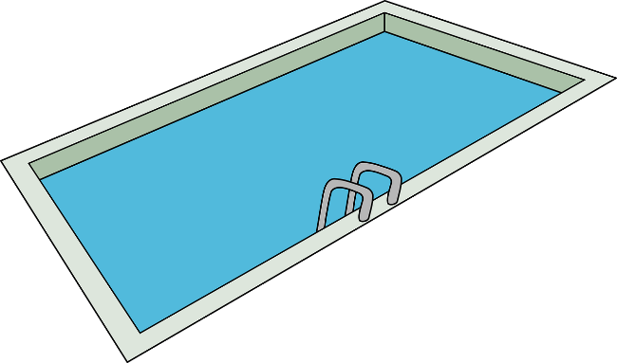

Sports are a valuable tool for teaching languages as they engage learners in a fun, immersive and enjoyable learning experience.

One of the benefits of using sports in language learning is the opportunity to expand your vocabulary. Different sports offer different terms and phrases related to equipment, positions, and actions. By teaching these sport-specific words, you can learn new words and concepts while having fun and taking part in sporting activities. From football to basketball, you can learn the names of equipment, positions, techniques, and strategies, and improve your language skills.

Sports provide an ideal opportunity for practicing conversational skills. Engaging in discussions, debates, and general conversations related to sports helps you improve your speaking and listening abilities. You can also plan strategies, analyse games, and discuss sports events, which can all help you become more comfortable in your new language and help you towards fluency. Taking part in sports conversations allows you to express your opinions, negotiate with teammates, and practice turn-taking, leading to better communication skills. 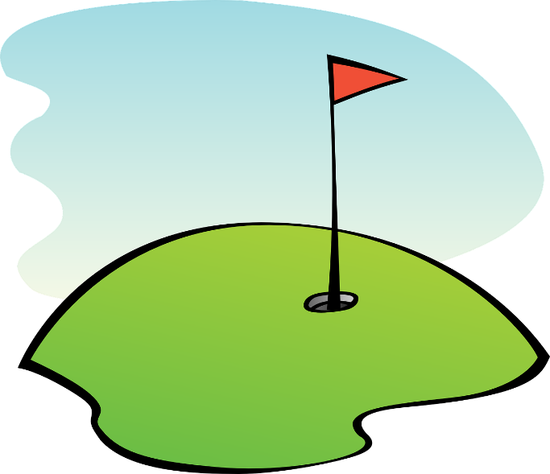

Sports involve teamwork, collaboration, and effective communication among participants. Taking part in team sports or hobbies in a different language provides you with opportunities to practice giving instructions, coordinating strategies, and offering encouragement. Through these interactions, you develop your language skills within a fun and social environment, as well as building your ability to communicate effectively.

Integrating sports and hobbies into language learning programs can significantly improve your motivation and engagement. Involving sports and hobbies in learning a language can encourage your interest and enthusiasm, as they offer a combination of physical activity and intellectual stimulation. By tapping into this enthusiasm, you can be part of a positive and motivating learning environment, which makes building your multilingual skills easier than being in a traditional classroom.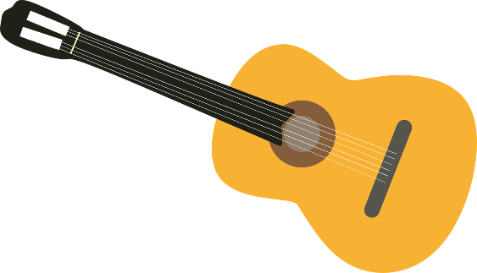

Learning languages through hobbies is a highly effective and enjoyable approach to language learning. By introducing language learning alongside hobbies, you can use your existing interests and motivation to improve your language skills. Whether it's painting, cooking, or playing a musical instrument, adding language learning alongside it makes it more engaging and fun. It allows you to explore specialised vocabulary related to your hobbies, follow instructional materials or tutorials in your target language, engage with online communities and resources, and even seek out opportunities to practice your language skills with others. Learning languages through hobbies not only facilitates language acquisition but also adds depth and enjoyment to the learning process. Not only does it allow you to pursue your passions but helps improve your language skills at the same time.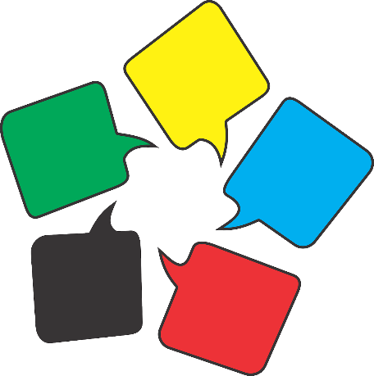

**Examples of ways you can improve your language skills through sports and hobbies**

* Join a sports team that only speaks the language you are learning
* Listen to a sports event on the TV or radio in the language you are learning
* In the language you are learning, learn the different phrases from the sport or hobby you take part in

| My Sports | My Hobbies |
| --- | --- |
|  |  |
|  |  |
|  |  |
|  |  |
|  |  |
|  |  |
|  |  |

# 

# Case study: Colaiste Uisce: Teaching the Irish Language Through water Sports

Coláiste Uisce is an Irish language summer school located in County Mayo, Ireland. It offers a unique approach to language immersion by combining traditional classroom learning with engaging water sports activities. By integrating Irish language instruction with water sports, Coláiste Uisce provides a dynamic and immersive environment for students to learn and practice Irish.

Coláiste Uisce was established in 1989 with the goal of promoting the Irish language and culture among young people. Recognizing the need for innovative teaching methods to engage students and make language learning enjoyable, the founders decided to incorporate water sports into the curriculum. The school is situated on the picturesque shores of Clew Bay, providing the perfect backdrop for outdoor activities.

The curriculum at Coláiste Uisce is designed to combine language instruction with practical application through water sports. The daily schedule includes a mix of language classes, sports activities, and cultural experiences. The classes are led by experienced and qualified Irish language teachers who are fluent in the language and passionate about sharing their culture.

The language instruction at Coláiste Uisce is interactive and communicative, focusing on building conversational skills. Students are encouraged to actively participate in discussions, role-plays, and group activities that enhance their vocabulary, grammar, and pronunciation. The teachers use a variety of teaching methods, including games, songs, and storytelling, to make the learning process enjoyable and memorable.

Water sports are an integral part of the Coláiste Uisce experience. The school offers a range of activities such as surfing, kayaking, sailing, windsurfing, and stand-up paddleboarding. These activities are carefully integrated into the curriculum, providing students with opportunities to practice their Irish language skills in real-life situations. For example, during a surfing lesson, students might learn to give directions or describe the waves using Irish. During water sports activities, instructors communicate primarily in Irish, encouraging students to use the language naturally and spontaneously. This immersion approach helps students develop their language skills and gain confidence in speaking Irish.

Coláiste Uisce's innovative approach to language learning has gained recognition both nationally and internationally. The school has been commended for its creative pedagogy, contributing to the revitalization of the Irish language among young people. The success of Coláiste Uisce has inspired other language schools to explore alternative teaching methods that combine education and physical activities.

**Questions**

1. How does Colaiste Uisce try to improve the multilingual skills of students in their courses?

______________________________________________________________________________________________________________________________________________________________________________________________________________________________________________________________________________________________________________________________________________________________________________________________________________________________

1. Do you think Colaiste Uisce’s method works better than teaching a language in a traditional classroom?

____________________________________________________________________________________________________________________________________________________________________________________________________________________________________________________________________________________

1. How do you think you could improve your multilingual skills using sports and hobbies?

____________________________________________________________________________________________________________________________________________________________________________________________________________________________________________________________________________________

# 

# Learning Activity

| **Transversal Theme** | Enhancing Multilingual Competences through Sports and Hobbies | | |
| --- | --- | --- | --- |
| **Activity Title** | The Language Olympics | | |
| **Type of resource** | **Learning Activity** | | |
| **Photo** |  | | |
| **Duration of Activity**  **(in minutes)** | 60 minutes | **Learning Outcome** | * Openness to step outside their comfort zone |
| **Aim of activity** | The aim of this activity is to create a fun and competitive environment where you can practice and improve your language abilities while enjoying various sports and hobbies. | | |
| **Materials Required for Activity** | * Sports equipment (based on the selected sports) * Language learning materials (e.g., vocabulary flashcards, Dictionary) * Flipchart paper * Stopwatch or timer | | |
| **Step-by-step instructions** | * **Step 1:** You will be given a list of four sports you can try out like basketball, football, tennis, badminton etc * **Step 2:** Get ready to engage in various sports challenges while incorporating language learning activities. For example, if the selected sport is basketball, you might practice shooting drills while learning basketball-related vocabulary in your target languages. * **Step 3:** Try each of the four activities and use a dictionary to look up the names for the specific terms related to that sport. For example look up the words associated with Tennis like Ace, Point, Net, Racket etc. Spend 10 minutes playing each sport and 5 minutes learning and practicing the terms associated with it. Work your way around the other sports until you have a database of terms to practice.   **Variations:**  This can be done as an individual but may work best in a group where you can practice your language skills with other people. | | |

# Additional Reading or Study Materials

Congratulations, you have reached this point and completed your self-reflection activities related to *‘Building Literacy Competences through Art’* What comes next? If you would like to learn more about the topics you have covered so far in this lesson, we have prepared the following additional reading materials for you. This section presents some links to extra materials and videos that we have found online that we think will help you to take the next step in developing your knowledge.

| **Resource Title:** | Why kids learn languages faster by doing sport |
| --- | --- |
| **Topic Addresses:** | The benefits of teaching language skills through physical activity |
| **Introduction to the resource:** | This article explores the connection between physical activity and language learning in children. The article explains that children can learn languages faster by engaging with it through sports. |
| **What will you get from using this resource?** | By reading this article, you will gain valuable insights into the connection between sports and language learning in children, and how this is backed up by science. |
| **Link to resource:** | <https://blog.esl-languages.com/blog/learn-languages/kids-learn-languages-faster-by-doing-sport/> |

| **Resource Title:** | Language, Music and Exercise. Are they connected to one another? |
| --- | --- |
| **Topic Addresses:** | The connection between music, physical activity and learning languages |
| **Introduction to the resource:** | This article explores cognitive development in children and how it develops into adulthood. It also examines if there is a connection between learning a language, music and physical activity. |
| **What will you get from using this resource?** | By reading this article you will learn more about the connection between music, physical activity and language learning. |
| **Link to resource:** | <https://files.eric.ed.gov/fulltext/ED594074.pdf> |

