Building Digital Competences through Digital and Social Media

Learner Handout

Contents

How can Digital and Social Media Be Used to Build Digital Competences 3

**Case study: An Cosan: Getting People Online** 4

Learning Activity 6

Additional Reading or Study Materials 9

# How can Digital and Social Media Be Used to Build Digital Competences

In today's interconnected world, digital competences have become important for personal, and professional growth. As the use of digital media and social media continues to grow, the ability to navigate and know how to use these platforms has become essential.

Digital competences empower people to communicate, connect, and collaborate in new ways. Digital media and social media platforms offer a wide range of channels to exchange ideas, share experiences, and engage with peers. 

Digital media and social media have revolutionised the way information is shared, providing users with access to a wealth of knowledge and resources. Digital competences enable users to navigate through the huge amount of online information, critically evaluate sources, and access a wide range of viewpoints. Acquiring these skills empowers users to stay informed, broaden their horizons, and tap into educational resources that cater to their interests and career aspirations.

Digital media and social media skills have become increasingly essential for the personal and professional development of job seekers in particular. People with a strong command of these competences can showcase their skills, talents, and achievements through online portfolios, professional networking platforms, and personal websites. They can also engage in continuous learning, accessing online courses, webinars, and tutorials that cater to their interests and career goals, accelerating their growth and future opportunities.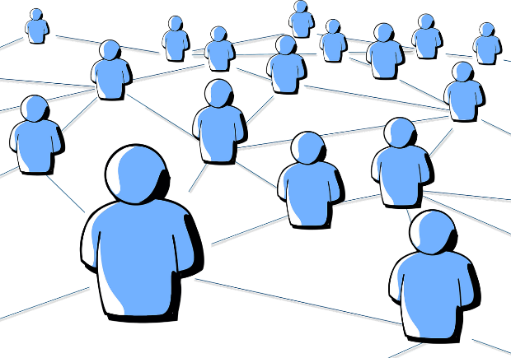

Creating a positive online presence is crucial, particularly when seeking employment. It guarantees that you make a favourable impression, as your digital footprint may be the first thing an employer examines. Your digital footprint encompasses the traces you leave behind while engaging online. This encompasses all information available on the internet about you, including personal details and social media profiles from platforms like Facebook, Twitter, TikTok, or LinkedIn.

It also includes the photos that you or others have posted online, and anything that you said online, e.g. contributions on discussion boards or blogs, or articles. Each time we add something about ourselves to the internet, we make our digital footprint even bigger. Potential employers are known to look online to find out more information about those they are interviewing for a job.

Your digital footprint also showcases your skills, professional experience, and interests. Much of the information on the web is public, and you never know who may come across you online. It is important to remember that what goes online potentially stays online. Therefore, it is important to think about what you are happy to present to the world. A good rule to follow is ‘If you wouldn’t say it to someone’s face then don’t say it online!’ A good first step in checking your digital footprint can be to assess your existing accounts and to de-activate any online profiles you are not using.

In today’s digital age, digital competences are vital skills that everyone should have. Almost everything is online including banking, shopping, utility bills etc Therefore it is important that you are able to navigate the online world confidently.

# 

# 

# 

# 





# **Case study: An Cosán: Getting People Online**

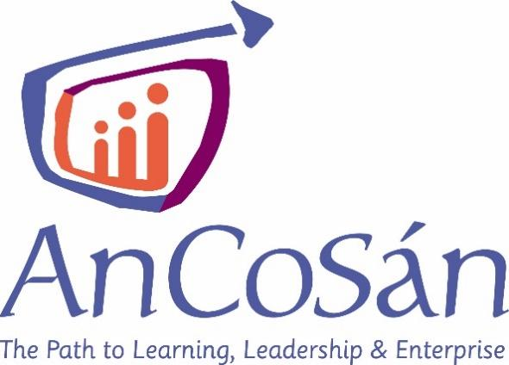

*An Cosán* is a programme that aims to empower individuals and communities through education, leadership development, and social enterprise. The organisation is rooted in the belief that education has the power to transform lives and create positive social change. They provide a range of educational programs and initiatives targeting marginalised and disadvantaged communities.

Their courses are designed to be accessible, flexible, and responsive to the needs of learners. An Cosán utilises a blended learning approach, combining online learning platforms with face-to-face teaching and support. An Cosán has had a transformative impact on the lives of individuals and communities in Ireland. Through their educational initiatives and commitment to social justice, they continue to make a positive difference, empowering individuals and enabling them to reach their full potential.

One of their programmes is called ***Get Yourself Online*** and aims to tackle digital literacy. *Get Yourself Online* is aimed at equipping community organisations and community educators to deliver digital skills training to adults to build their confidence and capacity in the use of digital skills.

Despite a rise in technology use, almost 1 in 2 adults in Ireland lack basic digital skills. Basic Digital Skills are required for things like: 

* Online shopping and banking;
* Doing online courses;
* Connecting online with friends and family;
* Finding a job;
* Being safe online

An Cosán believe that having basic digital skills is critical to supporting lifelong learning, active citizenship, employability, and inclusion. Through their network of 226 partners, their *Get Yourself Online* campaign reaches thousands of adult learners across the country with events taking place to raise awareness and help adults get online confidently and safely.

1. How does An Cosán try to improve the digital skills of students of their courses?

__________________________________________________________________________________________________________________________________________________________________________________________________________________________________________________________________________________________________________________________________________________________________________________________________________________________________________________________________

1. Do you think An Cosán have taken the needs of learners with low digital literacy skills into consideration when designing their courses? What other aspects could they cover?

____________________________________________________________________________________________________________________________________________________________________________________________________________________________________________________________________________________________________________

1. What specific measures or strategies does An Cosán employ to enhance the digital skills of students enrolled in their courses?

____________________________________________________________________________________________________________________________________________________________________________________________________________________________________________________________________________________________________________

1. In your opinion, do you believe An Cosán has adequately addressed the needs of learners with limited digital literacy skills in the design of their courses? What additional areas or aspects could they incorporate to further support these learners

____________________________________________________________________________________________________________________________________________________________________________________________________________________________________________________________________________________________________________

1. How do you think you could improve your digital skills using digital and social media?

____________________________________________________________________________________________________________________________________________________________________________________________________________________________________________________________________________________________________________

# Learning Activity

|  |  |  |  |
| --- | --- | --- | --- |
| **Transversal Theme** | Building Digital Competence through Digital and Social Media | | |
| **Activity Title** | Tracing Your Digital Footprint | | |
| **Type of resource** | Learning Activity | | |
| **Photo** |  | | |
| **Duration of Activity**  **(in minutes)** | 60 Minutes | **Learning Outcome** | * Knowledge of the role of digital and social media in today’s world |
| **Aim of activity** | The aim of this activity is to trace your digital footprint to see what information is available about you online. It will also allow you to take steps to improve your digital footprint. | | |
| **Materials Required for Activity** | * Computer or smartphone with access to the internet | | |
| **Step-by-step instructions** | Your digital footprint includes all the places where you are currently active online. It also includes what might have been put online in the past, either by you or by others about you. The aim of this activity is to trace your digital footprint.  **Step 1:** **Search your name on Google** Open a web browser and go to the Google search engine. Type your full name in the search bar and press enter. Look through the search results and take note of any findings. Re-do the search with your name and address or any other identifying information.  **Step 2: Reflect on your findings** Review the search results and identify different aspects of your digital footprint, such as:   * Mentions of other people with the same name as you. * Posts from your activity on social media sites like Facebook, TikTok, etc. * Older information about yourself that you had forgotten existed. * Information written about you by other people. * Photos of you that you may be tagged in and were unaware of.   **Step 3: Evaluate your online presence** Consider the impact of the information and images found during your search. Reflect on whether anything surprised you or if there are aspects you are unhappy with.  **Step 4**: **Take control of your digital footprint** Determine the purpose and audience for your online presence, especially if you are job hunting.   * Decide who you want to have access to your posts and tighten your privacy settings on social media platforms like Twitter, Facebook, Instagram, TikTok, etc. * Remove photos that don't portray you in the best light and ask others to remove unflattering photos in which you have been tagged. * Delete any posts that you no longer want people to see, following the provided guidance within the respective platforms' privacy and settings areas. * Always think before you post, considering the potential impact on your personal and professional life.   **Step 5: Shape your digital footprint consciously** Reflect on who is currently shaping your digital footprint—whether it's you or your friends.  **Step 6: Manage your privacy settings and online presence** Familiarise yourself with the privacy settings of the websites and platforms you use. Learn how to manage what others can see about you on those platforms. Consider setting up a Google alert to receive email notifications whenever your name is mentioned online.  **Step 7:** Review your digital footprint on a regular basis to make sure nothing new has been added | | |

# Additional Reading or Study Materials

Congratulations, you have reached this point and completed your self-reflection activities related to ‘ *Building Digital Competence through Digital and Social Media’*. What comes next? If you would like to learn more about the topics you have covered so far in this lesson, we have prepared the following additional reading materials for you. This section presents some links to extra materials and videos that we have found online that we think will help you to take the next step in developing your knowledge.

|  |  |
| --- | --- |
| **Resource Title:** | National Adult Literacy Agency: Digital Matters Workbook |
| **Topic Addresses:** | Digital Literacy |
| **Introduction to the resource:** | NALA has created the Digital Matters guide for adults who want to improve their literacy, numeracy and digital skills. It brings together information on digital matters such as using computers and phones. |
| **What will you get from using this resource?** | By reading this workbook and taking part in the activities in it, you will gain valuable insights into the connection between digital competences and digital and social media and learn how to do practical things like search the Internet and download apps to your phones. It also has information on podcasts as they are a great way to learn, especially if you learn by listening. |
| **Link to resource:** | <https://www.nala.ie/wp-content/uploads/2021/07/NALA-Digital-Matters-Workbook-final-web.pdf> |

|  |  |
| --- | --- |
| **Resource Title:** | Digital Stepping Stones |
| **Topic Addresses:** | Digital Literacy |
| **Introduction to the resource:** | This is an online tool by An Cosan to assess your digital skills, so you know what areas you may need help with. It is simple to use but you will need internet access to use it. |
| **What will you get from using this resource?** | You will be guided through an assessment of your digital skills to see what you know and what areas you may need to brush up on. This is a useful tool to see what digital skills you already have and what ones you may need assistance with. |
| **Link to resource:** | <https://www.digitalsteppingstones.ie/> |

