Multilingual Competence and Cultural disciplines

Learner Handout

Contents

[What is language? What is the definition of culture? 3](#_heading=h.gjdgxs)

[What is the relationship between multilingualism and culture? Why isn’t learning a language just a matter of grammar? 3](#_heading=h.30j0zll)

[Case study 5](#_heading=h.1fob9te)

[Learning Activity 7](#_heading=h.3znysh7)

[Additional Reading or Study Materials 10](#_heading=h.tyjcwt)

# 

# What is language? What is the definition of culture?

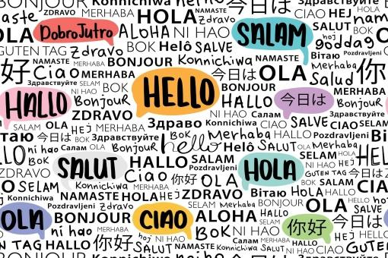

Language is the principal method of human communication, consisting of words used in a structured and conventional way. Language allows us to express our feelings and our thoughts.

On the other hand, culture is a way of life, especially the general customs and beliefs of a particular group of people. It can be the attitudes, behaviour, or opinions for example that define a culture. Culture plays an important role in the lives of everyone in a society because it gives a sense of belonging to something notably to a community.

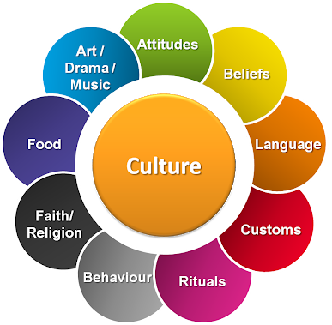

Culture includes literature, arts, and history but also scientific and ethnic knowledge, religious customs, social phenomena, and the geography of a country. It is also about lifestyles, social rites, behavioral habits in meeting situations, rules of politeness, gestures, and verbal expressions.

# What is the relationship between multilingualism and culture? Why isn’t learning a language just a matter of grammar?

Language is culture and culture is language. By learning a language you are learning a culture and by learning a culture you are also learning a language. Language evolves with the culture as a product of the way a society communicates.

Indeed, if we take for example our own language, we experienced the process of learning this language. As children, we learned more than sentences, grammar, vocabulary, or concepts: we learned the culture of our country or community. For instance, those living in Spain are very aware of the traditional *siesta.* This proves that learning a culture and language are fitting together.

This is the logic that will permit the development of multilingual competence through cultural activities. Developing these competencies is not just about learning grammar, vocabulary, or conjugation, but it is also about getting acquainted with the culture and traditions of the language that you want to learn. You can know thousands of words in another language, but you will be surprised at the result of trying to communicate with native speakers for the first time. For example, imagine you receive a Chinese delegation in your company for dinner. Your team has a “sit whenever you like” policy. But it’s a big mistake when receiving a Chinese delegation because they have a hierarchy culture where the head of the group would expect to sit at the head of the table and next to the most senior member of your team. This proves that even if you are fluent in Chinese but don’t know the culture, you will find yourself in awkward situations.

When you learn and speak a new foreign language, you open up to the world and to another culture. We are confronted with a certain number of differences, whether cultural in the broad sense, religious, in daily habits and customs, gastronomy, but also everything related to local music, cinema, or television.

The language is part of the culture of a country, its history, and its heritage and it is also the language which today transmits the history from generation to generation. The way of expressing oneself, the words used, and the expressions depend on the habits of its inhabitants. For example, the English language, which is the most widely spoken in the world, is not only the official language in England but also in the United States, Australia, India, and South Africa. So many countries with completely different lifestyles, customs, and cultures. However, the same word will not necessarily have the same meaning in each of these countries. And this is also equivalent for other languages ​​such as French, Spanish, and Portuguese. If you want to know more about these differences check out [this video](https://www.youtube.com/watch?v=ajmH5iXWUPU). 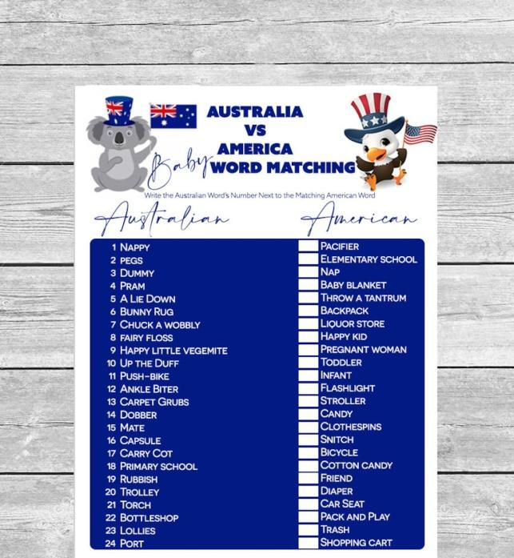



In conclusion, when learning or teaching it’s vital to understand the culture in which it’s spoken since language is deeply rooted in the culture. The more you think about a language’s cultural context, the faster you will learn it. If you aim to learn a foreign language, keep in mind that cultural awareness will be an essential part of your learning process.

# Case study

ESL offers Language Plus Cooking programs that are unique in their genre. Indeed, through an introduction to the cuisines of the world, practical culinary workshops, and tasty tastings of local products, they help to develop language skills. 

Combining language lessons with cooking lessons, nothing is more interactive and entertaining. Cooking is also the reflection of a culture, an art of living. By learning to marry the flavours and scents of the land, you will tame the traditions of your host country. And since cooking is an art that transcends borders, each participant will be able to add their personal touch to the preparation, according to their origin and their taste.

There is the Spanish + Cuisine, French, Italian and Japanese program. For example, the Spanish + Cooking program takes place in Malaga or San Sebastian, which allows you to discover the typical dishes of Spain. The Italian + Cuisine program can take place in several Italian cities, whether in Rome where you learn to make fresh pasta and participate in a local wine tasting or in Tropea where you discover Calabrian specialties. To learn more about these programs, check out the website <https://www.esl.fr/fr/programmes/cours-plus/cuisine>.

However, if linguistic visits abroad are not for you, you can discover « Les Cours d’Adultes de Paris » (Adult lessons) developed by the City of Paris (France). These lessons are reserved exclusively for adults aged 18 and over. It can be a training that is part of a professional project or intended to broaden the scope of one’s knowledge. Among the training offers, there are foreign language courses such as :

* German “on lunch break”
* German through art
* Arab and the Arab culture, major figures and humanist themes
* Spanish and the Hispanic world in 5 movies
* Italian “on lunch break”
* Korean” on lunch break”
* Portuguese by song
* Cultural and linguistic approach to Russian

These courses are not only focusing on the grammatical approach but are trying to have a cultural approach in order to learn the target language and have more fun. If you want to learn more about the program, check out the [website](https://www.paris.fr/pages/cours-municipaux-d-adultes-205).

**Q. What issues do the ESL’s Language + Cuisine program and the City of Paris’s Adult lessons initiative aim to address?**

\_\_\_\_\_\_\_\_\_\_\_\_\_\_\_\_\_\_\_\_\_\_\_\_\_\_\_\_\_\_\_\_\_\_\_\_\_\_\_\_\_\_\_\_\_\_\_\_\_\_\_\_\_\_\_\_\_\_\_\_\_\_\_\_\_\_\_\_\_\_\_\_\_\_\_\_\_\_\_\_\_\_\_\_\_\_\_\_\_\_\_\_\_\_\_\_\_\_\_\_\_\_\_\_\_\_\_\_\_\_\_\_\_\_\_\_\_\_\_\_\_\_\_\_\_\_\_\_\_\_\_\_\_\_\_\_\_\_\_\_\_\_\_\_\_\_\_\_\_\_\_\_\_\_\_\_\_\_\_\_\_\_\_\_\_\_\_\_\_\_\_\_\_\_\_\_\_\_\_\_\_\_\_\_\_\_\_\_\_\_\_\_\_\_\_\_\_\_\_\_\_\_\_\_\_\_\_\_\_\_\_\_\_\_\_\_\_\_\_\_\_\_\_\_\_\_\_\_\_\_\_\_\_\_\_\_\_\_\_\_\_\_\_\_\_\_\_\_\_\_\_\_\_\_\_\_\_\_\_\_\_\_\_\_\_\_\_\_\_\_\_\_\_\_\_\_\_\_\_\_\_\_\_\_\_\_\_\_\_\_\_\_\_\_\_\_\_\_\_\_

**Q. Would you like to take part in this kind of program to develop multilingual competencies through cultural disciplines?**

\_\_\_\_\_\_\_\_\_\_\_\_\_\_\_\_\_\_\_\_\_\_\_\_\_\_\_\_\_\_\_\_\_\_\_\_\_\_\_\_\_\_\_\_\_\_\_\_\_\_\_\_\_\_\_\_\_\_\_\_\_\_\_\_\_\_\_\_\_\_\_\_\_\_\_\_\_\_\_\_\_\_\_\_\_\_\_\_\_\_\_\_\_\_\_\_\_\_\_\_\_\_\_\_\_\_\_\_\_\_\_\_\_\_\_\_\_\_\_\_\_\_\_\_\_\_\_\_\_\_\_\_\_\_\_\_\_\_\_\_\_\_\_\_\_\_\_\_\_\_\_\_\_\_\_\_\_\_\_\_\_\_\_\_\_\_\_\_\_\_\_\_\_\_\_\_\_\_\_\_\_\_\_\_\_\_\_\_\_\_\_\_\_\_\_\_\_\_\_\_\_\_\_\_\_\_\_\_\_\_\_\_\_\_\_\_\_\_\_\_\_\_\_\_\_\_\_\_\_\_\_\_\_\_\_\_\_\_\_\_\_\_\_\_\_\_\_\_\_\_\_\_\_\_\_\_\_\_\_\_\_\_\_\_\_\_\_\_\_\_\_\_\_\_\_\_\_\_\_\_\_\_\_\_\_\_\_\_\_\_\_\_\_\_\_\_\_\_\_\_

**Q. Can you think of any cultural disciplines that you enjoy that incorporate multilingual skills?**

\_\_\_\_\_\_\_\_\_\_\_\_\_\_\_\_\_\_\_\_\_\_\_\_\_\_\_\_\_\_\_\_\_\_\_\_\_\_\_\_\_\_\_\_\_\_\_\_\_\_\_\_\_\_\_\_\_\_\_\_\_\_\_\_\_\_\_\_\_\_\_\_\_\_\_\_\_\_\_\_\_\_\_\_\_\_\_\_\_\_\_\_\_\_\_\_\_\_\_\_\_\_\_\_\_\_\_\_\_\_\_\_\_\_\_\_\_\_\_\_\_\_\_\_\_\_\_\_\_\_\_\_\_\_\_\_\_\_\_\_\_\_\_\_\_\_\_\_\_\_\_\_\_\_\_\_\_\_\_\_\_\_\_\_\_\_\_\_\_\_\_\_\_\_\_\_\_\_\_\_\_\_\_\_\_\_\_\_\_\_\_\_\_\_\_\_\_\_\_\_\_\_\_\_\_\_\_\_\_\_\_\_\_\_\_\_\_\_\_\_\_\_\_\_\_\_\_\_\_\_\_\_\_\_\_\_\_\_\_\_\_\_\_\_\_\_\_\_\_\_\_\_\_\_\_\_\_\_\_\_\_\_\_\_\_\_\_\_\_\_\_\_\_\_\_\_\_\_\_\_\_\_\_\_\_\_\_\_\_\_\_\_\_\_\_\_\_\_\_\_

# Learning Activity

|  |  |  |  |  |  |
| --- | --- | --- | --- | --- | --- |
| **Transversal Theme** | Culture Disciplines | | | | |
| **Activity Title** | A little cultural trip at home | | | | |
| **Type of resource** | **Learning Activity** | | | | |
| **Photo** | **Je vais traduire jusqu'à 800 mots dans vos textes en français/anglais vers  l'espagnol par Santiago_tr** | | | | |
| **Duration of Activity**  **(in minutes)** | 120-150 minutes | | **Learning Outcome** | * Developing language skills through cultural disciplines * Learning more about traditional cooking, traditional music, and traditional films * Learning vocabulary and words through this disciplines * Developing oral and written comprehension skills | |
| **Aim of activity** | This activity aims to build your language skills through the topic of culture. | | | | |
| **Materials Required for Activity** | * Music speaker * Phone or TV * Radio set * Kitchen and food | | | | |
| **Step-by-step instructions** | Learning English and the United Kingdom culture  **Step 1**: Take your phone and music speaker. Put English music like for example Ed Sheeran or The 1975.  **Step 2**: Listen to 2 or 3 songs from these artists. Try to get in the mood. At the same time try to understand the lyrics.  **Step 3:** Write on paper the lyrics and words that you understand. If you understand nothing, don’t worry, take the translation in your language and follow the music at the same time.  **Step 4:** Let the music play. Choose a typical dish from the UK such as *Fish and Chips* or *Jelly*.  **Step 5**: After having chosen your traditional dish, cook it. You have 2 options:   * First: Read the recipe and listen at the same time to traditional music. * Second: Listen to the recipe thanks to Youtube videos for example but don’t listen to music.   **Step 6**: Eat your traditional dish in front of a typical series such as *the Crown* or listen to the national radio such as *the BBC*. | Learning Spanish and the Culture of Spain  **Step 1**: Take your phone and music speaker. Put Spanish music like for example Enrique Inglesias or Rosalia.  **Step 2**: Listen to 2 or 3 songs from these artists. Try to get in the mood. At the same time try to understand the lyrics.  **Step 3:** Write on paper the lyrics and words that you understand. If you understand nothing, don’t worry, take the translation in your language and follow the music at the same time.  **Step 4**: Let the music play. Choose a typical dish from Spain such as *Paella* or *Tapas*.  **Step 5**: After having chosen your traditional dish, cook it. You have 2 options:   * First: Read the recipe and listen at the same time to traditional music. * Second: Listen to the recipe thanks to Youtube videos for example but don’t listen to music.   **Step 6**: Eat your traditional dish in front of a typical series such as *La Casa del Papel* or listen to the national radio such as *Radio Nacional (RNE).* | | | Learning French and the Culture of France  **Step 1**: Take your phone and music speaker. Put French music like for example Edif Piaf or Indilla.  **Step 2**: Listen to 2 or 3 songs from these artists. Try to get in the mood. At the same time try to understand the lyrics.  **Step 3:** Write on paper the lyrics and words that you understand. If you understand nothing, don’t worry, take the translation in your language and follow the music at the same time.  **Step 4:** Let the music play. Choose a typical dish from France such as *Boeuf Bourguignon* or *Blanquette de veau*.  **Step 5**: After having chosen your traditional dish, cook it. You have 2 options:   * First: Read the recipe and listen at the same time to traditional music. * Second: Listen to the recipe thanks to Youtube videos for example but don’t listen to music.   **Step 6**: Eat your traditional dish in front of a typical series such as 10% or listen to the national radio such as *France Inter*. |

# Additional Reading or Study Materials

Congratulations, you have reached this point and completed your self-reflection activities related to Multilingual Competencies and Culture. What comes next? If you would like to learn more about the topics you have covered so far in this lesson, we have prepared the following additional reading materials for you. This section presents some links to extra materials and videos that we have found online that we think will help you to take the next step in developing your knowledge.

|  |  |
| --- | --- |
| **Resource Title:** | Building Multilingual Competencies through Cultural disciplines |
| **Topic Addresses:** | Is culture important in language learning? |
| **Introduction to the resource:** | This additional material presents a well-explained video that explores the relationship between language and culture. It explained the difference between learning a language without having cultural knowledge and learning a language with cultural disciplines. |
| **What will you get from using this resource?** | This link provides additional information on how culture is indissociable from language.  By watching this video you will learn:   * The importance of culture when you interact with people in another language * How culture is indispensable to learn language * How culture is indispensable when you are in a public sphere and how to behave socially. |
| **Link to resource:** | <https://www.youtube.com/watch?v=841T17Smhkw> |

|  |  |
| --- | --- |
| **Resource Title:** | Building Multilingual Competencies through Cultural disciplines |
| **Topic Addresses:** | Slang Around the World |
| **Introduction to the resource:** | This additional material presents fun and helpful tools. This resource will help you reinforce your multilingual competencies and language skills. Indeed, slang helps keep languages interesting and alive. Moreover, many of the words and expressions used today in every language and culture started out as slang first. Often playful and colourful, slang is like a laboratory for language and represents the culture of the country’s language.  Slang is everywhere and can permit developing language skills in a fun and interactive way. This can provide you with an example to explore in your own life and how you can build your multilingual competencies through non-traditional learning. |
| **What will you get from using this resource?** | By using this resource, you will learn more about the different slang words and sentences used in different languages and countries. For example:   * You will learn funny Australian slang or Canadian slang. * You will learn French slang and expression * You will learn German slang * You will learn Swedish and Norwegian slang * You will learn Spanish slang from different countries and cultures   This resource can help you develop language skills and communication skills. Indeed, even if English is used in Canada, Australia, the UK or the United States, some expressions or words are changing and are not the same in each country. This is why it’s important to know the expressions and slang of different countries to avoid miscommunication. Cultural knowledge will thus help you develop your language skills. |
| **Link to resource:** | <https://www.k-international.com/blog/slang-around-the-world/> |

