Mathematical (STEM) competence and Art

Learner Handout

Contents

What is Art? 3

What are the relationships between Mathematics and Art? 3

Case study 7

Learning Activity 9

Additional Reading or Study Materials 14

# What is Art?

What is art? Art is a very diverse field. There are many ways to understand it, meaning that there are no universal definitions. For example, Rene Magritte defines art as “the mystery without which the world would not exist”.

But we can agree that art covers a wide range of human activities that involve creative and imaginative talent such as painting, sculpting, architecture, theatre, dance, music, film, or literature.

# What Are the Relationships Between Mathematics and Art?

We would tend to think that mathematics and art are very different fields but if we look more closely, we see that they have quite similarities. Indeed, maths and art are linked together. Mathematics can constitute a tool at the service of artists. But on the other hand, maths can also become a subject of art.

1. **Mathematics as a tool of Art**
2. *The Golden ratio*

This is an excellent example of the relationship between maths and art. In Ancient Rome, architects, painters, sculptors, and draftsmen understood the difference between an aesthetic work and a chaotic one. They were interested in this question and studied how a work can be pleasant to look at.

But what is the definition of the Golden ratio? The Golden ratio is the number equal to $\frac{1+\sqrt{5}}{2}$ which is approximately 1.618. This proportion is considered aesthetic. The Golden ratio is usually denoted by the letter φ.

Thus there are several figures taking advantage of the golden ratio. For example, there are the golden rectangle, the golden spiral, the golden triangle, the golden ellipse, or even the golden dots. All this data defines precisely where each element of a painting should be located in order to make the whole harmonious and pleasing to the eye.

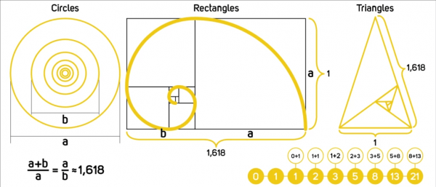

Luca Pacioli, a monk, wrote in 1498 a work entitled *De divina proportione*, in which he describes the effects of dividing a length according to the divine proportion. The golden ratio has been used a lot in architecture, it was then detected in a good number of paintings where the artist has been attributed either the will to voluntarily use the golden proportions, or to have used them intuitively.

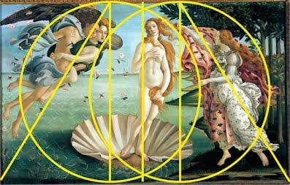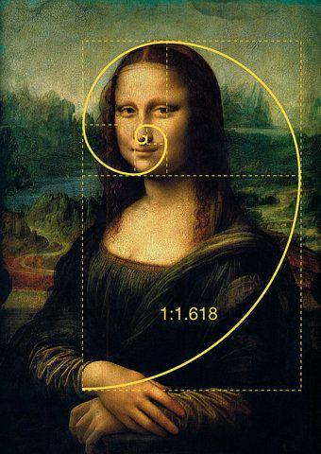



If you want to learn more about the Golden Ration check out this well explained [video](https://www.youtube.com/watch?v=6nSfJEDZ_WM).

1. *The perspective*

One of the greatest mathematical inventions in the field of art is certainly the representation of perspective. Perspective makes it possible to represent a three-dimensional reality on a two-dimensional support and to give the illusion of depth. When drawing in perspective, the further away objects are in space, the smaller they appear on the paper.

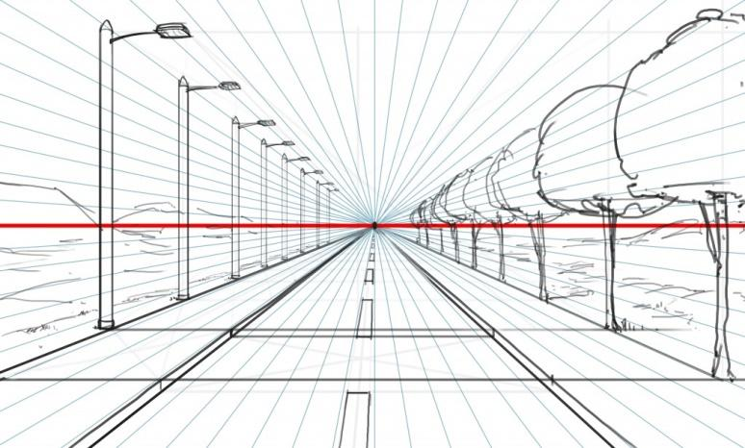

During the Renaissance, artists began to use the linear perspective system. A point is then indicated on the horizon line and lines are drawn on the drawing sheet, all joining this vanishing point. In this way, it is possible to draw a road lined with trees and lampposts for example, using the appropriate lines.

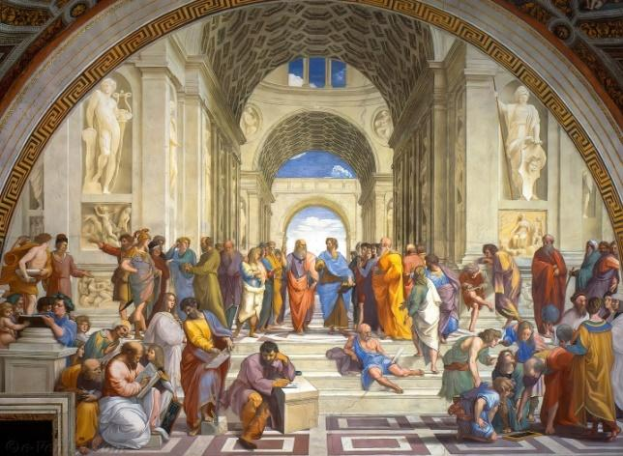

This mathematical technique has been used by many painters such as Raphaël in his painting “L’école d’Athènes” where we can see all the lines converge to a vanishing point in the center of the painting.



1. **Mathematics as a subject of Art.**

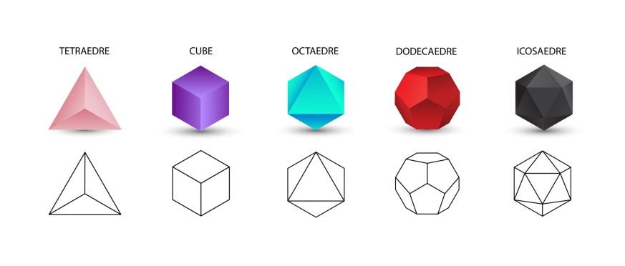

In geometry, there are two types of polyhedron: a Platon solid (there are five of them) and an Archimedean solid (there are thirteen of them). They are represented on the image below.

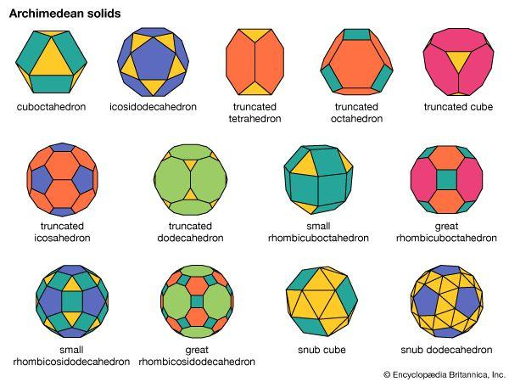

These geometric shapes have been enormously represented in artistic works from the Renaissance. For example, Leonardo da Vinci made a drawing to illustrate the work of his colleague Luca Pacioli. This drawing is a rhombicuboctahedron which is an Archimedean solid (see Figure 1).

Moreover in the engraving, Mélancolia I, Albrecht Dürer makes an illustration of the melancholic temperament. Around this character, he represented many mathematical objects such as a sphere or a block of stone carved in a polyhedron shape (see Figure 2). These two examples show that mathematics can be the subject of artistic works.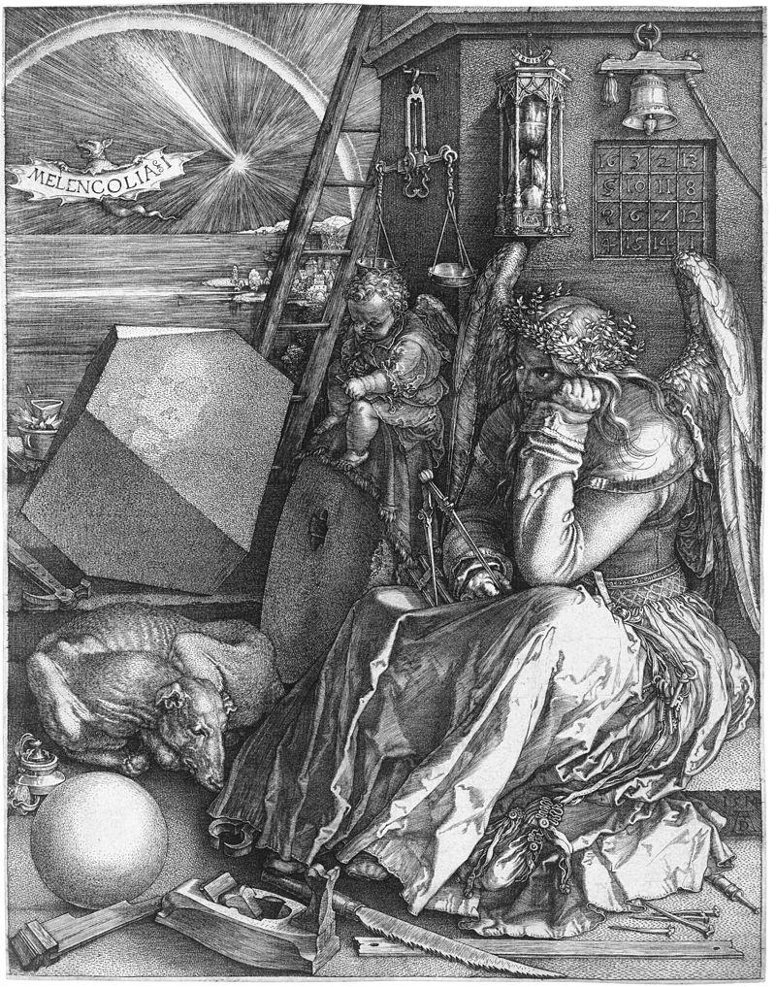

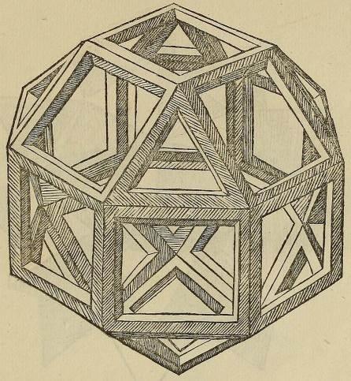

In conclusion, art and mathematics have many axes of convergence both in terms of interest that mathematicians and artists support each other but also around uses and processes. Since the Renaissance, many artistic works used mathematical skills such as geometry and the well-known Golden ratio. Developing mathematical competencies through art is easy: just take an object of everyday life, try to draw it or paint and you will realise the importance of maths to become an artist.

# Case study

Every year in France as part of the Mathematics Week which invites people to “stage mathematics”, the various French departments set up initiatives and programs to make students discover maths differently. In 2020, the Department of Finistère offered primary school teachers the opportunity to deploy arts-related activities in their classes. Among these, the visual arts help make the link with mathematics.

The pedagogical intentions were to awaken interest and curiosity for maths, to solve an atypical classification, and sorting problem and to understand the relationship between the arts and mathematics. The students learned:

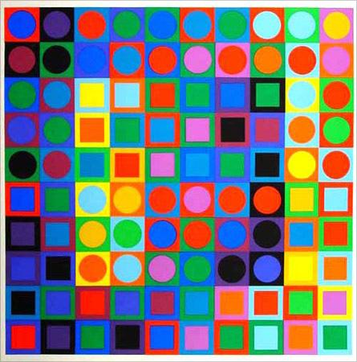

* To recognise the different geometries and their properties
* To count, classify, reproduce, order, and locate these shapes
* To use a ruler, a compass, and a set square
* To understand the different geometric concepts such as the median, the diagonals, the segments, and how to calculate or use them.

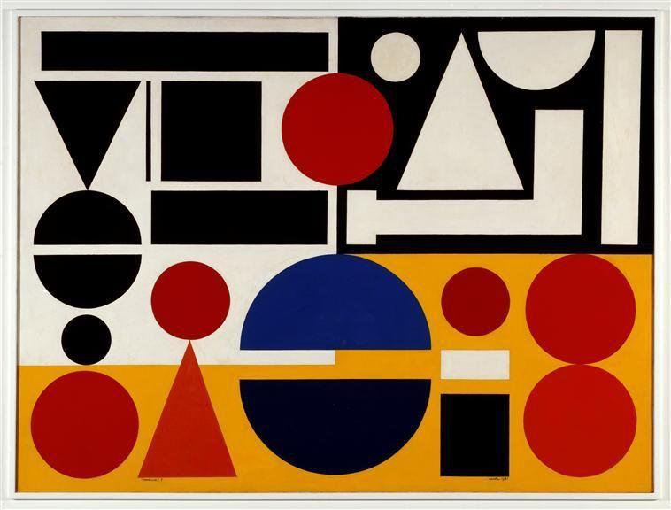

They had to reproduce one of the paintings by Vasarely or Auguste Herbin. By doing so, they understood and learned all the properties of all the geometric shapes.



Mathematics Week is an excellent example of how geometry and mathematical skills can be involved in daily activities such as artistic disciplines making learning more relatable, enjoyable, and accessible to all. To learn more about this initiative, check out the website <https://pedagogie.ac-rennes.fr/spip.php?article2714>. Moreover, if you want to know more about Mathematics Week, check out the Ministry of National Education and Youth [website](https://www.education.gouv.fr/la-semaine-des-mathematiques-7241#:~:text=Sites%20%C3%A0%20consulter-,Une%20semaine%20pour%20renforcer%20l'attractivit%C3%A9%20des%20math%C3%A9matiques,vivante%20et%20attractive%20des%20math%C3%A9matiques.).

Art-based learning is an educational approach that uses artistic disciplines as a vehicle for teaching academic subjects and life skills. It involves incorporating art activities into classroom lessons, with the goal of engaging students and helping them learn in a fun and interactive way. The teaching of maths can be done through painting but also music or even dance. Art is effective in improving academic outcomes and promoting personal development. It can be especially beneficial for students who dislike traditional classroom learning.

**Q. What issues do Mathematics Week and the Finistère 2020’s initiative aim to address?**

____________________________________________________________________________________________________________________________________________________________________________________________________________________________________________________________________________________________________________

**Q. Would you like to see a Mathematical Week, especially for adults developed? Would you like to take part in this kind of initiative to develop mathematical competencies through art?**

____________________________________________________________________________________________________________________________________________________________________________________________________________________________________________________________________________________________________________

**Q. Can you think of any artistic disciplines that you enjoy that incorporate mathematical thinking?**

____________________________________________________________________________________________________________________________________________________________________________________________________________________________________________________________________________________________________________

# Learning Activity

|  |  |  |  |  |
| --- | --- | --- | --- | --- |
| **Transversal Theme** | Artistic Disciplines | | | |
| **Activity Title** | Draw a face – Learning symmetry and geometry | | | |
| **Type of resource** | **Learning Activity** | | | |
| **Photo** | **Apprendre à la maison** | | | |
| **Duration of Activity**  **(in minutes)** | 60-90 minutes | **Learning Outcome** | | * Develop geometric and mathematical skills through art. * Build figures on paper * Locate oneself on a grid * Learn symmetry |
| **Aim of activity** | This activity aims to build your geometric and mathematical (STEM) competencies through the topic of arts. | | | |
| **Materials Required for Activity** | * Squared A4 sheet (small squares) * Pencil and rubber * Ruler and set square * Coloured pencil and fine black marker | | | |
| **Step-by-step instructions** | Instructions:  **Step 1**: Take a squared A4 sheet with small squares in the sense of height.  **Step 2**: Draw a rectangle 27 centimeters long and 20 centimeters wide. | |  | |
| **Step 3**: Identify the midpoints of the 4 sides of the rectangle (red points). | |  | |
| **Step 4**: Draw the 2 medians of the rectangle. A median is a segment which starts from the middle of a side and joins the middle of the opposite side. | |  | |
| **Step 5:** Draw 4 segments parallel to the length of the rectangle and 4 centimeters apart from each other.  **Step 6:** Name A, B, C, D, E and F the 6 columns. | |  | |
| **Step 7**: Draw 4 segments parallel to the width of the rectangle :   * The first is 3 centimeters from the top * The second is 8 centimeters from the first line * The third is 8 centimeters from the second line * The fourth is 4 centimeters from the third line.   **Step 8**: Name the 6 lines: 1, 2, 3, 4, 5 and 6. You get a grid with boxes/cells. | |  | |
| **Step 9**: Take a fine black marker. Draw the left eye on the line separating the cells B3 and B4. | |  | |
| **Step 10**: Draw the right eye on the line separating the cells E3 and E4.  You now have 2 symmetrical eyes. | |  | |
| **Step 11**: Draw the left eyebrow on the line separating the cells B2 and B3. Do the same with the right eyebrow using the symmetric (E2 and E3 cells)  **Step 12**: Draw the left nostril in the C4 cell. Draw the right nostril using the symmetric technique (D4 cell). | |  | |
| **Step 13**: Draw the left ear in the cells A3 and A4. Do the same with the right ear in the cells F3 and F4. | |  | |
| **Step 14**: Draw the mouth: it fits in cells B5, C5, D5 and E5. | |  | |
| **Step 15**: Draw the contours of the face: forehead and chin.  **Final step**: You can now erase the grid and customise the face by drawing the hair and by adding details. | |  | |

# Additional Reading or Study Materials

Congratulations, you have reached this point and completed your self-reflection activities related to building mathematical competencies through art. What comes next? If you would like to learn more about the topics you have covered so far in this lesson, we have prepared the following additional reading materials for you. This section presents some links to extra materials and videos that we have found online that we think will help you to take the next step in developing your knowledge.

|  |  |
| --- | --- |
| **Resource Title:** | Building Mathematical (STEM) Competencies through Artistic disciplines. |
| **Topic Addresses:** | Learning Maths through Art lessons. |
| **Introduction to the resource:** | This additional material presents fun and helpful lessons. These patterns of activities help to reinforce many important mathematical and geometric skills. These lessons make you build 3 dimensional objects, draw a maze or a snowflake among other things. This can provide you with an example to explore in your own life and how you can build your mathematical competencies through non-traditional learning and building artistic pieces. |
| **What will you get from using this resource?** | By using this resource, you will learn more about the different mathematical and geometric skills that you can develop in artistic disciplines. For example:   * You will learn the perspective and the three dimensions principles which are essential in painting and also in maths. * You will learn how to use a pair of compasses in order to produce some mazes and labyrinths. * You will learn how to do accurate measuring in order to produce curves, mandalas, and cardioids. * You will learn the fractions, decimals, and percentage conversion tasks thanks to the Modern Art Maths. * You will learn symmetry and asymmetry through the construction of snowflakes.   Mathematics and geometry are essential for creativity and innovation. By learning these competencies you will also develop your creativity and your open-mindedness. |
| **Link to resource:** | <https://www.artfulmaths.com/mathematical-art-lessons.html> |

|  |  |
| --- | --- |
| **Resource Title:** | Building Mathematical (STEM) Competences through Artistic disciplines. |
| **Topic Addresses:** | Link between maths and architecture |
| **Introduction to the resource:** | This additional material presents a well-explained video that explores the relationship between math and architecture, which is a type of art, and how they may be more closely linked than it seems. |
| **What will you get from using this resource?** | This link provides additional information on how mathematics are essential in everyday life and most of all in architecture.  By watching this video you will learn:   * How maths is important in architecture. * How architects use maths in their profession. * How buildings such as skyscrapers or bridges stand. * A little bit of history of the link that exists between mathematicians and architects. |
| **Link to resource:** | <https://www.youtube.com/watch?v=_pBXcYhm_3k> |

