<Competence area and transversal theme>

Learner Handout

Contents

**What are digital competences? 3**

**What is the connection between digital competences and sports and hobbies? 4**

**Case study - @homeWork 5**

**Learning Activity - Exploring Technology in Sports and Hobbies 7**

**Additional Reading or Study Materials 8**

# What are digital competences?

The fourth industrial revolution is happening right now and it's powered by cloud, social, mobile, the Internet of Things, and artificial intelligence. As with the previous three revolutions, each bringing the advancement of the steam engine, the age of science and mass production, and the rise of digital technology, the world around us fundamentally changed. Digital transformation is on the rise and affecting every industry imaginable. Consequently, digital competence is vital for participation in today’s society and economy. 

Digital competence, also known as digital literacy or digital skills, can be described as the ability to find, evaluate, use, share, and create content using digital devices, such as computers and smartphones. It encompasses a broad range of skills, knowledge, and attitudes that enable individuals to interact, communicate, and participate in the digital world with confidence and proficiency. It may sound simple but there’s more to it than just surfing the Internet.

As technology is the centre of our lives, and as our dependence on the internet and digital communications increases, the digital skills required in the workplace and in life in general are a bit more advanced. According to the European Digital Competence Framework for Citizens, also known as DIGCOMP, there are five areas that describe what it means to be “digital savvy”: Information Processing, Communication, Content Creation, Safety and Problem Solving.

According to Eurostat in 2021, 54% of people in the EU aged 16 to 74 had at least basic overall digital skills. There are a few ways of developing digital skills that don’t include attending traditional university programs. The Internet is a place with a vast amount of information on any topic you can think of and you can find lots of materials for self-learning and connect with professionals in your field. For a more structured experience, you can explore free online courses where you can learn at your own pace.

# What is the connection between digital competences and sports and hobbies?

Building digital skills through sports and hobbies can be an enjoyable and effective way for adults to enhance their technological proficiency. So how can you combine sports and hobbies with digital skills? 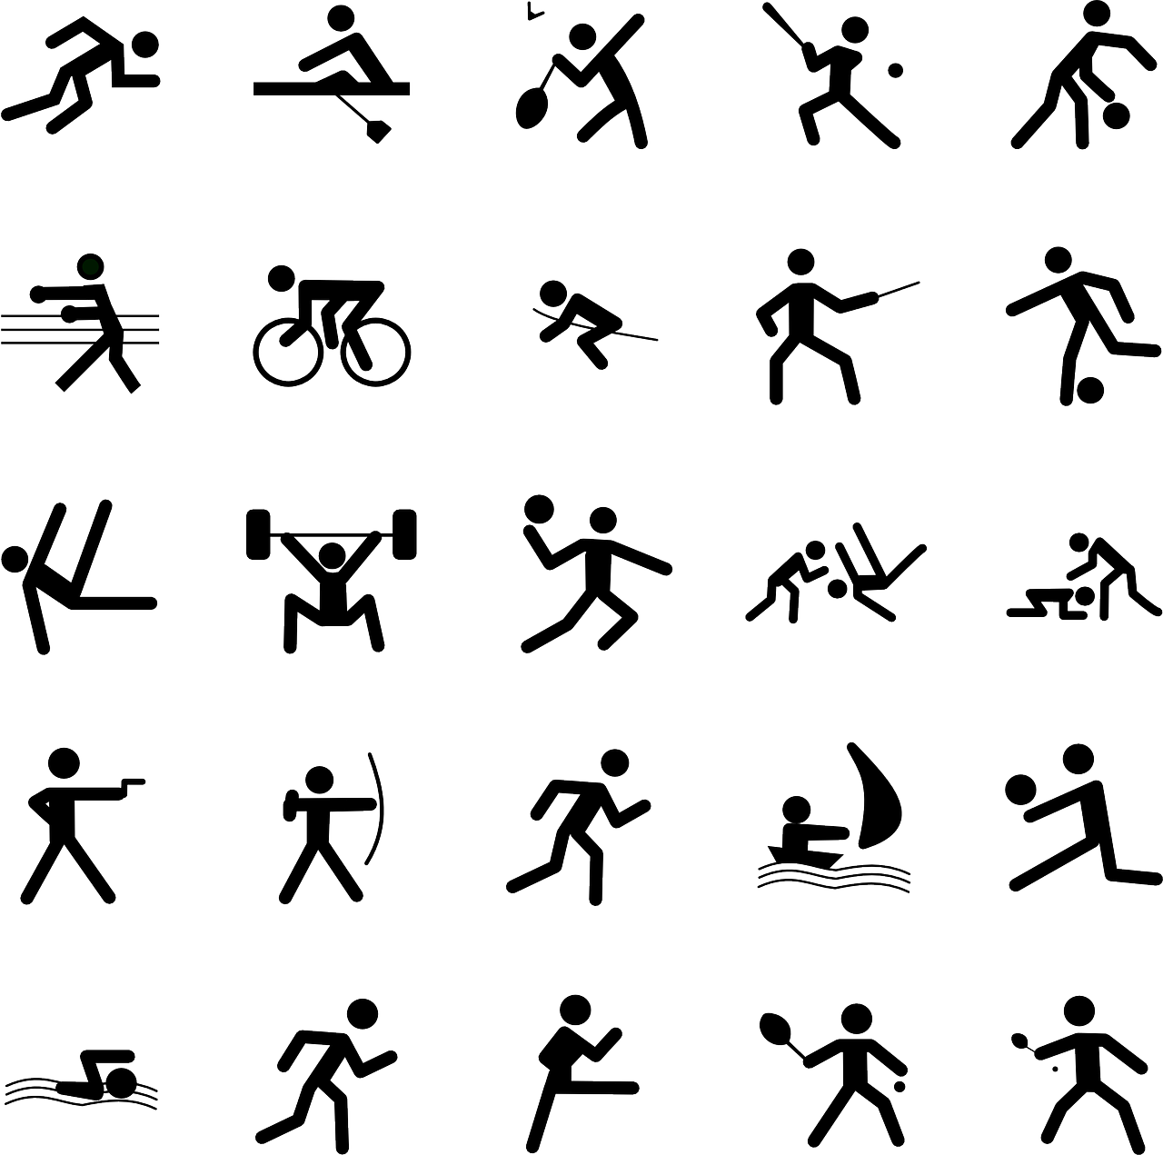

If you are a sport enthusiast, there are virtual coaching and training programs available. These online courses offer professional guidance and tips to improve skills and techniques in various sports. For recreationists, many sports and fitness activities can be complemented by using fitness apps and wearable technology. You can track your progress using fitness apps, set goals, and analyse performance data using apps and devices that sync with your activities.

You can also enroll in online courses or workshops related to sports to acquire new skills at your own pace.

If you prefer hobbies such as cooking, gardening, or DIY projects, you can access online tutorials and video guides. Platforms like YouTube offer a wealth of instructional content to enhance skills and learn new techniques. By using technology, you can learn to make an exotic dish, raise plants from seeds, make professional photographs, or become interior design expert and learn to drywall - the opportunities are endless!

By joining social media groups and forums dedicated to sports and hobbies can provide opportunities to connect with like-minded individuals. You can exchange knowledge, seek advice, and learn from each other's experiences. You can find online communities and platforms that are specific to certain hobbies such as photography, painting, or woodwork where you can share your work, discuss it, receive feedback and learn from others.

By using blogs and creating content, you can record your sports and hobbies activities and publish it online.

Digital sports simulations and video games can enhance strategic thinking, hand-eye coordination, and problem-solving skills. Engaging in sports-related games can be a fun way to improve digital competencies.

If you’re the competitive type, you can participate in virtual sports challenges or events that use digital platforms to compete with others globally. This fosters a sense of camaraderie and encourages adults to push their boundaries.

So there are lots of ways to integrate digital tools and platforms in your sports and hobbies. Choose some and make your learning process more dynamic and engaging!

# Case study - @homeWork

The Erasmus+ project [@homeWork](https://erasmus-plus.ec.europa.eu/hr/projects/search/details/2016-1-TR01-KA204-034403) aims to empower inactive women and housewives by enhancing their skills in using smartphones, tablets, and computers. The project focuses on enabling them to develop competencies in fashion design as a hobby. The two-phase online training utilises avatars as a teaching tool to achieve its objectives.

There are two primary goals of the project. The first is to create learning content that enhances the technological skills of inactive women, enabling them to better utilise smart devices and computers. Additionally, the project aims to provide e-learning content to guide them in developing fashion design competencies for their hobby purposes. The second goal is to establish an online guide that allows participants to use the web and social media for their fashion design hobby. This guide aims to create a scalable and adaptable platform that remains compatible with current and future technologies, including audio/video and gaming features, all supported by avatar-based e-training and e-guiding content. The project disseminates its outputs through women-focused NGOs across Europe and organises peer-to-peer workshops to maximise its impact.

The project specifically targets inactive women, referring to those who are neither employed nor actively seeking employment due to personal or family responsibilities. For instance, young women taking care of their newborn babies are among the target group. The project emphasises the importance of hobbies in everyone's lives, particularly for those confined to their homes, as hobbies help relieve stress, combat boredom, and promote a youthful mindset.

Women, in general, possess a natural inclination toward fashion and enjoy designing aspects of their lives, such as home decoration, dressing up, and makeup. The project seeks to organise and improve this activity by supporting participants in utilizing technological tools, mobile devices, tablets, social media, and web-based platforms to enhance their competencies and enjoyment of their hobbies. As a result, participants experience positive effects on their overall skills and become more adaptable to rapidly advancing technology.

**Questions**

1. How does the Erasmus+ project @homeWork aim to empower inactive women and housewives, and what are the key aspects of the training it offers?

_________________________________________________________________________________________________________________________________________________________________________________________________________________________________________________________________________________________________________________________________________________________

1. What are the primary goals of the project, and how does it utilise avatars to enhance the online training experience for developing competencies in fashion design as a hobby?

_________________________________________________________________________________________________________________________________________________________________________________________________________________________________________________________________________________________________________________________________________________________

1. How do you think you could improve your digital skills through sports and hobbies?

____________________________________________________________________________________________________________________________________________________________________________________________________________________________________________________________________________________

_____________________________________________________________________

# Learning Activity - Exploring Technology in Sports and Hobbies

|  |  |  |  |
| --- | --- | --- | --- |
| **Transversal Theme** | Digital Competence Through Sports & Hobbies | | |
| **Activity Title** | Exploring Technology in Sports and Hobbies | | |
| **Type of resource** | **Learning Activity** | | |
| **Photo** |  | | |
| **Duration of Activity**  **(in minutes)** | 60 minutes | **Learning Outcome** | * Explore various ways to leverage technology in chosen sports and hobbies |
| **Aim of activity** | The aim of this activity is to empower adults to combine their digital skills with their sports and hobbies, fostering creativity, innovation, and digital competence. | | |
| **Materials Required for Activity** | * Access to the internet and a computer or smartphone. * Sports or hobby equipment, depending on the chosen activity. | | |
| **Step-by-step instructions** | **Step 1**: Choose a sport or hobby you are passionate about and want to explore further using digital skills. It could be anything from crossfit, cycling, photography, cooking, gardening, painting, or any other interest you have.  **Step 2**: Do online research to find digital applications or tools related to your chosen sport or hobby. Look for apps, websites, or software that can enhance your experience, track progress, or provide creative opportunities.  **Step 3:** Find video tutorials or guides on platforms like YouTube or specialized websites that demonstrate how to combine digital skills with your chosen activity.  **Step 4:** Develop a plan on how you will integrate digital skills into your sports or hobby practice. Decide which tools or apps you want to use, and outline specific activities you'd like to try using technology.  **Step 5**: Spend time implementing the digital techniques you've learned. Take photographs, record videos, use fitness apps, edit digital content, or explore any other relevant activities.  **Step 6:** Take a moment to reflect on your experience combining digital skills with your sport or hobby. Consider how it enhanced your engagement, creativity, or understanding of the activity.  **Step 7**: Create a digital project, such as a photo gallery, video montage, or digital artwork, showcasing the combination of digital skills with your sports or hobbies. Share it with friends, family, or online communities. | | |

# Additional Reading or Study Materials

Congratulations, you have reached this point and completed your self-reflection activities related to Digital Competence through Sports & Hobbies. What comes next? If you would like to learn more about the topics you have covered so far in this lesson, we have prepared the following additional reading materials for you. This section presents some links to extra materials and videos that we have found online that we think will help you to take the next step in developing your knowledge.

|  |  |
| --- | --- |
| **Resource Title:** | How to Develop Your Technical Skills: Six New Hobbies to Learn |
| **Topic Addresses:** | Enhancing Your Digital Skills Through Hobbies |
| **Introduction to the resource:** | The aim of this resource is to give you an idea how you can find new hobbies to practice your digital skills. |
| **What will you get from using this resource?** | By using this resource, you’ll get motivated to replace your idle time with a new computer hobby and you’ll learn six new ways in which you can practice your digital skills. |
| **Link to resource:** | <https://www.makeuseof.com/develop-technical-skills-hobbies-to-learn/> |

|  |  |
| --- | --- |
| **Resource Title:** | How to Boost Your Digital Skills with These New Hobbies |
| **Topic Addresses:** | Enhancing Your Digital Skills Through Sport & Hobbies |
| **Introduction to the resource:** | The aim of this resource is to add a digital component to your real-world hobbies. |
| **What will you get from using this resource?** | By using this resource, you’ll learn more about digital spaces and have a broader digital literacy, take on your favourite hobbies and level up to expand your digital media skills. This resource is also linked to another interesting article that explores how creative hobbies improve our performance at everything else. |
| **Link to resource:** | <https://rachelbeaney.com/how-to-boost-your-digital-skills-with-these-new-hobbies/> |

