<Competence area and transversal theme>

Learner Handout

Contents

**What is Personal, Social, and Learning to Learn Competence? 3**

**What is the connection between Personal, Social & L2L Competence and Digital and Social Media? 4**

**Case study - Holistic Psychologist 5**

**Learning Activity 7**

**Additional Reading or Study Materials 9**

# What is Personal, Social, and Learning to Learn Competence?

Personal, social, and learning-to-learn competence, often referred to as key competences or transversal skills, are essential skills that have been recognised as one of the eight key competences for lifelong learning by the Council of the EU. It’s regarded as a transversal or soft skill because these skills are behavioral and interpersonal that relate to how effectively people interact with others and handle situations. These characteristics can be carried over to any job position as well as in personal lives and relationships. They are crucial for both our personal growth and development, professional growth and employability and overall well-being. 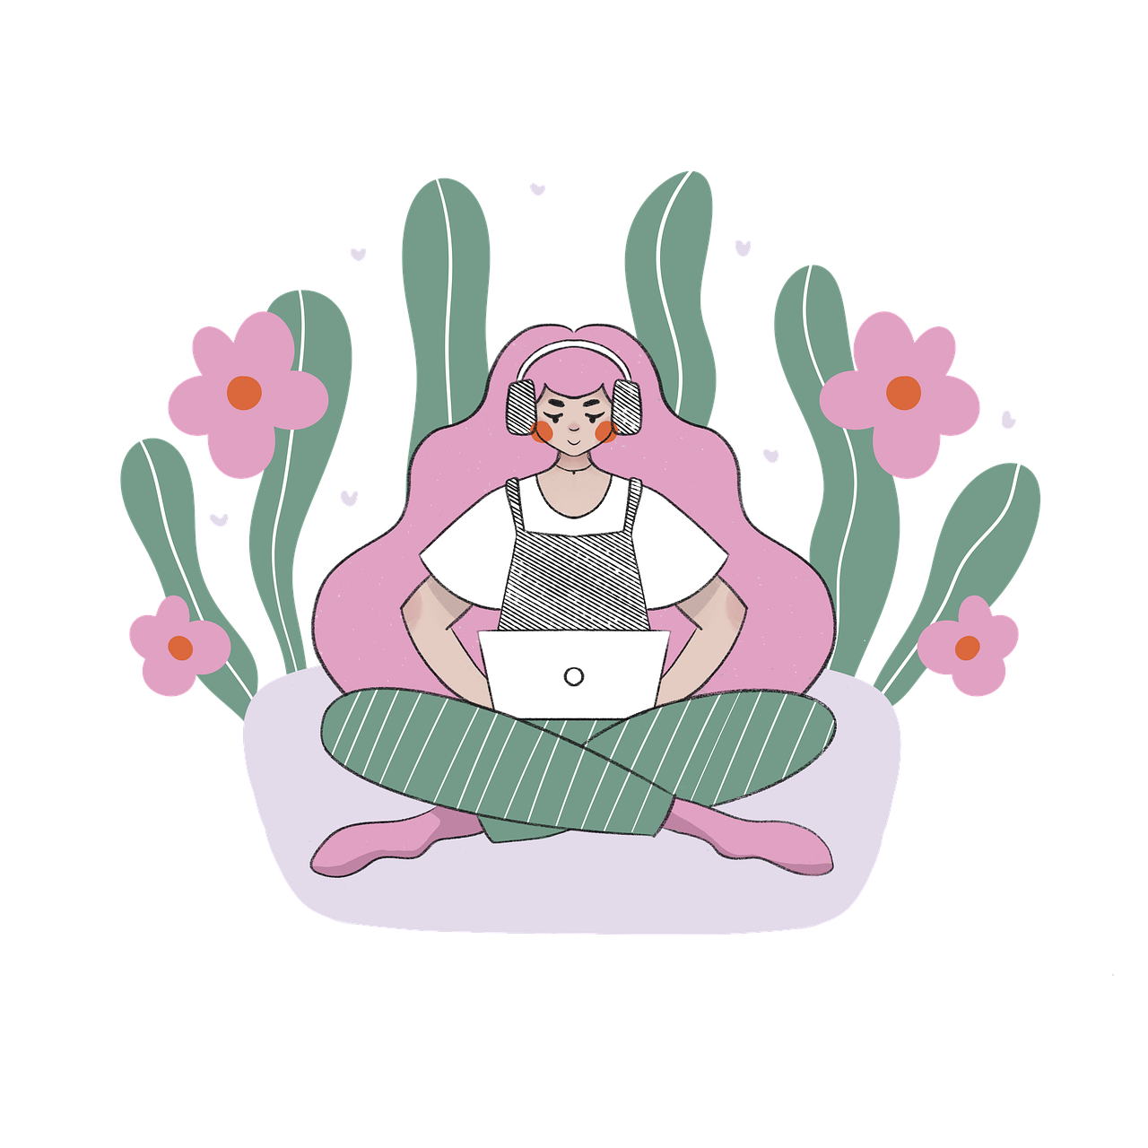

Personal competence means understanding oneself, managing emotions, and developing a positive self-image. It encompasses self-awareness, self-confidence, emotional intelligence, and resilience. Individuals with strong personal competence are better equipped to set and achieve goals, adapt to changes, and handle challenges effectively. This competence also includes time management, self-motivation, and a willingness to take initiative, all of which contribute to personal growth and success in both personal and professional spheres.

Social competence is about effectively interacting with others, building and maintaining positive relationships, and being empathetic and considerate towards others' feelings and perspectives. This competence includes communication skills, active listening, teamwork, conflict resolution, and cross-cultural awareness. Individuals with strong social competence can collaborate effectively in diverse environments, lead teams, and contribute positively to their communities.

Learning to learn competence is all about becoming an effective and autonomous learner. It involves developing the skills and attitudes necessary to acquire and apply knowledge throughout life. This competence includes critical thinking, problem-solving, information literacy, creativity, and curiosity. Individuals with strong learning-to-learn competence can adapt to new challenges, continuously acquire new skills and knowledge, and stay motivated to engage in lifelong learning.

These three competences are interconnected and mutually reinforcing. For instance, strong personal competence can lead to improved social interactions and better learning outcomes. Likewise, a well-developed learning-to-learn competence can contribute to personal growth and increased social adaptability.

# What is the Connection Between Personal, Social & Learning to Learn Competence and Digital and Social Media?

Digital technologies can enhance and facilitate the development of personal, social, and learning to learn competence in a number of ways.

**Tips for Enhancing Personal Competence Through Digital and Social Media**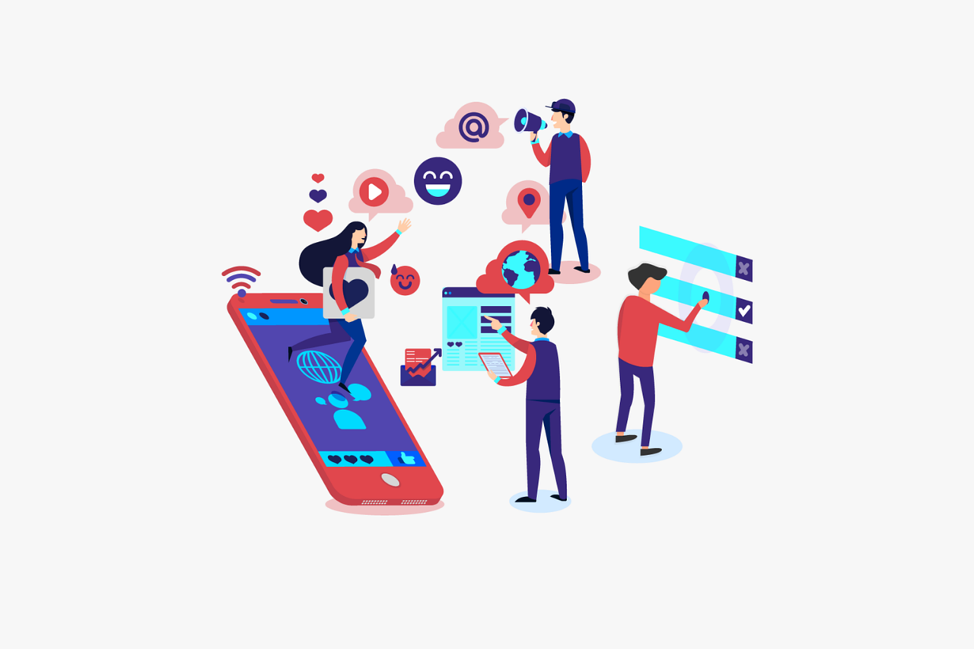

* Journaling apps can aid in self-reflection;
* Personal development websites can help you gain insights into your strengths and areas for improvement;
* Mindfulness and meditation apps can help you practice mindfulness and meditation to reduce stress;
* Online resources on emotional intelligence can provide guidance and help you understand and manage your emotions effectively.

**Tips for Enhancing Social Competence Through Digital and Social Media**

* Engage in online communities and participate in online discussions related to your interests and hobbies;
* Practice active listening by reading and understanding others' viewpoints before responding;
* Join virtual events (workshops, or conferences) to practice social skills in a virtual setting and connect with people from various backgrounds;
* Showcase your skills, achievements, and interests by creating and maintaining a professional online presence.

**Tips for Enhancing Learning to Learn (L2L) Competence Through Digital and Social Media**

* Digital calendars and productivity apps can assist you in organising your schedules and managing your time more efficiently;
* Explore e-learning platforms that offer a wide range of courses and resources, on various topics, such as Coursera, Udemy, and Khan Academy;
* Follow and subscribe to educational blogs, Instagram pages, and YouTube channels that offer valuable insights and information on topics of interest;
* Explore educational apps that align with your learning goals (e.g. for language learning, skill development, etc.).

# Case study - The Holistic Psychologist



Dr. Nicole LePera, also known as "The Holistic Psychologist," is a licensed clinical psychologist, content creator, and author known for her work in the field of psychology and mental health. She has authored three books, conducted workshops and engaged in public speaking to further spread awareness about mental health and the importance of holistic approaches to wellness.

Just as the name of her brand says, her approach is holistic which means that with her work she focuses on the integration of mind, body, and spirit in the healing and growth process. She empowers individuals to take an active role in their mental health journey and provides various tools to improve overall well-being.

She gained significant popularity through her social media presence, particularly on Instagram, Facebook, and YouTube, thanks to her engaging microlearning content on complex topics such as emotional intelligence, communication skills, trauma healing, self-care, mindfulness, building resilience, and attachment theories.

The microlearning content is the most important part of her work and it’s also free and accessible to anyone. Her followers can easily consume her bite-sized content on social media - her posts are concise, engaging and focus on delivering key insights or actionable tips through visually appealing graphics.

Through her great storytelling techniques, she’s able to deliver complex psychological concepts in a simple and effective way through great storytelling techniques and vulnerable and authentic sharing of personal experiences from her personal life. Through her posts, she shares valuable insights, practical tips, guidance, strategies, and self-help advice related to mental well-being and personal development. LePera's microlearning content provides practical advice and tools that viewers can apply to improve their mental well-being and personal growth. She offers actionable strategies that are easy to implement in daily life.

She also encourages her followers to share their own stories and experiences under each post. She frequently engages with her audience through live Q&A sessions and responds to comments, creating a sense of community and fostering open dialogue about mental health and personal development.

Engaging with Nicole LePera's microlearning content can be a valuable self-directed activity for adults seeking personal development and mental health insights, depending on your individual preferences and mental health challenges.

**Questions:**

1. **How does Nicole LePera incorporate personal skill competences through digital and social media?**

____________________________________________________________________________________________________________________________________________________________________________________________________________________________________________________________________________________________________________

1. **Would you like to work on enhancing your personal and social competence through this kind of micro-learning content?**

____________________________________________________________________________________________________________________________________________________________________________________________________________________________________________________________________________________________________________

1. **Can you think of any other digital and social media activities that you enjoy that incorporate personal, social, or Learning To Learn skills?**

____________________________________________________________________________________________________________________________________________________________________________________________________________________________________________________________________________________________________________

# Learning Activity

|  |  |  |  |
| --- | --- | --- | --- |
| **Transversal Theme** | Personal, Social, and L2L Competence Through Digital and Social Media | | |
| **Activity Title** | Improving Your Digital Time Management | | |
| **Type of resource** | **Learning Activity** | | |
| **Photo** |  | | |
| **Duration of Activity**  **(in minutes)** | 10 minutes each day for time audit  60 minutes for the activity | **Learning Outcome** | * Reflect on your own time management skills * Explore time management techniques and strategies |
| **Aim of activity** | The aim of this activity is to empower learners to enhance their time management skills through online resources and digital tools. | | |
| **Materials Required for Activity** | * Internet-connected device (computer, tablet, or smartphone) * Notebook and a pen | | |
| **Step-by-step instructions** | **Step 1**: Take the time management [test](https://www.skillsyouneed.com/quiz/171436). By answering a series of questions, the test will show you the level of your time management skills and areas to work on.  **Step 2:** Conduct a time audit for a few days. Use digital time tracking apps or set reminders to note how you spend your time throughout the day. Identify time-wasting activities and areas that can be improved.  **Step 3**: Read [this](https://www.skillsyouneed.com/ps/time-management.html) article about time management skills and strategies to improve them.  **Step 4**: Think about your test and time audit results and try to answer the following questions:   1. **How am I currently allocating my time throughout the day?**   *Reflect on your daily activities and how much time you spend on various tasks or distractions. Consider if your time allocation aligns with your priorities and long-term goals*.   1. **Did you identify any habits or activities that are wasting your time?**   *Identify any habits or activities that consume significant time without contributing to your productivity or well-being. Think about the ways to reduce or eliminate them from your daily routine.*   1. **How can I better organise and prioritise my tasks to improve my time management?**   *Write down your own task organisation and prioritisation methods and how efficient they are. Consider adopting time management techniques and strategies that you’ve learned from the article*. | | |

# Additional Reading or Study Materials

Congratulations, you have reached this point and completed your self-reflection activities related to Personal, Social, and Learning to Learn Competence Through Digital and Social Media. What comes next? If you would like to learn more about the topics you have covered so far in this lesson, we have prepared the following additional reading materials for you. This section presents some links to extra materials and videos that we have found online that we think will help you to take the next step in developing your knowledge.

|  |  |
| --- | --- |
| **Resource Title:** | Emotional Intelligence Test Through Digital Media |
| **Topic Addresses:** | Emotional intelligence |
| **Introduction to the resource:** | This self-assessment is designed to provide valuable insights into your emotional intelligence, helping you gain a better understanding of your emotions and interpersonal skills. |
| **What will you get from using this resource?** | * By answering a series of questions related to your personal and professional lives, you will receive personalised feedback that will show you the level of your emotional intelligence and areas to work on, all accompanied by a short motivational video. * The results will enable you to enhance self-awareness, empathetic understanding and effective emotional regulation in both personal and professional interactions. |
| **Link to resource:** | <https://www.ihhp.com/free-eq-quiz/> |

|  |  |
| --- | --- |
| **Resource Title:** | Interpersonal Skills Test |
| **Topic Addresses:** | Interpersonal skills through digital media |
| **Introduction to the resource:** | This free self-assessment will help you to understand how well developed your interpersonal skills are and identify areas that you can practice and improve. |
| **What will you get from using this resource?** | * Discover your interpersonal skills strengths and weaknesses. * Explore areas such as listening skills, verbal communication, emotional intelligence and working in groups. |
| **Link to resource:** | <https://www.skillsyouneed.com/interpersonal-skills.html> |

