Personal, Social and L2L Competence & Art

Learner Handout

Contents

What is Personal, Social and L2L Competence? 3

What is the link between Personal, Social and L2L Competence with Art? 3

Case study 4

Learning Activity 6

Additional Reading or Study Materials 8

# What is Personal, Social and L2L Competence?

The Council of the European Union in its Recommendation of 22 May 2018 defined personal, social and learning to learn competence as the ability to reflect upon oneself, effectively manage time and information, work with others in a constructive way, remain resilient and manage one’s own learning and career. It includes the ability to cope with uncertainty and complexity, learn to learn, support one’s physical and emotional wellbeing, to maintain physical and mental health, and to be able to lead a health-conscious, future-oriented life, empathise and manage conflict in an inclusive and supportive context.

In other words ‘Learning to learn’ (L2L) is the ability to develop self-awareness, follow and persist in learning and to organize your own learning. This includes good management of time and information, both individually and in groups.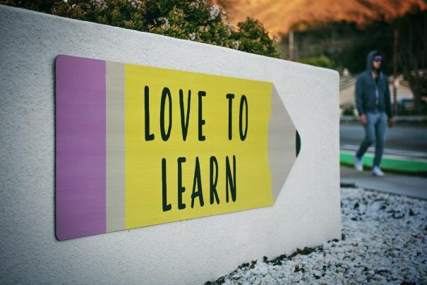

This skill comprises being aware of how you learn and your learning requirements, spotting opportunities when they present themselves, and overcoming challenges to learn effectively. To be competent, one must acquire, process, and assimilate new knowledge and abilities in addition to seeking out and utilising guidance.

In order to use and apply knowledge and skills in a range of contexts, including at home, at school, in youth organisations, at work, and in education and training, you must be able to draw on earlier learning and life experiences. This is what is meant by "learning to learn." It is a transversal skill, often known as a soft skill, which means that it may be used or applied to any subject or setting.

# What is the link between Personal, Social and L2L Competence with Art?

Art is an incredible tool to demonstrate cognitive strategies that help learners explore new content and demonstrate whether they actually understand what they are trying to learn. Thinking skills are essential for all learners and both art creation and encountering art provide opportunities for complex thinking.

Art can be used as an aid to support L2L competence. Indeed, drawing pictures or diagrams can help learners understand a subject. This is a strategy that is linked to visual art. Vocabulary, processes and stories can all be represented through visual art. If a learner is more kinesthetic, movement can also be used to illustrate ideas. Writing poetry, songs, and chants using metaphors and similes can help "draw" understanding with words.

Moreover, before producing a finished piece of visual art, many artists first make a model or sketch to allow for content practice. If music, dance or drama is being used to represent understanding, then the creation and rehearsal of the art is practice for the content being represented. It means that art will help you learn how to practice over and over until you nail a subject. 

Finally, art can help you think about your thinking strategy to check if you understand the principal idea of the subject. In the same meaning, when you don’t understand something in the subject you need to go back over it again. Indeed, if you come up against something you do not know or of which you are unsure, you have to go back to the subject to clarify understanding before you can create the art piece.

It's simple to see how learners can use the arts to help them become more self-assured independent learners by looking at each of these efficient learning techniques.

# Case study

An artist residency program called Learning Through Art (LTA) fosters student creativity by creating long-lasting, process-focused art pieces that promote learning throughout the curriculum. In order to produce and facilitate art projects that are included into the school curriculum, the initiative sends professional teaching artists into the public schools of New York City.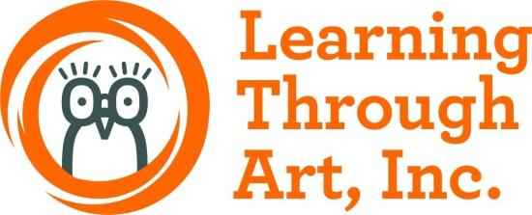

During their 20-week stay at school, students from all five school districts explore, discuss, and create works of art. A visit to the Guggenheim Museum supports residencies, provides new insights into art, and encourages students to think critically about art and ideas. At the end of the residency, the selected student's work will be presented at the Guggenheim Museum's annual exhibition "A Year with Children".

If you want to know more about this initiative, check the [website](https://www.guggenheim.org/for-educators/learning-through-art).

This program is giving tools to students to develop their problem solving and critical thinking skills. Indeed, compared to students who didn’t participate in this program, LTA students were more likely to be flexible and had a greater ability to recognise which resources they needed to complete their task. Art can permit students to discover things on their own and to learn by themselves what is the best solution. Check this [video](https://www.youtube.com/watch?v=PWibf3j7zuw) for more information.

**Q. What issues do the “Learning through Art” initiative aim to address?**

____________________________________________________________________________________________________________________________________________________________________________________________________________________________________________________________________________________________________________

**Q. Would you like to take part in this kind of project to develop personal, social and L2L competence?**

____________________________________________________________________________________________________________________________________________________________________________________________________________________________________________________________________________________________________________

**Q. Can you think of any artistic disciplines that you enjoy that incorporate L2L skills?**

____________________________________________________________________________________________________________________________________________________________________________________________________________________________________________________________________________________________________________

# Learning Activity

|  |  |  |  |
| --- | --- | --- | --- |
| **Transversal Theme** | Artistic Disciplines | | |
| **Activity Title** | Drawing & Reflecting | | |
| **Type of resource** | **Learning Activity** | | |
| **Photo** | **persona che immerge il pennello sulla vernice** | | |
| **Duration of Activity**  **(in minutes)** | 90 minutes | **Learning Outcome** | * Self esteem * Time management * Discover artistic disciplines * Diagnose your own learning needs * Knowing yourself as a learner |
| **Aim of activity** | This activity aims to build your personal, social and L2L skills through the topic of art more especially through drawing and painting. The goal is to learn how to learn through art. | | |
| **Materials Required for Activity** | * Paper * Pens or Paint * Colored pencils * Eraser | | |
| **Step-by-step instructions** | **Step 1**: Take a blank sheet of paper  **Step 2**: Think of something you want to draw. It can be a face, an animal, a landscape, or something abstract. However, your drawing must be something quite substantial that must be done in a minimum of 1 hour and a maximum of 1 hour 30 minutes.  **Step 3**: Take your pencils, your paint and your adequate materials.  **Step 4**: Draw or paint what you have chosen.  **Step 5**: You have 1hr minimum and 1h30 maximum to make your artistic work.  **Step 6**: When you're done, look at how long it took you to finish your drawing or painting.  **Step 7**: Now answer these questions. Take some time to think about what you want to answer.   * What strategies did you use to draw or paint? * What did not work so well? * What would you change next time? * To what extent have you taken advantage of all the learning supports available? * Were you struggling with your motivation? * Did you have some confusion about the exercise? * Did you complete the activity in time ? If not, how can you improve?   **Step 8:** After answering these questions, try to find the positives and negatives of your working method. Write them down.  **Step 9**: You can now try to do this activity again by drawing something else and building on your positive points and trying to improve your negative points | | |

# Additional Reading or Study Materials

Congratulations, you have reached this point and completed your self-reflection activities related to artistic disciplines. What comes next? If you would like to learn more about the topics you have covered so far in this lesson, we have prepared the following additional reading materials for you. This section presents some links to extra materials and videos that we have found online that we think will help you to take the next step in developing your knowledge.

|  |  |
| --- | --- |
| **Resource Title:** | Metacognition: The Skill that Promotes Advanced Learning |
| **Topic Addresses:** | What is L2L Competence /Metacognition? |
| **Introduction to the resource:** | This additional material is a video about metacognition. Learning is an active process, and honing a skill called metacognition can help you create the best possible opportunity to become a successful learner. This video explains what metacognition is. |
| **What will you get from using this resource?** | * How to become a successful learner * What is metacognition * How to learn efficiently * What is cognitive strategy * The metacognition process * Some study options |
| **Link to resource:** | <https://www.youtube.com/watch?v=elZFL4FLVLE&t=65s> |

|  |  |
| --- | --- |
| **Resource Title:** | What is Learning to Learn Competence? |
| **Topic Addresses:** | L2L Competence and how to develop it. |
| **Introduction to the resource:** | This additional material is a website that introduces the L2L competence and describes how to develop it. The L2L approach provides learners tools and methods for reflective and strategic thinking that will help them develop and improve their way of learning. This website is part of a European project. It shows tools and methods of learning of non-formal and informal education. |
| **What will you get from using this resource?** | * What is the L2L competence * Your strengths and weakness * Metacognition * Different learning methods and strategies * The different questions that you can yourself in order to develop metacognitive skills |
| **Link to resource:** | <https://mylearningtolearn.com/home/> |

