<Competence area and transversal theme>

Learner Handout

Contents

What types of art can be used to improve language competences? 3

Case study: ESL Through Art - English Language Learning Programs Through Art 4

Learning Activity 6

Additional Reading or Study Materials **7**

# What types of art can be used to improve language competences?

When it comes to language learning, an old saying might apply: **a picture is worth a thousand words**. Art, as an expression of ideas and emotions through a physical medium, can be used to improve language competences. This physical medium can be visual arts, music, drama, poetry, film, creative writing, and digital media. Integrating art into language learning can result in a more creative and engaging process that can enhance language acquisition, cultural understanding, and personal expression. Here are a few examples of different types of art that can be used to improve language competences.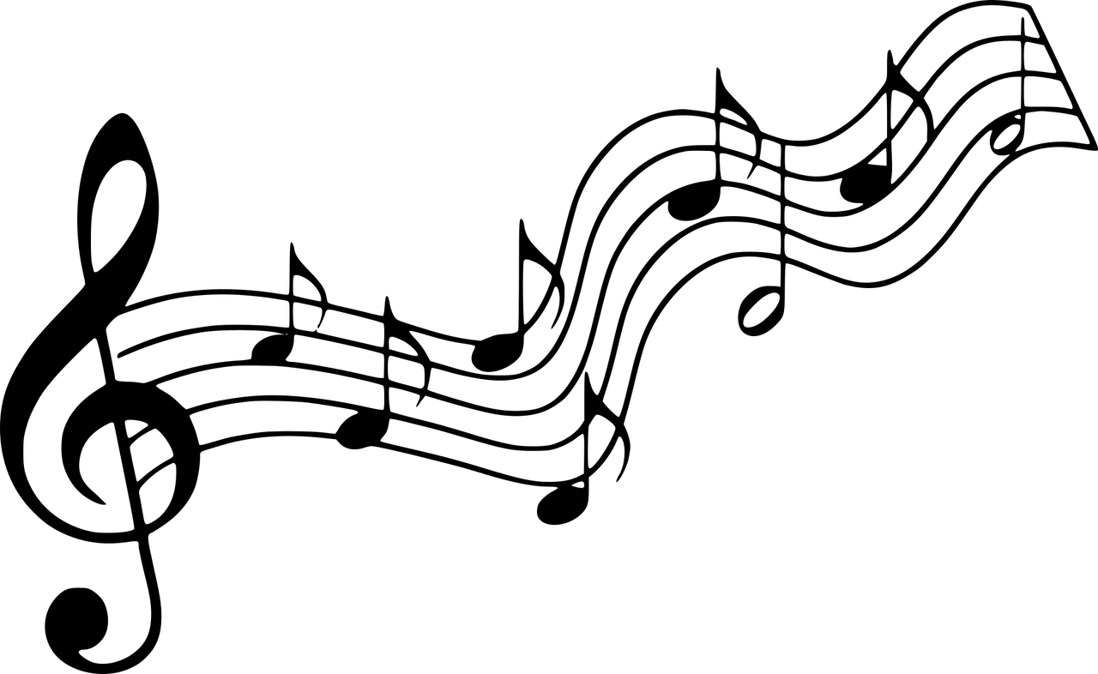

One way to embed art into language learning is through **music and dance**. Listening to songs in a foreign language helps improve listening, comprehension and pronunciation. Singing along to songs can enhance vocabulary, grammar, and intonation. You can also discuss and analyse song lyrics as well as understand cultural concepts embedded in the lyrics.

When combining language learning and **visual art forms** such as paintings, drawings and photography, you can describe and discuss visuals, identify and name objects, colours, and shapes, and express emotions or narratives through artistic interpretation. Visual art can also be used to create visual aids for vocabulary learning or storytelling activities.

**Drama and theatre** can significantly contribute to language learning - you can enhance your speaking and listening skills and at the same time build confidence and creativity. By performing dialogues, monologues, role plays, or short plays, you can practice pronunciation, intonation, and expressing emotions.

Engaging in **poetry and literature** can also facilitate language learning and vocabulary building through analysing poems, stories and novels. You can also discuss themes, characters, and literary techniques.

**Films and visual media** have always been a great tool in language learning - you can practice your listening skills and vocabulary acquisition by watching authentic audiovisual content and you can also help yourself with using subtitles. You can also discuss plot and characters, enhance your cultural understanding and practice critical thinking.

Engaging in **creative writing** and journaling gives you lots of opportunities for practicing your writing skills, expanding vocabulary, and expressing your thoughts and experiences. Choose a topic of your interest to write short stories, essays, and personal reflections.

You can also incorporate **digital dimension** in language learning through art. Creating multimedia presentations, designing infographics, recording podcasts or videos can facilitate language learning as well as encourage research, organization, and effective communication of information.

# Case study: ESL Through Art - English Language Learning Programs Through Art

Sequoia Center, a Croatian language school, has developed a special English language learning program through art - "ESL Through Art" - with the aim of addressing participants' needs and bridging their language barriers using the universal language of visual arts.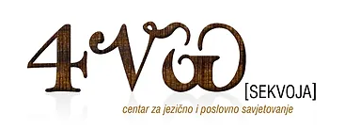

Their curriculum uses artworks as a catalyst to enhance English language communication skills, learn new vocabulary, and equally importantly, expose participants to the richness of world cultures, a variety of arts, and diverse experiences.

The main goal of this program is not to delve into deep analyses of artworks and theories but to use visual art as a tool for learning a foreign language, primarily English. The underlying meaning or message of an artwork is not as crucial as finding interesting ways to utilize artworks for language and vocabulary instruction, especially in programs designed for beginners.

Participants in the program will become acquainted with various artistic periods, techniques, and specific artworks, but they do not always need to fully comprehend them. The process of observing artworks will provide them with reference points for acquiring foreign language knowledge - grammar, vocabulary, and ultimately the ability to communicate freely in a foreign language, primarily English.

Based on their existing knowledge, the participants will improve language proficiency and communication skills in the foreign language, equally develop written and spoken elements of the English language, experience a relevant and meaningful learning process, build confidence in themselves, their language abilities, and general cultural knowledge, stimulate their creativity and foster critical thinking about the world around them, cultivate appreciation for history, art, and the beauty in our surroundings, learn to recognize similarities and differences, focus on interpreting and communicating various ideas and opinions, enjoy themselves in a relaxed environment and meet new people who share an interest in self-development and continuous learning, and visit museums in Zagreb and learn English while exploring artistic exhibits.

**Questions**

1. How does Sequoia Center try to improve the multilingual skills of students in their courses?

______________________________________________________________________________________________________________________________________________________________________________________________________________________________________________________________________________________________________________________________________________________________________________________________________________________________

1. Do you think Sequoia Center’s method works better than teaching a language in a traditional classroom?

______________________________________________________________________________________________________________________________________________________________________________________________________________________________________________________________________________________________________________________________________________________________________________________________________________________________

1. How do you think you could improve your multilingual skills using arts?

______________________________________________________________________________________________________________________________________________________________________________________________________________________________________________________________________________________________________________________________________________________________________________________________________________________________

# Learning Activity

|  |  |  |  |
| --- | --- | --- | --- |
| **Transversal Theme** | Multilingual Competence Through Art | | |
| **Activity Title** | Multilingual Art Collage | | |
| **Type of resource** | **Learning Activity** | | |
| **Photo** |  | | |
| **Duration of Activity**  **(in minutes)** | 60 minutes | **Learning Outcome** | * To explore multilingualism * To express your own artistic creativity * To reflect on language |
| **Aim of activity** | To explore and celebrate the diversity of languages and cultures through art by creating a multilingual collage. | | |
| **Materials Required for Activity** | * Magazines and newspapers in different languages * Scissors * Glue or tape * Large poster or canvas * Markers or pens | | |
| **Step-by-step instructions** | * **Step 1:** Gather old magazines and newspapers in various languages and browse through the collected materials. * **Step 2:** Select pages or sections of text that are visually appealing, interesting, or meaningful to you. Then identify and select words, phrases or sentences that catch your attention. Look for different languages, fonts, and visual elements. Don’t worry if you don’t understand all the words, focus on exploring the texts and appreciating the aesthetics and variety of languages. * **Step 3:** Take a large poster or canvas for arranging a collage. Use scissors to carefully cut out the selected words and phrases, choosing a diverse range of languages. Arrange and glue/tape the cut-out words and phrases onto your canvas, creating an artistic composition. Play with the arrangement, unleash your creativity and consider various colour combinations, layering, and overlapping of different languages. * **Step 4:** After you finish, reflect on your artistic composition and write a short reflection, thoughts or stories related to the languages and cultures depicted. Choose your preferred language and share your thoughts, emotions, or personal connections to the languages featured. | | |

# 

# Additional Reading or Study Materials

Congratulations, you have reached this point and completed your self-reflection activities related to Multilingual Competence through Art. What comes next? If you would like to learn more about the topics you have covered so far in this lesson, we have prepared the following additional reading materials for you. This section presents some links to extra materials and videos that we have found online that we think will help you to take the next step in developing your knowledge.

|  |  |
| --- | --- |
| **Resource Title:** | How to use movies and TV to practice your language |
| **Topic Addresses:** | Ways to use movies and TV to practice your language |
| **Introduction to the resource:** | The article explores how watching TV shows and movies in foreign languages can be an effective language practice tool. It highlights the benefits of using authentic language, context, and visual cues to improve listening and comprehension skills. It also recommends incorporating subtitles in the target language for a more immersive and effective language learning experience. |
| **What will you get from using this resource?** | You will gain valuable insights into the connection between films and language learning by reading this article which was written by Duolingo, a leading educational technology company which produces learning apps and provides language certification. |
| **Link to resource:** | <https://blog.duolingo.com/language-practice-with-tv-movies/> |

|  |  |
| --- | --- |
| **Resource Title:** | Learn a Language through Music: Science and the Best Songs for Beginners |
| **Topic Addresses:** | Learning language through music |
| **Introduction to the resource:** | Singing can benefit students when learning a language because there are common features to both music and language that allow music to improve and shape language processing. |
| **What will you get from using this resource?** | It highlights the benefits of using music as a powerful tool for language learning. It emphasises that music helps learners improve pronunciation, vocabulary, and language retention by combining melody and rhythm with linguistic elements. The article also suggests that learning through music fosters cultural understanding, enhances motivation, and makes the language learning experience enjoyable and engaging. |
| **Link to resource:** | <https://lingopie.com/blog/learning-language-through-music/> |

