Literacy Competence and Digital & Social disciplines

Learner Handout

Contents

What is Literacy Competence? 3

What is the link between Literacy Competence and Digital and Social disciplines? 3

Case study 4

Learning Activity 5

Additional Reading or Study Materials 7

# 

# What is Literacy Competence?

Literacy is the ability to identify, understand, express, create and interpret concepts, feelings, facts and opinions in both oral and written form, using visual, sound/audio and digital materials across disciplines and contexts. It implies the ability to communicate and connect effectively with others in an appropriate and creative way.

In summary, literacy competence includes listening, speaking, reading and writing. They also include such things as awareness of the sounds of language, awareness of print, and the relationship between letters and sounds. Other literacy skills include vocabulary, spelling, and comprehension. They help us to gain knowledge through reading texts as well as viewing media and using technology.

# What is the Link between Literacy Competence and Digital and Social Disciplines?

We are in the heart of a technology revolution, in which significant changes occur quickly. Facebook didn't exist a number of years ago, but today many individuals cannot imagine their lives without it. Nowadays, ordinary cell phones are more powerful than PCs from a few years ago. Technology is everywhere around us, and most of it serves many purposes.

Because of this evolution, a new form of literacy appears: **digital literacy**. It involves the ability to use technology effectively and for a purpose. Among the skills of digital literacy there are: 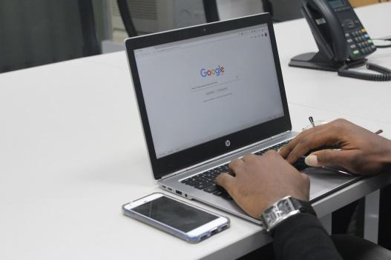

* Reading website
* Using search engines and researching on the Internet
* Accessing videos and podcasts
* Using emails, chat services, texts
* Blogging
* Using social media

Many people already use these digital tools. But, now you can develop your existing literacy skills and learn new ones. Indeed, for example by searching on the internet, you will learn how to evaluate the information, by talking with your friends on social media, you will learn how to use correct grammar and spelling and by reading newspapers or online books, you will learn new vocabulary and written comprehension.

In conclusion, the internet and the digital world can help you improve and develop your literacy competence.

# Case study

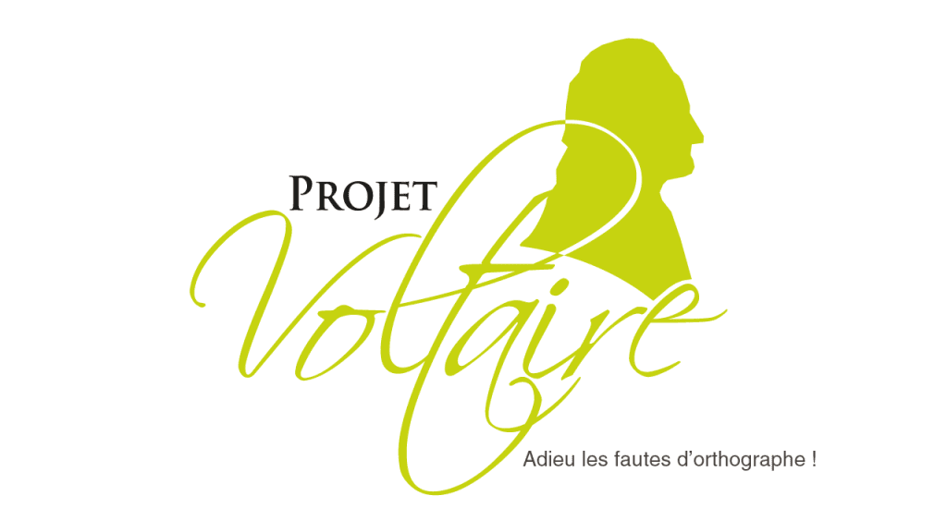

The “Projet Voltaire” is an initiative from France. It has created a tool making expression and spelling accessible to everyone. Whatever your age, your initial level, your objectives and your pace of acquisition, the Voltaire Project offers you a completely individualised course.

Two watchwords: fun and effective! The goal is to avoid the return to textbooks and tedious grammar lessons. This website makes learning, consolidating and developing literary skills fun.

Its know-how and innovative approach make the Voltaire Project the number one in expression and spelling refresher courses with more than 7 million users, 5,000 educational establishments and 2,200 partner companies.

The online service generates a refresher program totally targeted at your shortcomings. The course updates automatically to keep pace with your acquisition rate, and ensure that you memorise key points quickly and durably. You can continue your journey from a tablet or smartphone. You can pass the Voltaire certificate to certify your level on your CV.

**Q. What issues do the Projet Voltaire aim to address?**

____________________________________________________________________________________________________________________________________________________________________________________________________________________________________________________________________________________________________________

**Q. Would you like to take part in this kind of game to develop your grammar, syntax and conjugation skills?**

____________________________________________________________________________________________________________________________________________________________________________________________________________________________________________________________________________________________________________

**Q. Can you think of any social media and digital tools that you enjoy that incorporate literacy skills?**

____________________________________________________________________________________________________________________________________________________________________________________________________________________________________________________________________________________________________________

# Learning Activity

|  |  |  |  |
| --- | --- | --- | --- |
| **Transversal Theme** | Digital and Social | | |
| **Activity Title** | “Writing your journey” | | |
| **Type of resource** | **Learning Activity** | | |
| **Photo** |  | | |
| **Duration of Activity**  **(in minutes)** | 90-120 minutes | **Learning Outcome** | * Developing literary skills * Learn to write a long text on the computer or on a mobile phone * Connect to the internet and use digital tools * Describe your day and your activities * Recognise your mistakes and understand them |
| **Aim of activity** | This activity aims to build your literacy skills especially your writing skills through the topic of digital and social media. | | |
| **Materials Required for Activity** | * Internet connection * Laptop or Mobile phone * Wattpad account | | |
| **Step-by-step instructions** | **Step 1**: Take your computer or cell phone.  **Step 2**: Type in the search bar, the site "Whattpad" or click [here](https://www.wattpad.com/login).  **Step 3:** Log in or create an account. It's free.  **Step 4**: If you create an account, say that you like both reading and writing.  **Step 5**: Click on the "I write for fun" button and the button “No I have never written a story".  **Step 6**: At the top bar click on "Write" and “Create a new story”.  **Step 7**: For the title write “My own journey”.  **Step 8:** Type your text describing your day and what you have done. You can tell what you eat, what you do, what emotions you are feeling.You should write approximately 500 words.  **Step 9:** When you have finished writing your story, copy and paste your text in to a spell checker website. Look at the mistakes you made and try to understand them.  **Step 10:** Save your story to your drafts. Don't publish your story unless you want it to be public.  **Step 11**: Repeat this experience every day. You can write your day or start a real story. Each time, correct your mistakes and learn from them. If you don’t want to write you can discover some stories written by other people. | | |

# Additional Reading or Study Materials

Congratulations, you have reached this point and completed your self-reflection activities related to literacy competence and digital and social. What comes next? If you would like to learn more about the topics you have covered so far in this lesson, we have prepared the following additional reading materials for you. This section presents some links to extra materials and videos that we have found online that we think will help you to take the next step in developing your knowledge.

|  |  |
| --- | --- |
| **Resource Title:** | EU Read and Art |
| **Topic Addresses:** | The first European digital library of book trailers and adult creativity expressions. |
| **Introduction to the resource:** | This additional material is a European project that is trying to help adult learners to empower literacy, cultural, language and digital skills. The website is composed of book trailers and articles.  The book trailers make you discover books of different genres and different countries.  The articles are talking about social topics or about books and their authors. |
| **What will you get from using this resource?** | By using this resource you will learn:   * Discover new authors and books in a fun way * Develop your reading skills and comprehension skills * Learn how to do a book trailer * Read many articles about books or other social topics |
| **Link to resource:** | <https://europeanbooktrailers.eu/> |

|  |  |
| --- | --- |
| **Resource Title:** | How to Improve Your English Speaking Skills |
| **Topic Addresses:** | Development of oral skills |
| **Introduction to the resource:** | This additional material is a video that talks about how to improve your oral skills through implicit learning. The video explains how imitation can help you develop oral skills such as pronunciation, tones, grammar and fluency. |
| **What will you get from using this resource?** | This link provides additional information on how digital disciplines and social media can help you develop literacy competence.  By watching this video you will learn:   * Develop oral competence through imitation. * Improve your oral pronunciation * Improve your ability to express emotions, feelings, an idea or a though * Improve your grammar and conjugation. * Learn speaking patterns |
| **Link to resource:** | <https://www.youtube.com/watch?v=CAU2zx2Ri_M> |

