<Competence area and transversal theme>

Learner Handout

Contents

**What is adult literacy? 3**

**How to improve your literacy competence through the lens of culture? 4**

**Case study 5**

**Learning Activity 7**

**Additional Reading or Study Materials 8**

# What is adult literacy?

The simplest answer to this question is an individual’s ability to read and write. And indeed, in the past, individuals were considered literate just if they could write their name. But at what level do you have to be able to read and write to be considered literate? Do you need to know the basics of math - adding, subtracting, multiplying, and dividing to balance your cheque book? Is general knowledge necessary to be considered literate? Are you literate if you don’t speak English or don’t have basic knowledge of other cultures? And what about digital literacy?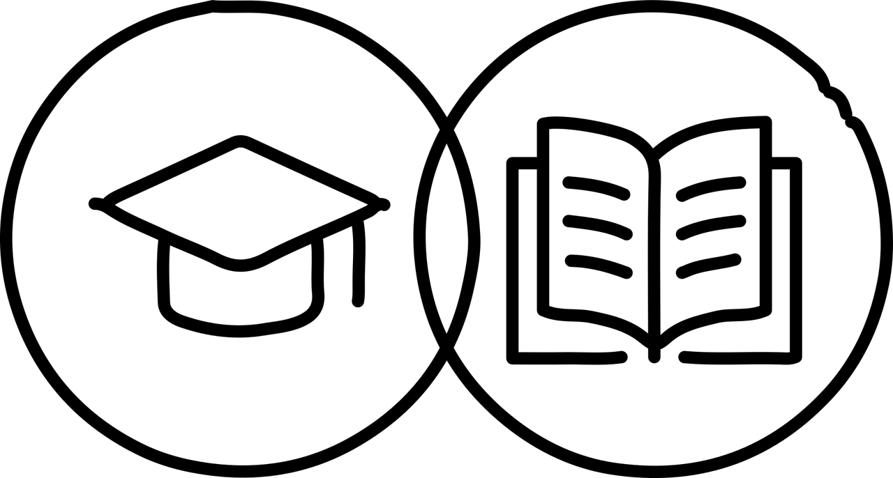

In the 21st century, adult literacy refers to the ability of adults to read, write, and comprehend information at a level that allows them to effectively participate in society, achieve personal goals, and engage in lifelong learning. It involves a range of literacy skills, including reading, writing, numeracy, digital literacy, and problem-solving abilities.

The ability to read and write is considered a fundamental skill for individuals to access information, obtain employment, participate in civic activities, and improve their quality of life.

The areas that are generally referred to when adult literacy is discussed are:

* Reading: "Functional literacy" is often defined as the ability to read at a particular grade level.
* Writing: Written literacy might best be considered to be an individual's capacity to write in clear and accurate language.
* Math: "Numeracy" or "Mathematical literacy" usually refers to the ability to perform the basic mathematical operations - addition, subtraction, multiplication, division.
* Second language: Have speaking, listening, reading, and writing skills in English in addition to your native language.
* Cultural literacy: Being able to understand the traditions, regular activities and history of a group of people from a given culture.
* Digital literacy: technology brought about a new kind of learning that is not dependent on just books and writing, so it’s important to stay up to date with the technological advancements.

# How to improve your literacy competence through the lens of culture?

There is a significant connection between adult literacy and culture - culture plays a crucial role in shaping the way we learn and engage with literacy, while literacy, in turn, can influence and preserve cultural traditions and practices. You can transform your journey towards literacy through the lens of culture - stories, traditions, and experiences of your own culture.

There are lots of benefits of improving your literacy skills through the lens of culture. You can start by embracing your own culture and becoming familiar with its stories and traditions which will give you an engaging and enjoyable reading experience.

As you read and write about your own culture, it will help you discover your voice and you'll gain confidence in expressing your thoughts and ideas. Your unique identity will shine through your words, empowering you to share your story with pride. Your culture is a source of knowledge passed through generations and improving your literacy skills empowers you to preserve your cultural heritage, ensuring that your traditions and stories continue to be cherished by future generations. By improving your literacy skills through sharing stories, reading together within a family and celebrating your culture, it will bring you closer together with your community and set an example for your future generations. 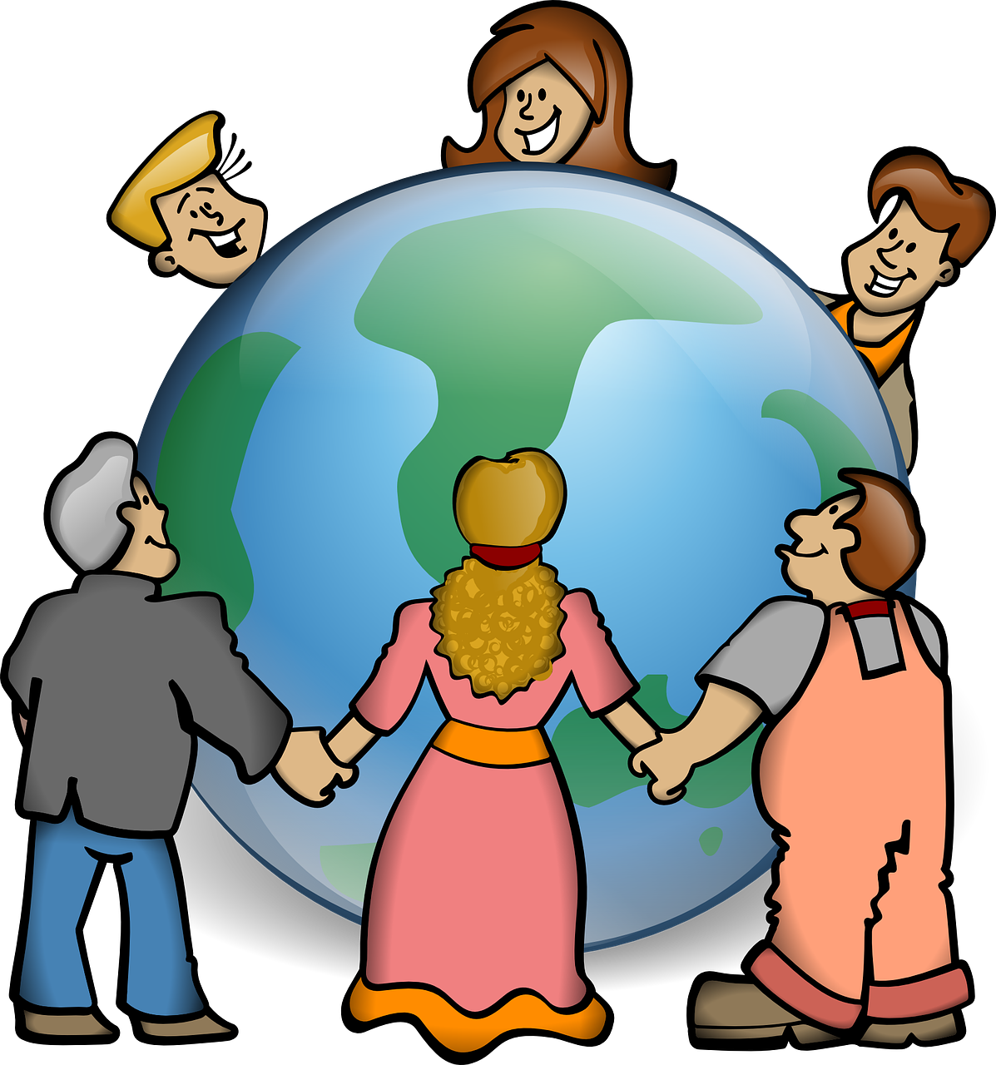

By exploring diverse cultures through reading, it will enhance your cultural literacy which will open doors to understanding others, foster empathy and broaden your worldview.

Adding the digital component to it, such as learning to read and write online, will offer you a world of possibilities - access to endless information, connection with others, and discovering new interests.

Improved literacy will open you doors to better opportunities in your professional and personal life, e.g. when seeking employment, or communicating with others.

Keep learning, keep growing, and let your cultural roots be the guiding star on your path to literacy!

# Case study

Rupi Kaur is a Canadian poet and artist of Indian descent that expresses her culture through her poetry, art, and personal experiences which means that her work can be utilised to improve literacy skills through culture. 

Her work often reflects her cultural heritage, identity, and the experiences of the South Asian diaspora and often explores themes of identity, belonging, and the complexities of being a first-generation immigrant. It also often incorporates elements of South Asian traditions, such as references to cultural festivals, familial relationships, and customs. She uses these references to highlight the importance of cultural heritage in shaping individual experiences.

Kaur's poetry often emphasises the experiences of women, shedding light on issues such as gender roles, femininity, and empowerment. Her work challenges stereotypes and societal expectations placed upon women, drawing from her own cultural background.

Her poetry and art offer an excellent opportunity to engage learners in meaningful and culturally relevant literacy activities to improve their literacy. For example, her poetry books "Milk and Honey" and "The Sun and Her Flowers," can be used as culturally relevant reading material, especially for learners from South Asian backgrounds or those interested in exploring diverse cultures can connect with her work, making the reading experience more meaningful.

Learners can analyse various themes such as identity, relationships, empowerment, and social issues and critically think about cultural representation and social contexts. Furthermore, by analysing her poetry, learners can develop a broader understanding of cultural diversity and its role in shaping artistic expression.

But her poetry goes beyond her South Asian background and offers universal themes making them relatable to readers from various cultural backgrounds. By reading her poetry, learners can reflect on how different cultural experiences shape individuals’ lives and build empathy. Incorporating Kaur’s work into your literacy activities, you can enhance your learning experience, promote a sense of cultural pride and understanding and have a more enjoyable literacy learning.

The overall reading experience is also enhanced through visual arts that compliment her poetry. Her Instagram profile offers a great selection of poems available for free.

Rupi Kaur’s latest book “Healing Through Words” welcomes you into her world of writing and creativity through the collection of her curated guided writing exercises encourages you to explore themes of trauma, loss, heartache, love, healing, and celebration of the self. You can use it for engaging into creative writing and self-expression, reflecting your own cultural backgrounds and experiences.

**Questions**

1. How can Rupi Kaur’s poems help in improving the literacy of adult learners?

_________________________________________________________________________________________________________________________________________________________________________________________________________________________________________________________________________________________________________________________________________________________

1. What type of topics does she offer to her audience?

_________________________________________________________________________________________________________________________________________________________________________________________________________________________________________________________________________________________________________________________________________________________

1. How do you think you could improve your literacy through culture?

____________________________________________________________________________________________________________________________________________________________________________________________________________________________________________________________________________________

_____________________________________________________________________

# Learning Activity

|  |  |  |  |
| --- | --- | --- | --- |
| **Transversal Theme** | Literacy Competence Through Culture | | |
| **Activity Title** | Cultural Stories and Traditions | | |
| **Type of resource** | **Learning Activity** | | |
| **Photo** |  | | |
| **Duration of Activity**  **(in minutes)** | A minimum of 60 minutes (depending on your reading material) | **Learning Outcome** | * Exploring diverse cultures * Improving literacy competence * Fostering a lifelong love for learning and appreciation of global diversity |
| **Aim of activity** | The aim of this activity is to explore and appreciate diverse cultures through reading, writing, and reflection, thereby enhancing literacy competence and cultural awareness. | | |
| **Materials Required for Activity** | * Any reading material to your liking (a book, a short story, a poem) * Notebook * Pen or pencil | | |
| **Step-by-step instructions** | * **Step 1:** Choose a book, a short story, a poem or any reading material that reflects a culture different from your own. It can be any genre, any author, physical book, digital resource or audiobook. Explore it at your own pace. * **Step 2**: Read the selected material. Make notes and highlight passages that resonate with you or provide insights into the culture that is portrayed. * **Step 3:** After you’ve finished with reading, think about what you have learned about the culture portrayed in the book. Which parts would you highlight and how do they relate to your own experiences? * **Step 4**: Prepare to write a short piece about your own culture, focusing on its unique traditions, customs, or historical significance. Focus on drawing parallels between your culture and the one portrayed in the reading material. | | |

# Additional Reading or Study Materials

Congratulations, you have reached this point and completed your self-reflection activities related to Literacy competence through culture. What comes next? If you would like to learn more about the topics you have covered so far in this lesson, we have prepared the following additional reading materials for you. This section presents some links to extra materials and videos that we have found online that we think will help you to take the next step in developing your knowledge.

|  |  |
| --- | --- |
| **Resource Title:** | “The Lottery,” by Shirley Jackson |
| **Topic Addresses:** | A short story that portrays a specific culture |
| **Introduction to the resource:** | "The Lottery" is a classic short story that delves into the darker aspects of a small-town American culture. |
| **What will you get from using this resource?** | A better insight into a specific culture while practicing your literacy skills. You can also make a comparison of your own culture and the American culture. |
| **Link to resource:** | <https://www.newyorker.com/magazine/1948/06/26/the-lottery> |

|  |  |
| --- | --- |
| **Resource Title:** | Literacy is the Answer |
| **Topic Addresses:** | The importance of literacy |
| **Introduction to the resource:** | John shares the staggering magnitude of our global illiteracy problem and the potential an international focus on increasing literacy has for creating greater social and economic equality for the world’s next generation. |
| **What will you get from using this resource?** | You’ll learn about the definitions of literacy, how many people in the world are still illiterate and about the transformative power of literacy. |
| **Link to resource:** | <https://www.youtube.com/watch?v=z-h-BhcV7DM> |

