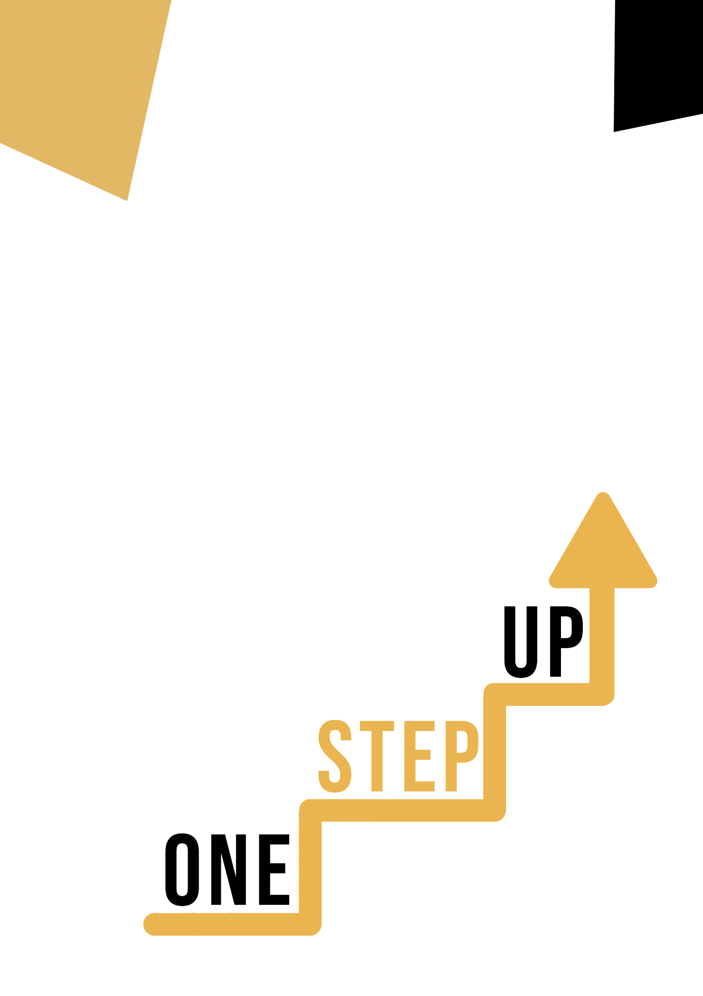
ARTISTIC DISCIPLINE AND DIGITAL COMPETENCE
Learner Handout

Discovering Digital Artistry and Creativity

Welcome to the fascinating world of personal social and learning-to-learn abilities, cultural competency, and both. We will examine the importance of cultural diversity and its effects on individual development and social dynamics in this learner handout. Prepare to examine actual situations and participate in activities that will improve your comprehension of these crucial competencies.

Case study

Celebrating Cultural Diversity
Imagine you are part of a dynamic team that has been chosen to organise a community event aimed at celebrating cultural diversity. The event, named "Unity in Diversity Festival," is intended to promote intercultural dialogue, understanding, and appreciation within your community. As a member of this team, you have the unique opportunity to contribute your skills and insights to create an event that reflects the rich tapestry of cultures that make up your community.

Key Questions
- How might the diverse backgrounds of your team members contribute to the overall success of the cultural diversity event?
- What challenges might arise when collaborating with people from different cultural backgrounds, and how can you address them?
- How might the event impact the community's perception of cultural diversity and intercultural communication?

Learning Activity

Transversal Theme | Cultural
Activity Title | Creating a Cultural Showcase
Type of resource | Learning Activity
Photo
Duration of Activity  (in minutes) | 45-60 minutes | Learning Outcome | By the end of this activity, you will be able to collaborate effectively with individuals from diverse cultural backgrounds and contribute to a cultural event that promotes intercultural dialogue.
Aim of activity | This activity aims to encourage collaboration, empathy, and creative thinking while fostering an understanding of the value of cultural diversity.
Materials Required for Activity | - Large sheets of paper or a whiteboard  - Markers, coloured pencils, or pens  - Sticky notes
Step-by-step instructions | Formation of Teams: Divide the participants into small teams, ensuring each team is culturally diverse.  Cultural Research: Assign each team a different culture or country. The teams should conduct quick research to understand the cultural practices, traditions, and symbols of the assigned culture.  Cultural Showcase Design: Each team will design a cultural showcase booth for the event. They should incorporate elements such as traditional foods, clothing, music, and artifacts that represent the assigned culture.  Collaborative Brainstorming: Have the teams brainstorm and discuss ideas for the showcase. Encourage open dialogue and the sharing of cultural insights.  Showcase Creation: Provide the teams with the necessary art supplies to create a visual representation of their showcase booth on the large paper or whiteboard. They can use drawings, labels, and short descriptions.  Team Presentations: Ask each team to present their cultural showcase to the rest of the group. Emphasize the importance of respectful and attentive listening during the presentations.  Reflection and Discussion: Lead a discussion about the experience. Ask participants to share how they felt working with team members from different backgrounds, what they learned, and how they could apply these skills in other contexts.  Remember, this activity is an opportunity for you to step into the shoes of intercultural collaboration and appreciate the beauty of diverse perspectives. Have fun, be respectful, and let your creativity shine!

Additional Reading or Study Materials
Congratulations, you have reached this point and completed your self-reflection activities related to Digital Artistry and Creativity. What comes next? If you would like to learn more about the topics you have covered so far in this lesson, we have prepared the following additional reading materials for you. This section presents some links to extra materials and videos that we have found online that we think will help you to take the next step in developing your knowledge.
Resource Title: | Cultural diversity in digital space
Topic Addresses: | The issue of cultural diversity.
Introduction to the resource: | You can find out what this issue is.
What will you get from using this resource? | - Knowledge of AI and cultural diversity, digital media and cultural diversity.
Link to resource: | Cultural diversity in digital space - 2023 | DW Observatory

Resource Title: | Digital Technology is transforming the art world
Topic Addresses: | Art and digital technology
Introduction to the resource: | Article describes how digital technology is impacting art.
What will you get from using this resource? | - Understanding new ways of creating and promoting art, understanding digital artistry and new forms of creation.
Link to resource: | DIGITAL TECHNOLOGY IS TRANSFORMING THE ART WORLD - Impakter
