Cultural Awareness and Expression Competence & Sports and Hobbies

Learner Handout

Contents

What is Cultural Awareness and Expression Competence? 3

What is the link between Cultural Awareness and Sports & Hobbies? 4

Case study 5

Learning Activity 7

Additional Reading or Study Materials 9

# What is Cultural Awareness and Expression Competence?

Cultural awareness means being sensitive to the differences and similarities between cultures when communicating or interacting with members of other cultural groups. Developing values, attitudes, and understanding that show acceptance and respect for various cultures, faiths, languages, garb, and communication techniques entails being culturally sensitive. 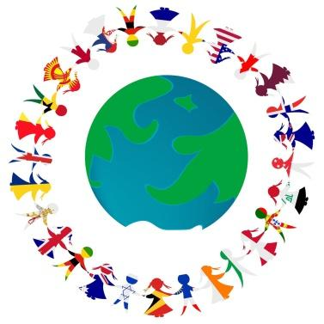

Moreover, “cultural awareness and expression” is defined by the EU as something that touches on many elements such as creative expression of ideas, experiences and emotions in a range of media, including music, performing arts, literature, visual arts and the interdisciplinary and hybrid forms that have emerged thanks to new media.

Cultural knowledge includes an awareness of local, national and European cultural heritage and its place in the world. It covers a basic knowledge of major cultural works, including popular contemporary culture. It is essential to understand the cultural and linguistic diversity in Europe and other regions of the world, the need to preserve it and the importance of aesthetic factors in daily life.

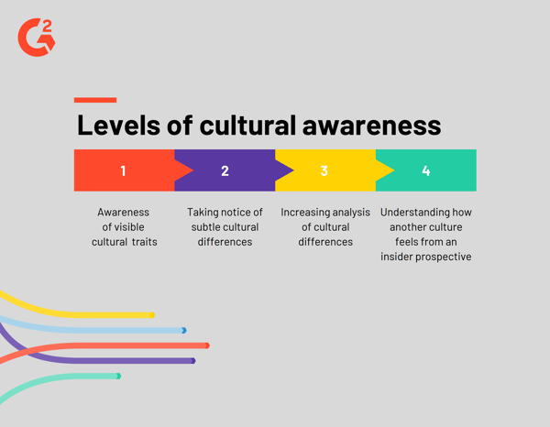

In summary, the definition of this competence is based on the assumption that a solid understanding of one’s own culture and a sense of identity can be the basis for an open-minded attitude towards others and respect for diversity of cultural expression.

# What is the Link Between Cultural Awareness and Sports and Hobbies?

“*Sport has the power to change the world. It has the power to inspire. It has the power to unite people in a way that little else does. Sport can awaken hope where there was previously only despair. Sport speaks to people in a language they can understand*.”- Nelson Mandela. 

The world of sports has been long accepted as an instrument of social integration, and now furthermore a means of intercultural understanding in an ever more diversified world. Just like food, music, theatre, sport too has a potential for interculturalism, as it has throughout the history of mankind, contributed towards the blending of cultures. 

Sports such as cricket, tennis, football, netball and basketball have a broad cross-cultural following and are becoming leading examples of how culturally diverse people can come together as equals with common interests.

Although sport is becoming more diverse and inclusive, further progress is still needed. We just have to take the example of the movement Black Lives Matter or the racial abuse that many football players such as Raheem Sterling suffer.

This is why it’s important to be culturally aware and competent and sport is a great tool to develop these competencies. It takes more than just observing, comprehending, and accepting differences to be culturally conscious. It necessitates a great deal of self-awareness. We all have prejudices and values based on our own experiences and are products of our own cultural identities. 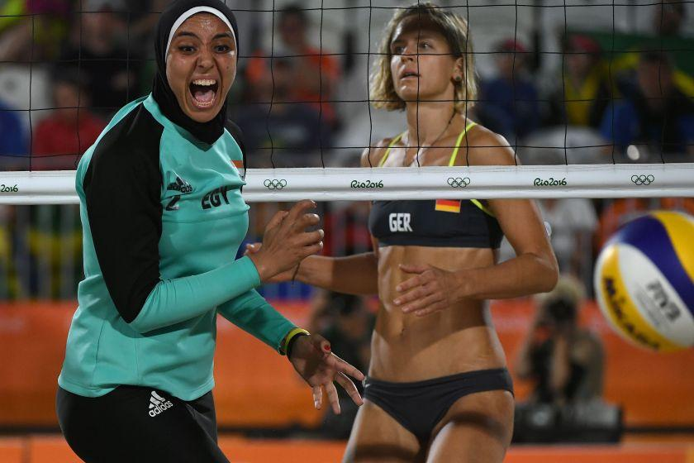

For instance, when scheduling practices or games, a coach from a Christian background might automatically equate religious services with Sundays and never consider the fact that the Jewish athletes in his squad have religious services on Saturdays. 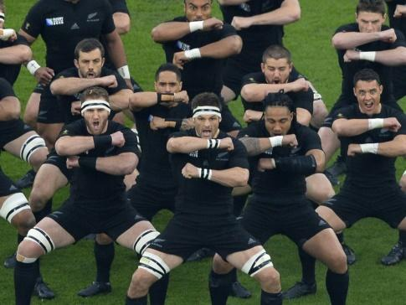

In conclusion, sports and hobbies are great tools to understand cultural awareness and to develop this competence. Even if there is still progress to make in the world of sport in terms of diversity and cultural sensitivity, being self aware of the cultural differences and how to address them is a step toward being completely culturally aware.

# Case study



The “Start on the Street 75” project is part of a European project called “Start on the Street”, led by UFOLEP IDF and supported by the European Commission. It organises outdoor sports activities in underprivileged neighborhoods to stimulate social cohesion and trust and transmit positive values.

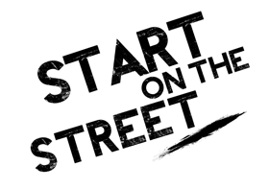

Over a sports season (September 2021 to June / November 2022), the project worked in immersion in the heart of the Curial district (Paris 19th), in order to set up sports, educational, collective and support actions for young people aged 15-25 years.

From September 2021:

* Young people aged 15 to 25 are able to benefit from a free "street workout and multisport" activity, every Wednesday, from 3 p.m. to 5 p.m.
* Identification and support of young people aged 17 to 25 will be carried out in order to offer them individual training courses, towards the professions of sports animation

The goal of this initiative is to promote the development of sports practice for the public furthest from practice. Backed by the values ​​of secularism, solidarity and civic engagement, they use sport as an educational tool and a lever for integration and the fight against discrimination.

Moreover this practice permits to educate people to improve their social skills and strengthen social inclusion and cultural integration. This initiative opened up the perspectives of vulnerable young people and made them aware of their cultural sensibility through sport.

If you want to know more about this initiative check the [website](https://cr.ufolep.org/iledefrance/iledefrance_a/cms/index_public.php?PHPSESSID=t8qv8fnd59nc8t03b0oddlj6e6&us_action=show_note&ui_id_site=1&ui_id_doc=1030200002).

**Q. What issues does the “Start on the Street” initiative aim to address?**

____________________________________________________________________________________________________________________________________________________________________________________________________________________________________________________________________________________________________________

**Q. Would you like to take part in this kind of project to develop cultural awareness and expression competence?**

____________________________________________________________________________________________________________________________________________________________________________________________________________________________________________________________________________________________________________

**Q. Can you think of any sports or hobbies that you enjoy that incorporate cultural awareness or expression?**

____________________________________________________________________________________________________________________________________________________________________________________________________________________________________________________________________________________________________________

# Learning Activity

|  |  |  |  |
| --- | --- | --- | --- |
| **Transversal Theme** | Sports and Hobbies | | |
| **Activity Title** | Dancing Around the World | | |
| **Type of resource** | **Learning Activity** | | |
| **Photo** |  | | |
| **Duration of Activity**  **(in minutes)** | 60-90 minutes | **Learning Outcome** | * Developing cultural awareness * Expressing yourself * Exercising yourself * Discovering other cultures through sound, music and song |
| **Aim of activity** | This activity aims to build your cultural awareness and expression skills through the topic of sports and hobbies more especially through dancing. The final goal is to discover many cultures and be aware of them through dance. | | |
| **Materials Required for Activity** | * Speaker * Music Apps (You Tube, Spotify, Deezer…) * Some space to move | | |
| **Step-by-step instructions** | **Step 1**: Be ready to embark on a dancing journey through many cultures!  **Step 2**: Open your music App.  **Step 3**: Discover Hip Hop. Put the music “In Da Club” by 50 Cent. Dance to this music and enjoy.  **Step 4**: Reflect and take your breath.  **Step 5**: Discover the Flamenco from Spain. Put the music “Estamos de Paso” by Danza Fuego. Dance to this music and enjoy.  **Step 6**: Reflect and take your breath.  **Step 7**: Discover the Bollywood from India. Put the music “Jai Ho” by AR RAHMAN. Dance to this music and enjoy.  **Step 8**: Reflect and take your breath.  **Step 9**: Discover African dance. Put the famous song “Jerusalema” by Master KG. Dance to this music and enjoy.  **Step 10**: Reflect and take your breath.  **Step 11**: Discover the Samba from Brazil. Put the music “Samba De Janeiro” by Bellini. Dance to this music and enjoy.  **Step 12:** Reflect and take your breath.  **Step 13**: You can keep going with another piece of music. For example you can put Blakan music, Tango music or Polynesian music. | | |

# Additional Reading or Study Materials

Congratulations, you have reached this point and completed your self-reflection activities related to Cultural awareness and Sports and Hobbies. What comes next? If you would like to learn more about the topics you have covered so far in this lesson, we have prepared the following additional reading materials for you. This section presents some links to extra materials and videos that we have found online that we think will help you to take the next step in developing your knowledge.

|  |  |
| --- | --- |
| **Resource Title:** | How to Diversify Sports and Create an Inclusive Environment. |
| **Topic Addresses:** | Strategies on how to diversity sport and create inclusive environments and being self aware of cultural differences. |
| **Introduction to the resource:** | This additional material is a well-explained article on how cultural awareness and sports are linked. The author is stating that sport is the perfect tool to unite every person on the planet. However it is said that there is still progress to be made today. This is why, some tips and strategies are given in this material to overcome these differences and try to learn from the mistakes that have been made before. |
| **What will you get from using this resource?** | * Being culturally aware of cultural differences * Learning what is diversity and inclusion * Some example of social issues still actual in sports * Strategies for diversifying sport * What is cultural awareness * How to be culturally competent in communication and having a welcoming climate in sport * What is enculturation |
| **Link to resource:** | <https://humankinetics.me/2018/12/11/diversify-sport/> |

|  |  |
| --- | --- |
| **Resource Title:** | Importance of Diversity in Sports - Sport Action |
| **Topic Addresses:** | Diversity of culture in sports: Why it’s important for sport to be more inclusive |
| **Introduction to the resource:** | Sport Action is the initiative that brings all the colours of sport closer, all the spirits of people. It promotes equality and positive change and emphasises sport as a tool for societal improvements and motivates education through fun and games.  It's part of the project "Sport to promote change for LGBT". |
| **What will you get from using this resource?** | * How it is important to promote diversity in sports * How diversity in sport can help us respect and value one another * How if there is no diversity in sports it can prejudice others. * How to be culturally aware in collective and individual sports |
| **Link to resource:** | https://www.youtube.com/watch?v=CGN-lyp4geQ |

