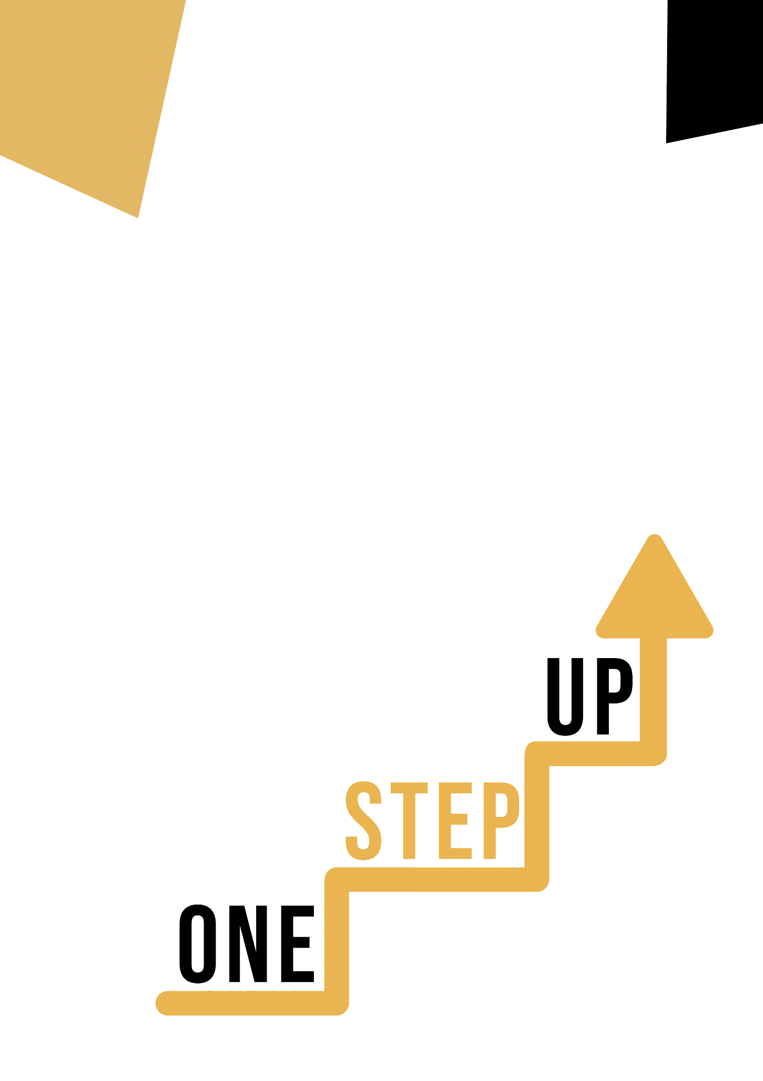
CULTURAL AWARENESS AND EXPRESSION COMPETENCE DIGITAL AND SOCIAL
Learner Handout
Contents
Introduction to the topic 3
Case study 4
Learning Activity 5
Additional Reading or Study Materials 7

Introduction to the topic

Cultural awareness and expression competence in digital and social realms are indispensable facets of our modern, interconnected world. These concepts encapsulate the profound importance of understanding, appreciating, and effectively engaging with diverse cultures and identities in the digital sphere. In today's globalised landscape, where social media, online communities, and virtual spaces unite people worldwide, the ability to navigate cultural nuances is paramount. It fosters inclusive, respectful, and harmonious interactions. This competency empowers individuals, businesses, and organizations to bridge cultural gaps, avoid misunderstandings, and harness the immense potential of cross-cultural connections in an increasingly digital age, enriching our collective online experience.

Case study

Imagine that you are a job seeker in social media. You come in for an interview and are asked three questions about your potential job. You try to answer them. ☺
Before you do the task, think about it:
- Do you use social media yourself? If so, which ones?
- Do you know what working in the social media industry is like?

Learning Activity

Read the case study, then with the help of the Internet, answer the following 3 questions:

- What is the most popular social media platform in your country?

- Do you think social media has the potential to foster positive social change? Why?

- What ways do you know of to stay safe on the Internet? Please name at least two.

Wonderful! Congratulations and thank you for completing the exercise. ☺

Transversal Theme | Digital and Social
Activity Title | Interview ☺
Type of resource | Learning Activity
Photo | 
Duration of Activity  (in minutes) | 60 min | Learning Outcome | - greater awareness of social media, its potential and online safety
Aim of activity | The goal of this task is to deepen knowledge of the digital world.
Materials Required for Activity | - pen  - paper  - the Internet
Step-by-step instructions | 1 Read the case study.  2. Read the task order and with the help of the Internet try to answer three questions. Don't stress, your every thought is very valuable. :)  3. Congratulations on completing the task!

Additional Reading or Study Materials
Congratulations, you have reached this point and completed your self-reflection activities related to Cultural Awareness and Expression Competence – Digital and Social. What comes next? If you would like to learn more about the topics you have covered so far in this lesson, we have prepared the following additional reading materials for you. This section presents some links to extra materials and videos that we have found online that we think will help you to take the next step in developing your knowledge.
Resource Title: | “Cultural awareness and expression”
Topic Addresses: | Cultural awareness and expression competence
Introduction to the resource: | Here you can learn more about cultural awareness and expression competence.
What will you get from using this resource? | - With this resource you will learn more about cultural awareness and expression.
Link to resource: | https://www.schooleducationgateway.eu/en/pub/viewpoints/experts/cultural_awareness_and_express.htm

Resource Title: | Cultural Awareness and Expression 2
Topic Addresses: | Mentioned competences
Introduction to the resource: | Let’s find out more about cultural awareness and expression competences.
What will you get from using this resource? | - You will increase your knowledge on the listed topics
Link to resource: | https://www.youtube.com/watch?v=xYPOP3FLMHM
