<Competence area and transversal theme>

Learner Handout

Contents

**What is citizenship competence? 3**

**What is the connection between citizenship competence and sports and hobbies? 4**

**Case study - Sport & Citizenship (France) 5**

**Learning Activity - Civic Values Through Sport & Hobbies 7**

**Additional Reading or Study Materials 8**

# What is citizenship competence?

"Citizenship" means being a member of a particular country or nation, holding a set of rights and responsibilities. Besides the most obvious ones, such as respecting and obeying federal, state, and local laws and paying income and other taxes, it also involves participating in civic life and being engaged in the community and political process. 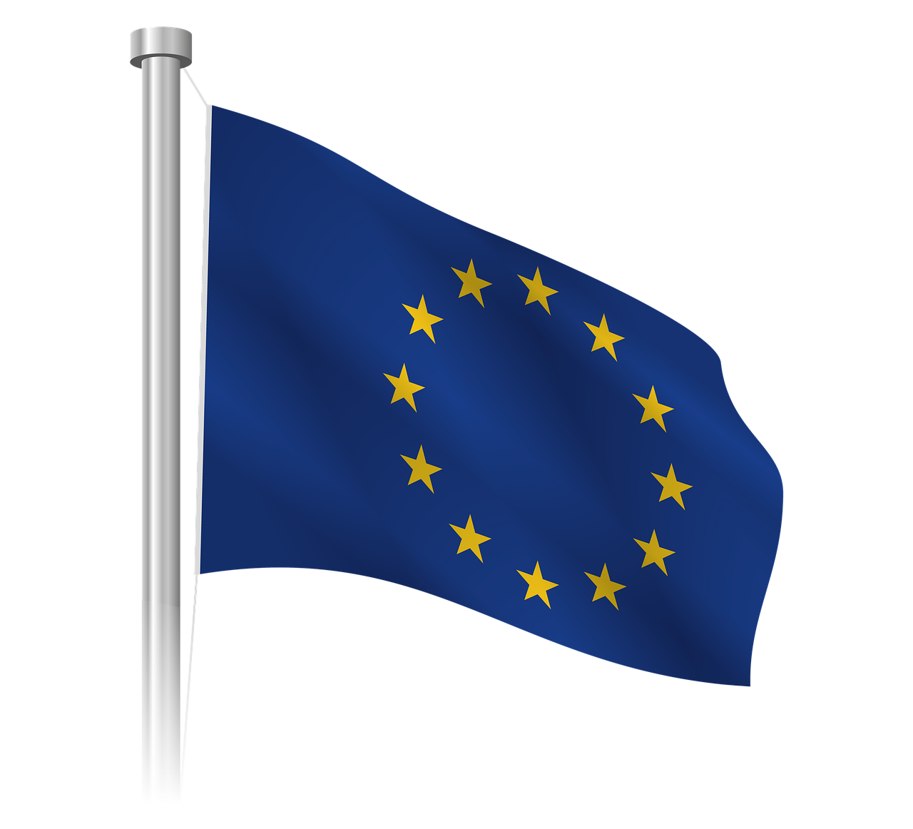

Active citizenship refers to taking an active role in the community. It goes beyond just holding legal citizenship status and involves taking an active role in civic life, public affairs, and decision-making processes. Active citizens stay informed about public issues, advocate for causes they believe in, volunteer, participate in public discussions, and collaborate with others to address societal challenges. By being actively involved, citizens make their communities better and play a crucial role in shaping a more inclusive and democratic society.

To be able to perform these tasks effectively, you need to have "citizenship competence". According to the Council of the European Union, citizenship competence is defined as “the ability to act as a responsible citizen and to participate fully in civic and social life, based on understanding of social, economic, legal and political concepts and structures, as well as global developments and sustainability”.

Strengthening your citizenship competence means developing and enhancing your knowledge, skills, and engagement as a responsible and active citizen:

* Read, learn and stay informed about your country's history, political system, and current affairs;
* Participate in debates, discussions, and community forums to exchange ideas and perspectives with others;
* Volunteer for community initiatives to directly contribute to your community's well-being;
* Familiarise yourself with your rights and duties as a citizen to actively fulfill your role in society;
* Advocate for causes that you believe in and advocate for positive change;
* Vote in elections, referendums, and other civic processes;
* Join local or national organisations that focus on civic engagement, human rights, environmental protection, or other relevant issues;
* Engage with people from different backgrounds to develop empathy and foster a sense of inclusivity;
* Act responsibly and ethically, respecting the rights and dignity of others.
* Encourage family and friends to become more informed and engaged citizens as well.

# What is the connection between citizenship competence and sports and hobbies?

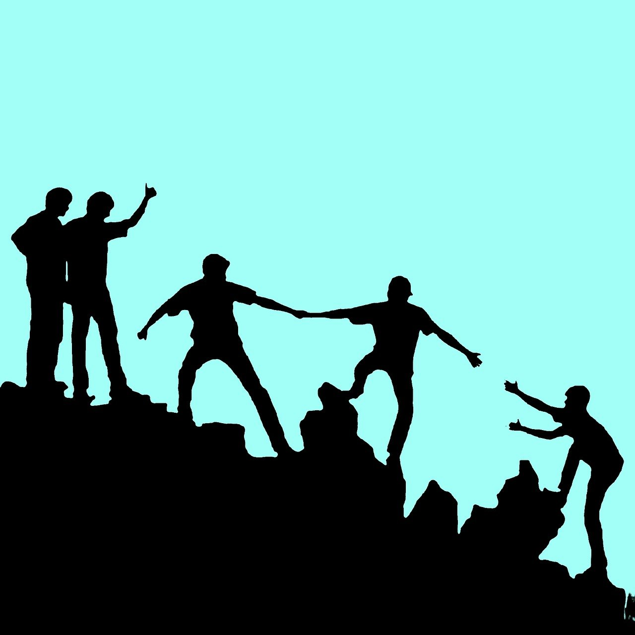

Civic values are all influenced by personal life experiences, relationships and social contexts at home, school, work, or even sports. Sports can play a significant role in helping people become better citizens and it’s a big part of the lives of many adults, especially young people. Sports help develop values, skills, and attitudes that are important to become an active and responsible participant in society. Sports provide opportunities for participation, breaking down cultural barriers, building community identity, and making friends. It promotes tolerance, teamwork, empathy, the value of hard work and socialisation skills.

Sports can positively influence individuals and empower them to become better citizens through teamwork, fair play, discipline, leadership, conflict resolution, resilience, sense of belonging, and inclusivity.

Sports teaches us teamwork and the importance of working together towards a common goal. For example, if players learn teamwork during their matches and realise that each player’s contribution is important to achieving success, this understanding can influence their approach regarding collaborative efforts in community projects and civic engagement.

When players learn to congratulate their opponent and shake their hands at the end of the match, they learn to treat their peers with respect and fairness. In this sense, sports promote the idea of fair play, integrity, and respect for opponents, which can foster a sense of fairness and respect for others in various social interactions.

An individual’s training schedules and practice discipline helps them improve their performances. They learn discipline and self-control and these skills can also be transferred to other areas of their personal life such as academic or work challenges, as well as civic life.

Participation in sports can provide opportunities to take on leadership roles, which encourages individuals to initiate community service projects and encourages others to get involved.

Disagreements and arguments often happen in sports and it can be a great area for practicing a respectful discussion, ensuring everyone's opinions are heard while encouraging compromise. This conflict resolution skills can prove beneficial when applied to resolving differences in society and promoting understanding.

Sports is both about winning as it is about losing. When individuals face both victory and defeat in sports, it can foster resilience and adaptability, qualities that help individuals cope with setbacks and changes in their civic engagement efforts.

Being part of a sports team or fan community can create a sense of belonging, which can be translated into a sense of responsibility and commitment to one's broader community and nation.

Finally, sports is often a place where diverse backgrounds mix which fosters a sense of inclusivity and friendship among participants and breaks down barriers between different communities.

# Case study - Sport & Citizenship (France)



Photo by Sport and Citizenship, available [here](https://www.sportetcitoyennete.com/en/)

The association "Sport and Citizenship" is the only European Think Tank on sport that aims to analyse sports policy and to study the societal impact of sport. It was established in September 2007 as the first European think-tank focused on sport. Its main objective is to highlight the core values of sports in society, particularly in politics, economics, and media. The association serves as a platform for new ideas and advocacy, engaging with political, corporate, and associative communities at a European level.

Key points of their work:

* a space for critical thinking and analysis related to sports and its impact on society.
* actively proposes and advocates for positive changes and developments in the field of sports
* acts as a central entity for the sports movement, institutions, and actors involved in civic sports
* shares information about successful sports practices and contributes to their development
* publish a quarterly journal focusing on important societal themes related to sports, featuring contributions from European experts
* pay special attention to the policies led by the European Commission, including the White Paper on Sport.
* organise and participate in events that address the intersection of citizenship and sports across Europe.
* foster dialogue and consultation with citizens and civil society on significant sports-related issues.

They are part of various projects that focus on the inclusion of migrants and refugees through sport, the links between sport and sustainable development, the links between sport and cultural heritage, and increasing women’s participation in sports.

One of the projects where Sport and Citizenship were partners is VECA, which aims to promote European citizenship through sport. The association "Paris Athlé 2020" organised the European Athletics Championships from 25 to 30 August 2020 in Paris, involving 1500 athletes from 51 countries, 20 officials, 2000 children, and 1400 volunteers. The event aimed to be unifying, promoting shared values, education, social responsibility, and ethical principles. "Paris Athlé 2020" created a valued volunteer program, fostering active European citizenship and incorporating European values throughout the program's phases, from recruitment to evaluation. The goal was to assimilate participation in a European sports event with European civic engagement.

Questions:

1. How does the association "Sport and Citizenship" try to improve citizenship skills through sports?

_________________________________________________________________________________________________________________________________________________________________________________________________________________________________________________________________________________________________________________________________________________________________________________________________________________________________________________________________

1. How do you think you could improve your citizenship competences through sports and hobbies?

_________________________________________________________________________________________________________________________________________________________________________________________________________________________________________________________________________________________________________________________________________________________________________________________________________________________________________________________________

# Learning Activity - Civic Values Through Sport & Hobbies

|  |  |  |  |
| --- | --- | --- | --- |
| **Transversal Theme** | Enhancing Citizenship Competences Through Sport | | |
| **Activity Title** | Civic Values Through Sport & Hobbies | | |
| **Type of resource** | **Learning Activity** | | |
| **Photo** |  | | |
| **Duration of Activity**  **(in minutes)** | 60 minutes | **Learning Outcome** | * Explore citizenship values in the context of their hobbies |
| **Aim of activity** | The aim of this activity is for learners to engage in self-reflection, analysing how their sport activities and hobbies connect to citizenship principles and contribute to community engagement. | | |
| **Materials Required for Activity** | * Internet connection * Mobile phone or computer * Pens, papers | | |
| **Step-by-step instructions** | **Step 1:** Watch [this](https://www.youtube.com/watch?v=K4mhtXPVAI0&t=76s) UNESCO’s video and write down core sport values that empower people to be engaged, motivated and active in society. Then write down three that you find most important.  **Step 2:** Select a sport or a hobby that interests you most or that you practice regularly. Examples: running, cycling, swimming, yoga, gardening, or home-based exercises (e.g., bodyweight workouts).  **Step 3:** Research the benefits and values associated with your chosen sport or hobby. Consider how core sport values play a role in practicing and improving in your selected sport or hobby. Think about how these values extend beyond sports and into your daily life as a responsible citizen.  **Step 4:** Self-reflect with the help of these questions:   * How do the core sport values relate to being a responsible and engaged citizen? * In what ways can practicing core sport values contribute positively to your community? * How can the lessons learned from core sport values be applied to daily interactions and civic involvement? * Can you think of some examples of how these values are demonstrated in various aspects of community life? | | |

# Additional Reading or Study Materials

Congratulations, you have reached this point and completed your self-reflection activities related to Building Citizenship Competences Through Sports & Hobbies. What comes next? If you would like to learn more about the topics you have covered so far in this lesson, we have prepared the following additional reading materials for you. This section presents some links to extra materials and videos that we have found online that we think will help you to take the next step in developing your knowledge.

|  |  |
| --- | --- |
| **Resource Title:** | Sportsmanship As Citizenship |
| **Topic Addresses:** | Building Citizenship Competence Through Sport |
| **Introduction to the resource:** | The Rose Bowl Institute partnered with RISE, a social justice nonprofit, for a critical conversation on "Sportsmanship as Citizenship." The panelists, including athletes and sports leaders, discussed the role of sports in civic engagement, social justice, and equity. The conversation explored how sportsmanship aligns with citizenship values and supports athlete activism for inclusion and racial equity. |
| **What will you get from using this resource?** | You can gain insights into the intersection of sportsmanship, citizenship, and social justice. The panelists, including athletes and sports leaders, will share their experiences and perspectives on the role of sports in advancing civic engagement, equity, and inclusion. You will learn about the values of sportsmanship and how they align with citizenship principles, such as fair play, respect, and collaboration. Listening to this event can broaden your understanding of the positive impact sports can have on society and inspire you to actively engage in promoting civic values within your community. |
| **Link to resource:** | <https://rosebowlinstitute.org/programs/sportsmanship-as-citizenship/> |

|  |  |
| --- | --- |
| **Resource Title:** | The Power of Sport Values |
| **Topic Addresses:** | Building Citizenship Competence Through Sport |
| **Introduction to the resource:** | This photobook represents a tribute to the integrity of sportsmanship and its photographs embody the values such as fair play, equality, respect, and solidarity. |
| **What will you get from using this resource?** | You will read short stories and look at different photographs from Congo, Qatar, India, Mexico, Bangladesh, etc. about the transformative power of sports and the social and physical roles of sports. |
| **Link to resource:** | <https://unesdoc.unesco.org/ark:/48223/pf0000244344> |

