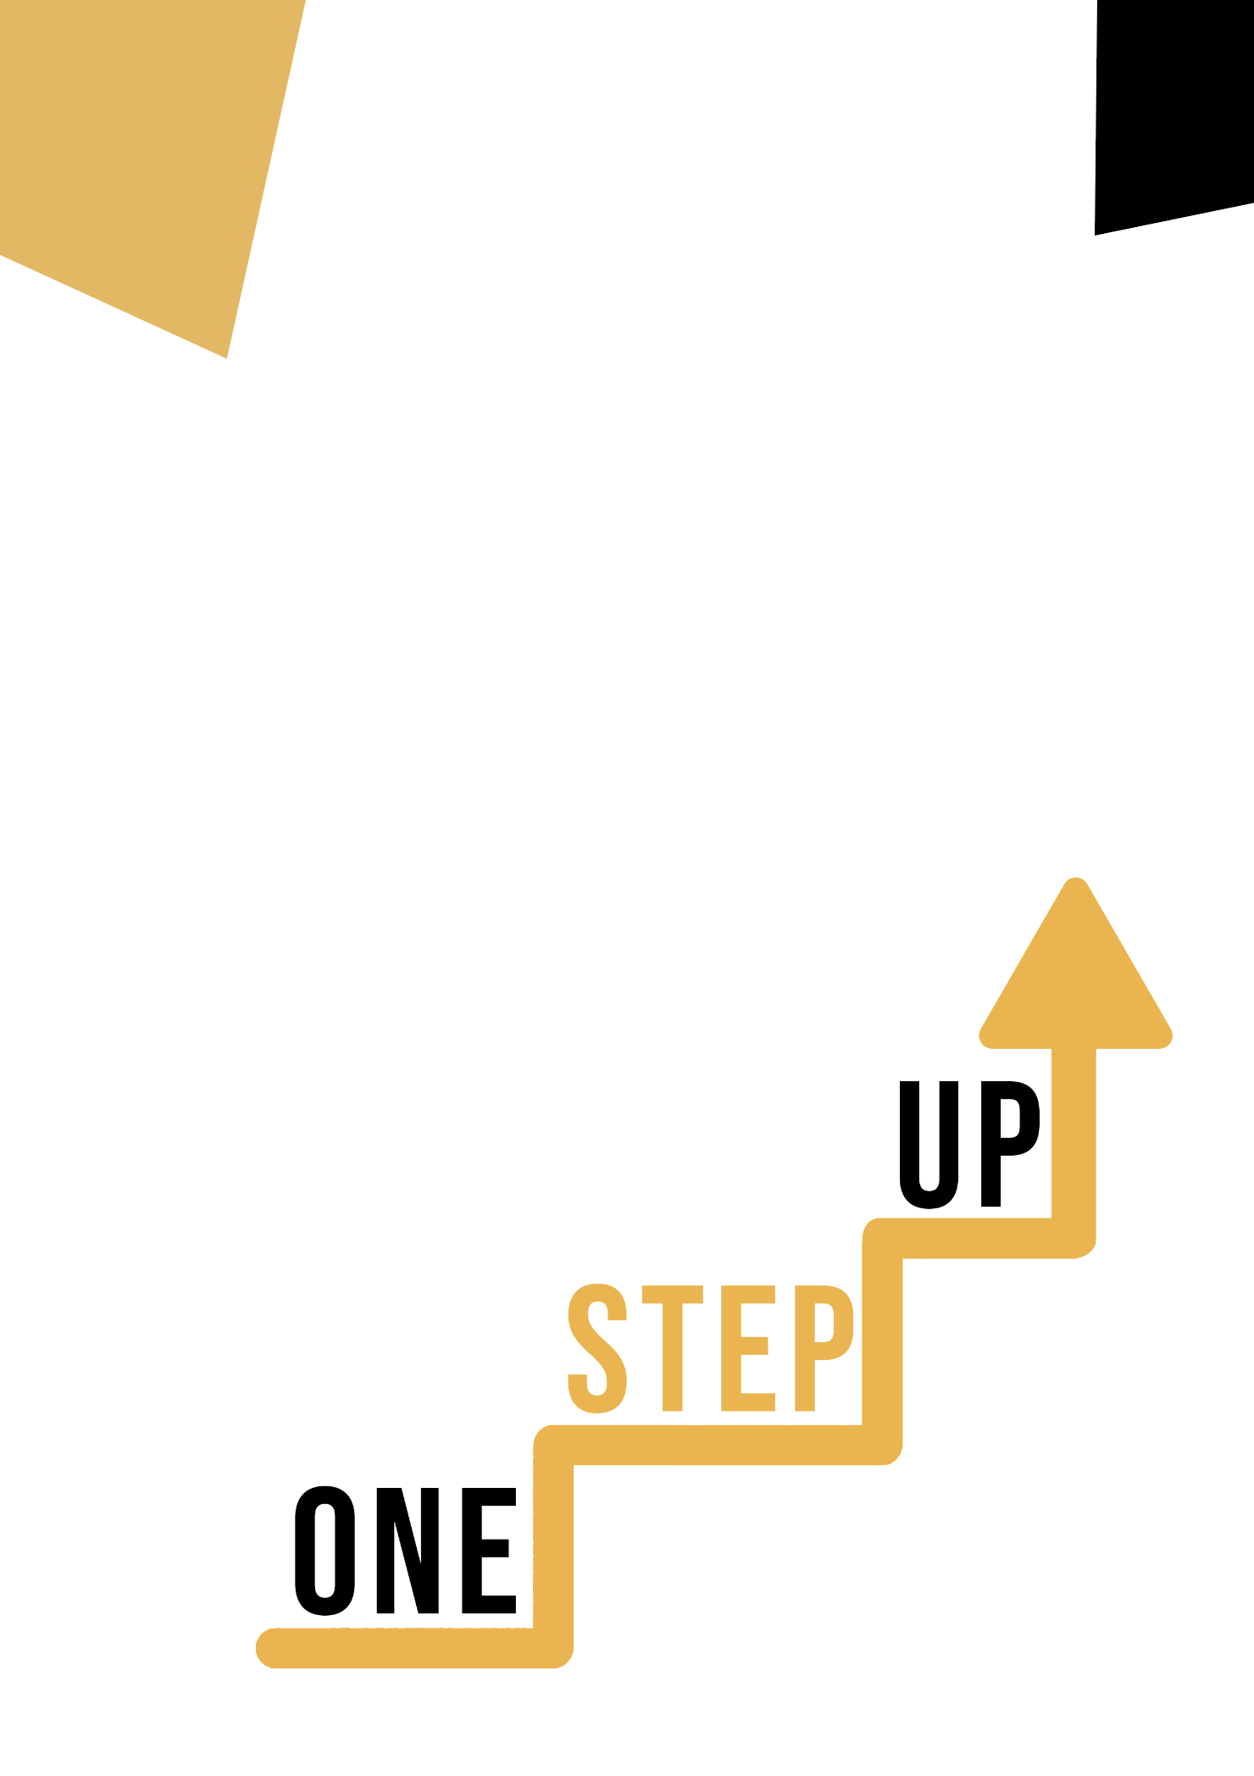
citizenship Competence artistic disciplines
Learner Handout
Contents
Introduction to the topic 3
Case study 4
Learning Activity 5
Additional Reading or Study Materials 8

Introduction to the topic

The task is to better understand the link between art and citizenship competence.
Let's give it a try! ☺

Case study

Your friend is not interested in art on a daily basis. There are subjects that interest her much more. She doesn't believe there are threads of citizenship competition in art. You want to show her that.
Your task is to list 5 different fields of art and for each of them to find an example that relates in its theme to citizenship competence.
Firstly, please answer following questions:
- How would you justify the importance of art?
- What are some examples of citizenship competencies?
Good luck! ☺

Learning Activity

Activity: “Citizenship competence in art”
Please, fill in the gaps with examples found on the Internet ☺
- Example:
Field of art: documentary photography
Art work with citizenship competence theme: “Migrant Mother” Dorothea Lange
- Field of art:

Art work with citizenship competence theme:

- Field of art:

Art work with citizenship competence theme:

- Field of art:

Art work with citizenship competence theme:

- Field of art:

Art work with citizenship competence theme:

- Field of art:

Art work with citizenship competence theme:

Well done! Thank you! ☺

Transversal Theme | Artistic disciplines
Activity Title | “Citizenship competence in art”
Type of resource | Learning Activity
Photo | 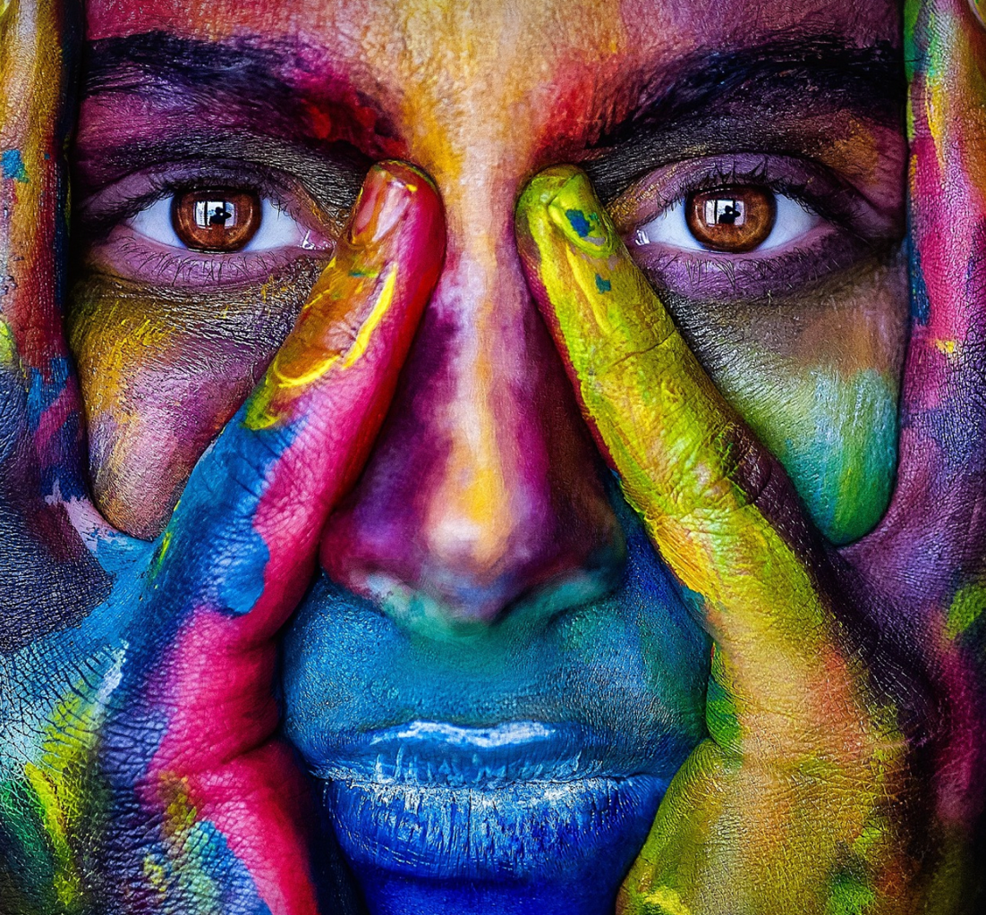
Duration of Activity  (in minutes) | 60 minutes | Learning Outcome | - Knowledge about different fields of art  - Knowledge of what citizenship competencies are  - The link between art and citizenship competence
Aim of activity | The purpose of this exercise is to gain knowledge about art and citizenship competence and how they are interrelated
Materials Required for Activity | - Internet  - Paper  - Pen
Step-by-step instructions | - Please, read the description of the activity.  - Find on the Internet examples of different forms of art.  - Then, search the Internet and find what citizenship competence is.  - Please, search the internet for different examples of art works with citizenship competence theme.  - Fill in the blanks in the exercise: Field of art and Art work with citizenship competence theme.  - Thank you for your work! ☺

Additional Reading or Study Materials

Congratulations, you have reached this point and completed your self-reflection activities related to Citizenship competence in art What comes next? If you would like to learn more about the topics you have covered so far in this lesson, we have prepared the following additional reading materials for you. This section presents some links to extra materials and videos that we have found online that we think will help you to take the next step in developing your knowledge.
Resource Title: | “Citizenship competence”
Topic Addresses: | The issue of citizenship competence.
Introduction to the resource: | You can find out what this issue is.
What will you get from using this resource? | Knowledge of citizenship competencies.
Link to resource: | https://www.cedefop.europa.eu/en/tools/vet-glossary/glossary/competencia-de-cidadania

Resource Title: | “Types of Art – An Exploration of the Different Types of Art”
Topic Addresses: | Different forms of art.
Introduction to the resource: | You can get to know more about different forms of art.
What will you get from using this resource? | Knowledge of the vast field that is art.
Link to resource: | https://artincontext.org/types-of-art/
