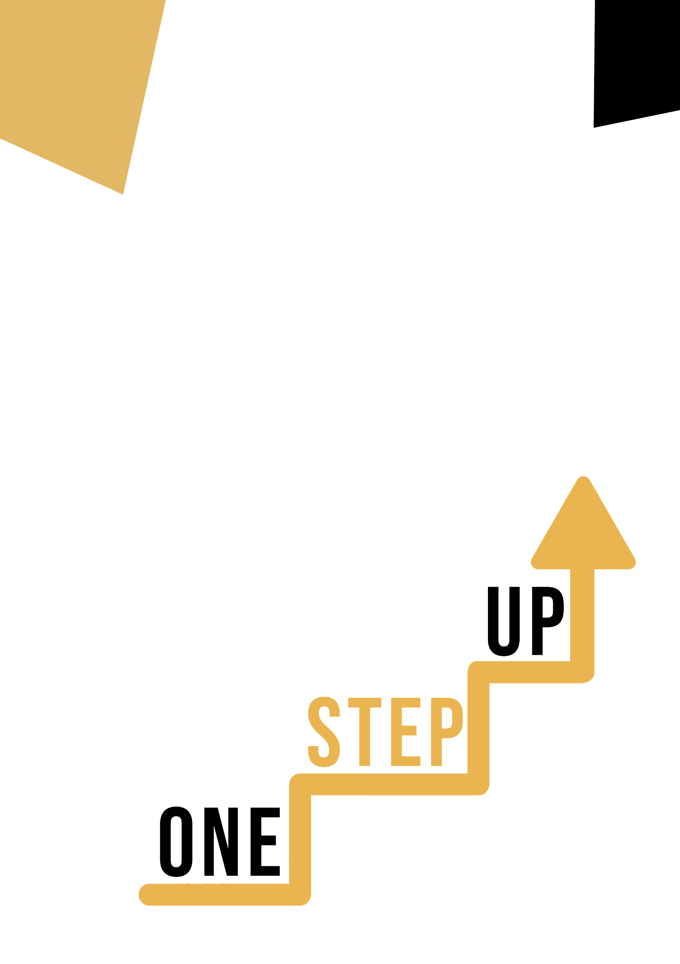
ARTISTIC DISCIPLINE AND DIGITAL COMPETENCE
Learner Handout

Discovering Digital Artistry and Creativity

Welcome to the world of digital art! This journey integrates technological innovation with artistic expression, providing you the resources to create and invent in previously unheard-of ways. We'll examine both the theoretical and practical sides of digital art in this handout under the direction of the EU's Key Competence for Lifelong Learning.

Case study

Imagine a world where traditional artistic methods and digital technologies coexist together. We'll look at how a digital artist named Maya combines her passion of traditional painting with cutting-edge technology in this case study. She is able to push the frontiers of creativity while producing art that speaks to today's audiences.

Case Study: Bridging Traditional and Digital Artistry

Meet Maya, an enthusiastic artist who combines traditional and digital creative processes to redefine creation. The story of Maya shows the amazing possibilities of fusing cutting-edge technology with time-honored artistic methods.

Maya's artistic background: Maya showed early on that she had a natural talent for painting. She developed her conventional artistic abilities, portraying the beauty of nature and the emotions of people on paint. Maya's artwork exhibited deft compositional understanding, vivid colors, and precise brushwork.
Embracing the Digital Canvas: As technology advanced, Maya recognized a chance to further her artistic abilities. She entered the world of digital art and embraced the opportunities it provided. With the use of a digital tablet and specialized software, Maya was able to expand the scope of her imagination.

Combining the Old and the New: Maya's journey did not involve giving up her cultural origins. Instead, she managed to combine the greatest aspects of both. She would begin by drawing her concepts on paper to capture the bare bones of her notion. Maya would then improve her sketches using her digital skills, including minute details, dynamic lighting, and vivid colors.
Making Original Works of Art: Maya's fusion of techniques produced art that appealed to both traditionalists and digital fans. Her works combined traditional painting's depth and passion with the creativity and potential of the digital age. Each piece was evidence of her ability to successfully combine two seemingly unrelated approaches into one beautiful whole.
Impact and Recognition: A number of art communities started to pay attention to Maya's works. Galleries that often displayed conventional artwork recognized the worth of her strategy. Art fans were in wonder of how she skillfully combined history and technology to produce works that communicated to a wide audience.
Others' Inspiration: Maya's voyage has influenced other artists to investigate the fusion of tradition and technology. Her experience demonstrates that innovation may actually enrich tradition rather than erasing it. Artists may create new directions while sticking to their artistic legacy by combining traditional techniques with modern technology.
In conclusion:
The story of Maya shows the value of embracing change while respecting artistic tradition. Her capacity to combine these elements has enhanced not only her personal artistic expression but also
provided opportunities for a new generation of creatives. Maya's narrative serves as a reminder that artistic expression has limitless potential and that it is a dynamic, ever-evolving process.

Key Questions
- How do you think Maya combines traditional and digital techniques in her art?
- What advantages do you see in using digital tools for artistic expression?

Learning Activity

Transversal Theme | Digital and Technology-Based Competences
Activity Title | Infusing Tradition with Innovation
Type of resource | Learning Activity
Photo
Duration of Activity  (in minutes) | 60 minutes | Learning Outcome | - By the end of this activity, you'll have gained hands-on experience in blending traditional and digital art techniques.
Aim of activity | To explore the harmonious fusion of traditional art techniques and digital tools, resulting in a unique artwork that reflects your creative voice.
Materials Required for Activity | - A sketchbook or drawing paper  - Pencils, pens, and markers  - A computer or tablet with digital art software (optional)  - Internet access (optional)
Step-by-step instructions | Choose Your Theme: Select a subject or concept that inspires you. It could be a favorite object, a scene from nature, or an abstract idea.  Traditional Sketching: Start by creating a traditional sketch on paper. Use pencils, pens, and markers to bring your idea to life.  Digitize Your Sketch: If you have access to digital tools, scan or photograph your traditional sketch. Alternatively, you can start directly on a digital platform.  Digital Enhancement: Use digital tools to enhance your sketch. Experiment with color, shading, and effects to add a new layer of depth to your artwork.  Traditional and Digital Merge: Bring your enhanced digital sketch back into the physical realm. Print it out and apply finishing touches using traditional media if desired.  Reflect and Evaluate: Step back and reflect on your artwork. Consider how the fusion of traditional and digital techniques has influenced the final piece.  Debriefing Questions:  - How did combining traditional and digital techniques impact your creative process?  - What aspects of this activity challenged you, and how did you overcome them?  - In what ways do you see yourself integrating digital tools into your future artistic endeavors?  - How did this activity align with the key competences for lifelong learning, particularly Digital and Technology-Based Competences?  - What did you discover about the intersection of tradition and innovation in art during this activity?

Additional Reading or Study Materials
Congratulations, you have reached this point and completed your self-reflection activities related to Artistic Discipline and Digital Competence. What comes next? If you would like to learn more about the topics you have covered so far in this lesson, we have prepared the following additional reading materials for you. This section presents some links to extra materials and videos that we have found online that we think will help you to take the next step in developing your knowledge.
Resource Title: | Cultural Diversity in Art
Topic Addresses: | Meaning of cultural diversity in art
Introduction to the resource: | Exploring cultural diversity in art isn't just an academic exercise — it's a way to foster understanding and appreciation of different cultures. It challenges our perceptions, broadens our worldview, and deepens our empathy.
What will you get from using this resource? | - Understanding different cultures and broadening of wordview
Link to resource: | Cultural Diversity in Art: Techniques & Best Practices (daisie.com)

Resource Title: | The Role of Cultural Diversity in Modern Art
Topic Addresses: | Cultural diversity and art
Introduction to the resource: | Modern art is a global language that communicates the innermost thoughts, feelings, and experiences of an individual.
What will you get from using this resource? | - Understanding the role of cultural diversity in modern art
Link to resource: | The Role of Cultural Diversity in Modern Art (youthtimemag.com)
