Personal Social & L2L competence and cultural theme
Adult educator manual
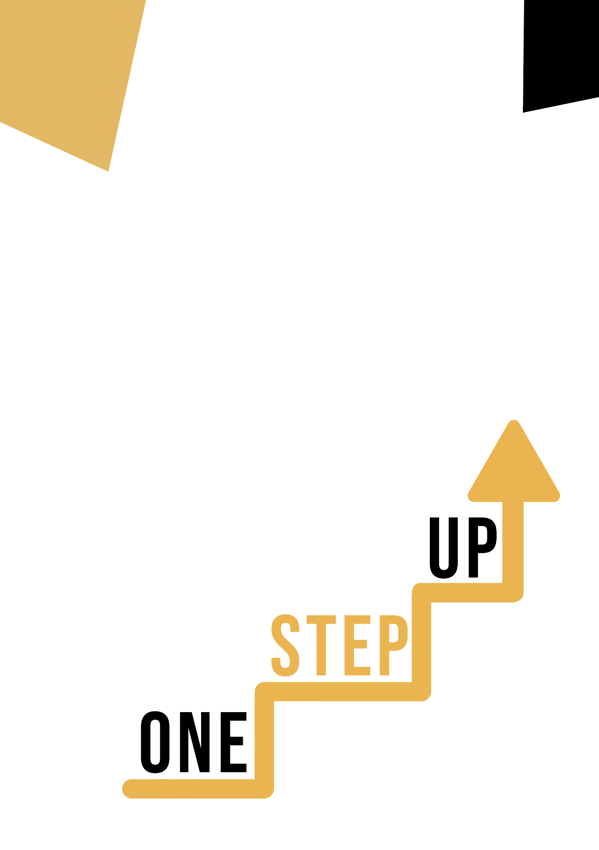

Micro-learning resources to re-engage low-skilled adult learners in education and training

Adult Educator Manual
Lesson Plan
The aim of this short handbook is to support you, as an experienced educator working with low-skilled and marginalised adult learners, with diverse needs, to use the video resources and the activity sheets provided in the Suite of Micro-Learning Resources to Re-Engage Low-Skilled Adult Learners in your centre and in your community. Through this short manual, we will provide you with some background information on the topic being discussed in the video resource and provide some guidance to support you to introduce and implement the accompanying activity with adult learners in your group. The activity that has been developed to accompany the video resources aims to further develop their understanding of the topic outlined in the video resource. Finally, this manual will also present you with some debriefing questions that you can use in your group of adult learners, to assess the user-friendliness and quality of the activity you have completed with them.
The topic of this manual relates to the video resources Personal, Social & L2L competences and Cultural Theme

Introduction to the Topic

For navigating a world that is becoming more varied and linked, cultural competence, personal social competence, and learning-to-learn competence are essential. Low-skilled adult learners have the chance to use these tools to investigate the value of cultural variety, cross-cultural dialogue, and personal development in an interesting and productive way. Learners improve their capacity for cooperation, communication, and flourishing in a variety of social and educational contexts by developing these competencies.

Introduction to the Activity

The accompanying activity is based on a case study that explores the complexities of cultural diversity and how it affects both personal development and societal dynamics. Students will interact with real-world situations that emphasize the value of empathy, open-mindedness, and cross-cultural cooperation. Through this exercise, students will consider their own experiences and viewpoints while deepening their comprehension of various other viewpoints.

Using this Resource with a Group
To use this resource with adult learners in your local group, we recommend that you begin by showing them the video resource to introduce the theme of Personal, Social & L2L competence and Cultural Theme. This video will help learners to understand the topic before they begin the Learner Handout activity. Once they have gained a general knowledge of the theme, they will be able to begin the handout. For this, we recommend that you print one handout per learner to complete. All learners need for this resource is a pen to complete the learner handout and a computer to view the video. This resource will take one hour in total to complete.

Debriefing Questions

- How did the video resource enhance your understanding of cultural competence and its relevance in today's world?
- Reflect on a personal experience where you collaborated across cultural differences. What did you learn from that experience?
- In what ways do you believe open-mindedness can positively impact your interactions with individuals from diverse backgrounds?
- Share an instance where you demonstrated empathy towards someone from a different culture. How did it affect your perception of cultural diversity?
- What aspects of the Learner Handout activity resonated with you the most, and how might you apply these insights to your daily life?
These debriefing questions are designed to facilitate thoughtful discussion and encourage learners to connect the concepts from the video and activity to their own experiences and perspectives.
