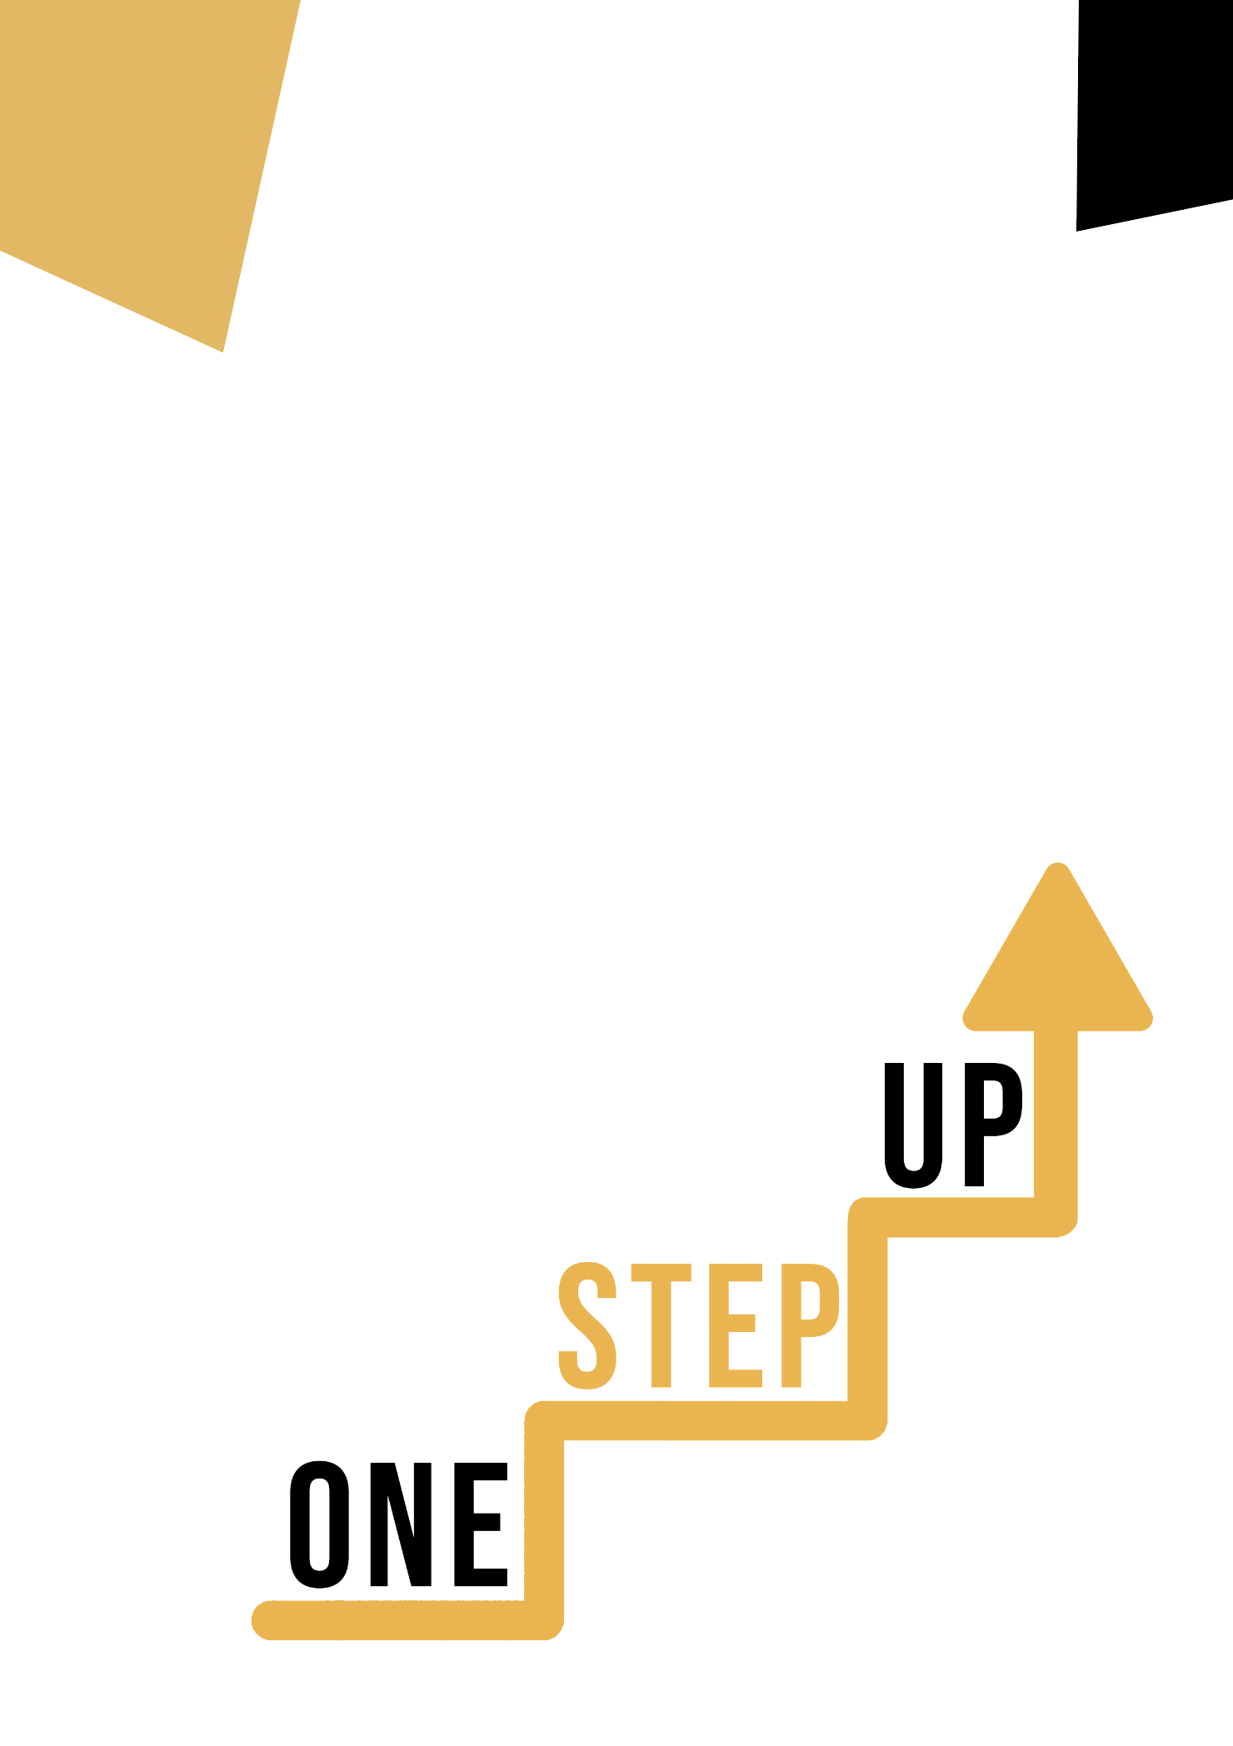
<Competence area and transversal theme>
Adult educator manual

Micro-learning resources to re-engage low-skilled adult learners in education and training

Adult Educator Manual
Lesson Plan
The aim of this short handbook is to support you, as an experienced educator working with low-skilled and marginalised adult learners, with diverse needs, to use the video resources and the activity sheets provided in the Suite of Micro-Learning Resources to Re-Engage Low-Skilled Adult Learners in your centre and in your community. Through this short manual, we will provide you with some background information on the topic being discussed in the video resource and provide some guidance to support you to introduce and implement the accompanying activity with adult learners in your group. The activity that has been developed to accompany the video resources aims to further develop their understanding of the topic outlined in the video resource. Finally, this manual will also present you with some de-briefing questions that you can use in your group of adult learners, to assess the user-friendliness and quality of the activity you have completed with them.

The topic of this manual relates to the video resources Personal, Social, and L2L Competence Through Digital and Social Media.

Introduction to the Topic

In the digital era, harnessing the power of online platforms for personal, social, and learning-to-learn (L2L) competence development offers transformative opportunities, especially for low-skilled adults. Leveraging digital and social media resources, individuals can access a wide range of educational content, interactive tools, and virtual communities to improve emotional intelligence, communication, and adaptability. For low-skilled adults facing barriers to traditional learning avenues, this self-directed approach fosters empowerment, boosting confidence, and nurturing essential skills essential for career advancement and personal growth.

Introduction to the Activity

Using the case study of the Holistic Psychologist, learners are introduced to microlearning content, e.g. bite-sized content that delivers complex psychological topics in a very simple and effective way. It’s an example of good practice because engaging with Nicole LePera's content can be a valuable self-directed activity for adults seeking personal development and mental health insights. Learners also have a chance to try out the “Improving Your Digital Time Management” with the aim of empowering them to enhance their time management skills through online resources and digital tools. This will demonstrate how practicing one aspect of personal, social and learning to learn competence such as time management skills, can be useful and fun in combination with working on their own digital skills.

Using this Resource with a Group
To use this resource with adult learners in your local group, we recommend that you begin by showing them the video resource to introduce the theme of Personal, Social, and Learning to Learn Competence Through Digital and Social Media. This video will help learners to understand the topic before they begin the Learner Handout activity. Once they have gained a general knowledge of the theme, they will be able to begin the handout. For this, we recommend that you print one handout per learner to complete. All learners need for this resource is a pen to complete the learner handout and a computer to view the video. This resource will take one hour in total to complete.

De-Briefing Questions

- What do you think is the key to the success of the Holistic Psychologists’s work?
- What is one key takeaway that you will bring from this case study and activity? How will you apply it to your own life or work?
- How did you find "Improving Your Digital Time Management”? Did you find it helpful in improving your interpersonal skills?
- How do you think the use of digital and social media can be incorporated into improving your personal, social and learning-to-learn competences?

