Multilingualism digital and social
Adult educator manual
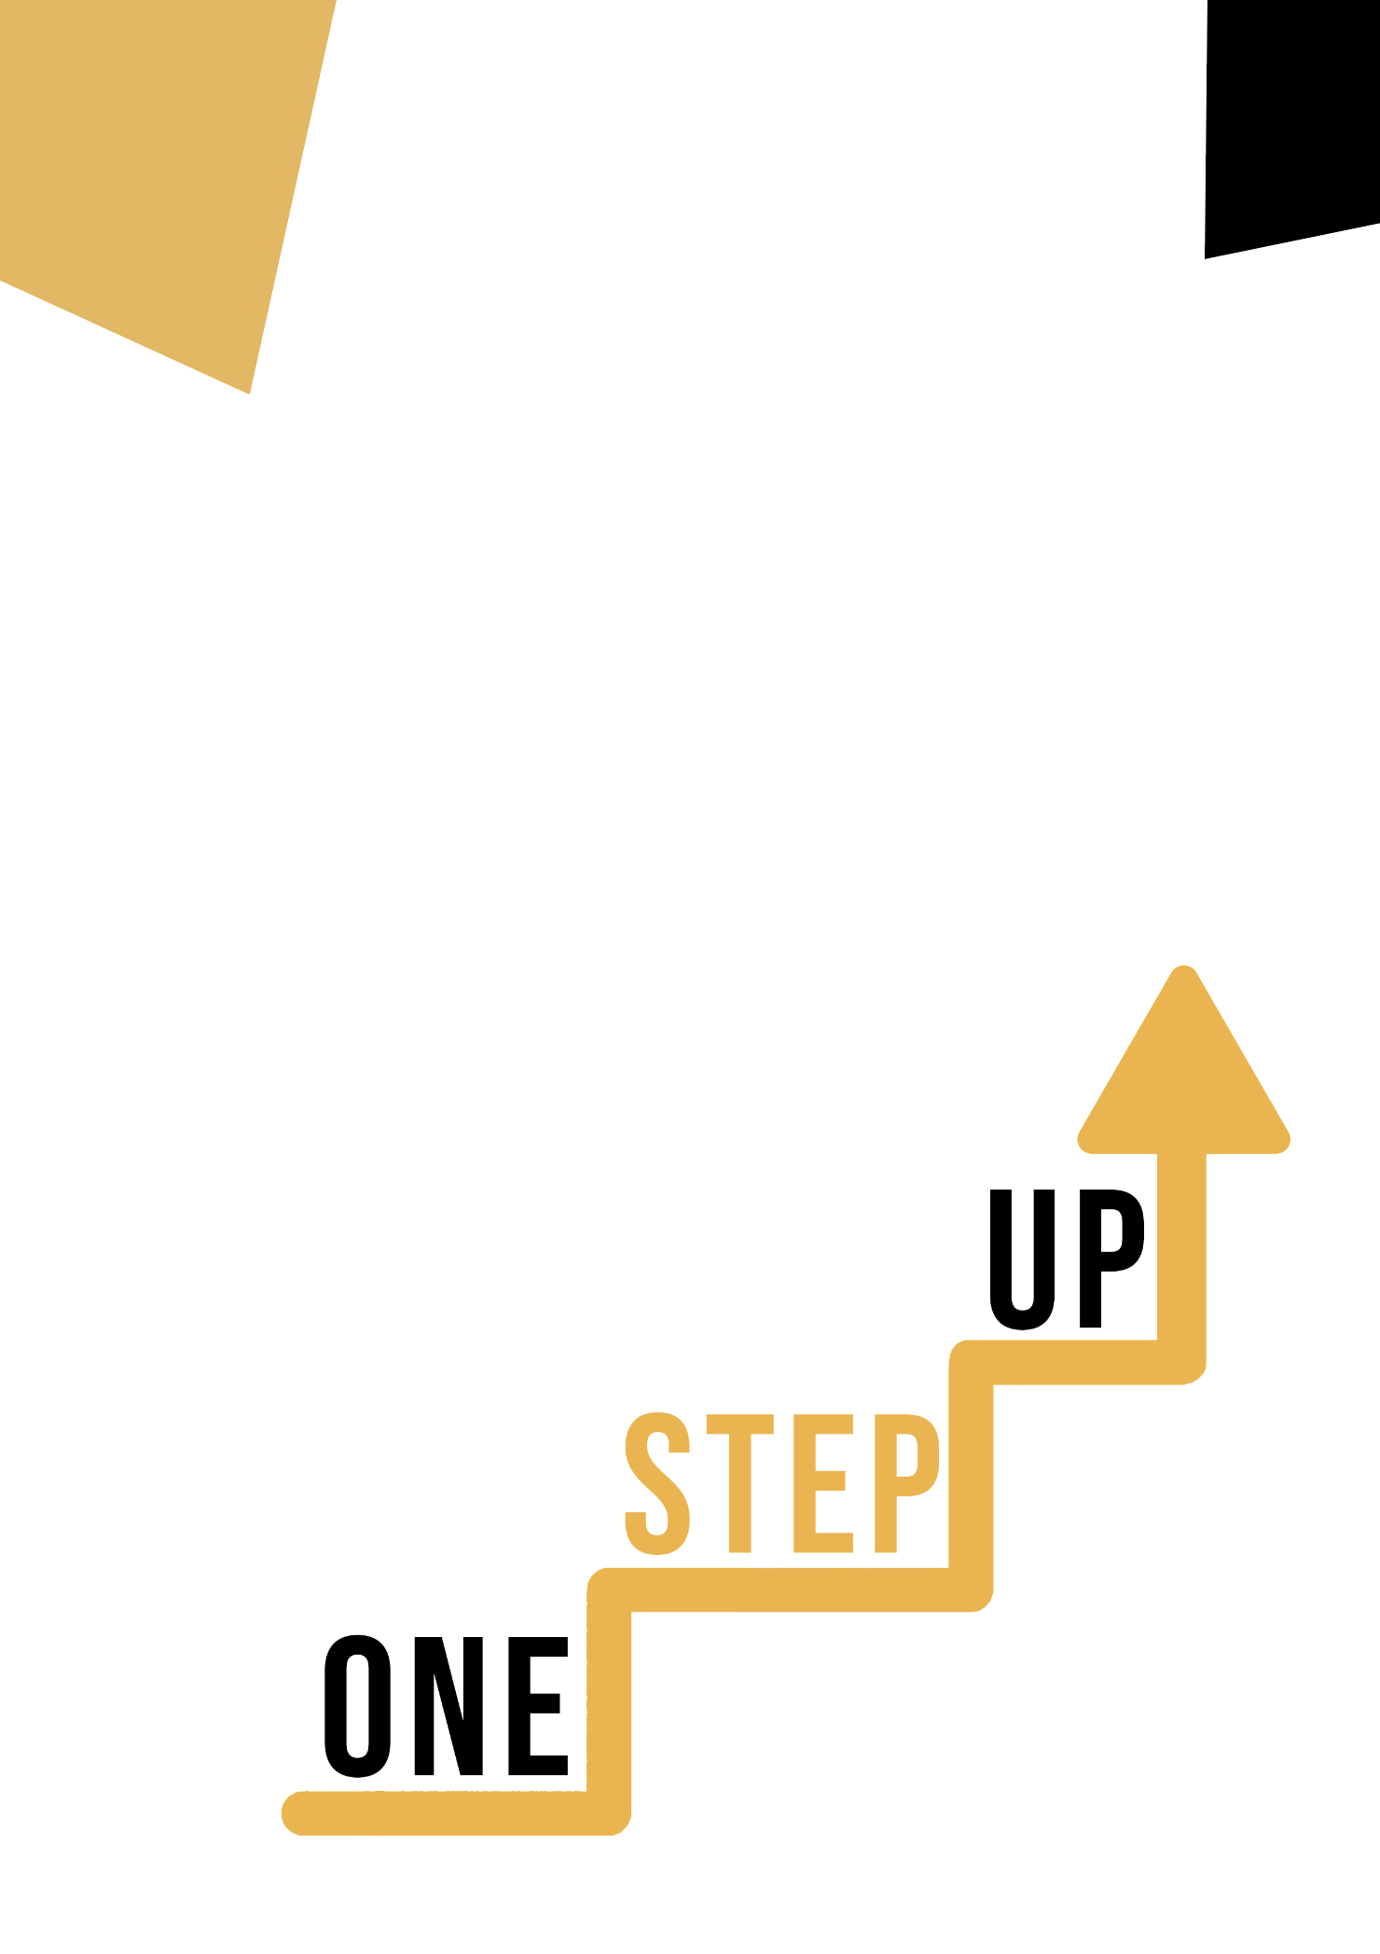

Micro-learning resources to re-engage low-skilled adult learners in education and training

Adult Educator Manual
Lesson Plan
The aim of this short handbook is to support you, as an experienced educator working with low-skilled and marginalised adult learners, with diverse needs, to use the video resources and the activity sheets provided in the Suite of Micro-Learning Resources to Re-Engage Low-Skilled Adult Learners in your centre and in your community. Through this short manual, we will provide you with some background information on the topic being discussed in the video resource and provide some guidance to support you to introduce and implement the accompanying activity with adult learners in your group. The activity that has been developed to accompany the video resources aims to further develop their understanding of the topic outlined in the video resource. Finally, this manual will also present you with some debriefing questions that you can use in your group of adult learners, to assess the user-friendliness and quality of the activity you have completed with them.

The topic of this manual relates to the video resources Multilingual competence and Digital and Social Theme.

Introduction to the Topic

In this resource, we will delve into the intriguing realm of Digital Media and Cross-Cultural Communication. Our participants will receive practical knowledge of the global nature of digital media and its impact on society as adult learners. We'll look at how multilingual communication and transnationalism influences digital media habits and conventions. Furthermore, the video will equip students with the ability to produce, curate, and disseminate multimedia material, promoting global communication and understanding. By the end of this resource, your students will value inclusivity and diversity, understanding the value of engaging with other perspectives and groups via digital media channels.

Introduction to the Activity

The accompanying activity consists of a case study based on a real-life scenario in which learners use their knowledge of digital media and cross-cultural communication. They will develop multimedia material that promotes inclusivity and bridges cultures using digital media tools and techniques. This task will allow learners to put the principles addressed in the video resource into practice, developing critical thinking.

Using this Resource with a Group
To use this resource with adult learners in your local group, we recommend that you begin by showing them the video resource to introduce the theme of Digital Media and Multilingual competence. This video will help learners to understand the topic before they begin the Learner Handout activity. Once they have gained a general knowledge of the theme, they will be able to begin the handout. For this, we recommend that you print one handout per learner to complete. All learners need for this resource is a pen to complete the learner handout and a computer to view the video. This resource will take one hour in total to complete.

Debriefing Questions

- What role do you believe digital media can play in promoting cross-cultural understanding and inclusivity?
- What difficulties did you encounter while working on the multimedia content development activity, and how did you overcome them?
- What impact has this learning experience had on your understanding of the global nature of digital media and the significance of cross-cultural communication?
- How can you implement what you've learned from this resource in your personal or professional life?
Please provide an example of how embracing diversity in digital media techniques can result in beneficial social impact.
You will empower low-skilled adult learners to traverse the digital landscape with confidence by using this educator manual and the accompanying video materials, fostering understanding and inclusivity in their interactions, and contributing to a more connected world.

Sources:
Integrating Social Factors into Cross-cultural Medical Education
https://journals.lww.com/academicmedicine/Fulltext/2002/03000/Integrating_Social_Factors_into_Cross_cultural.3.aspx
Green, Alexander R. MD; Betancourt, Joseph R. MD, MPH; Carrillo, J. Emilio MD, MPH
Academic Medicine 77(3):p 193-197, March 2002.

Research Anthology on Adult Education and the Development of Lifelong Learners
https://www.igi-global.com/chapter/adult-learner-characteristics-important-for-successful-learning-in-cross-cultural-web-based-learning-environments-in-higher-education/279739
Joseph George M. Lutta Copyright: © 2021

Multilingualism on the internet
https://www.academia.edu/download/13686668/Ch_22_-_Leppanen_-_Peuronen__pre-print.pdf
In Martin-Jones, M., Blackledge A., and Creese Angela. (Forthcoming in 2012).
The Routledge Handbook of Multilingualism. London and New York: Routledge.

