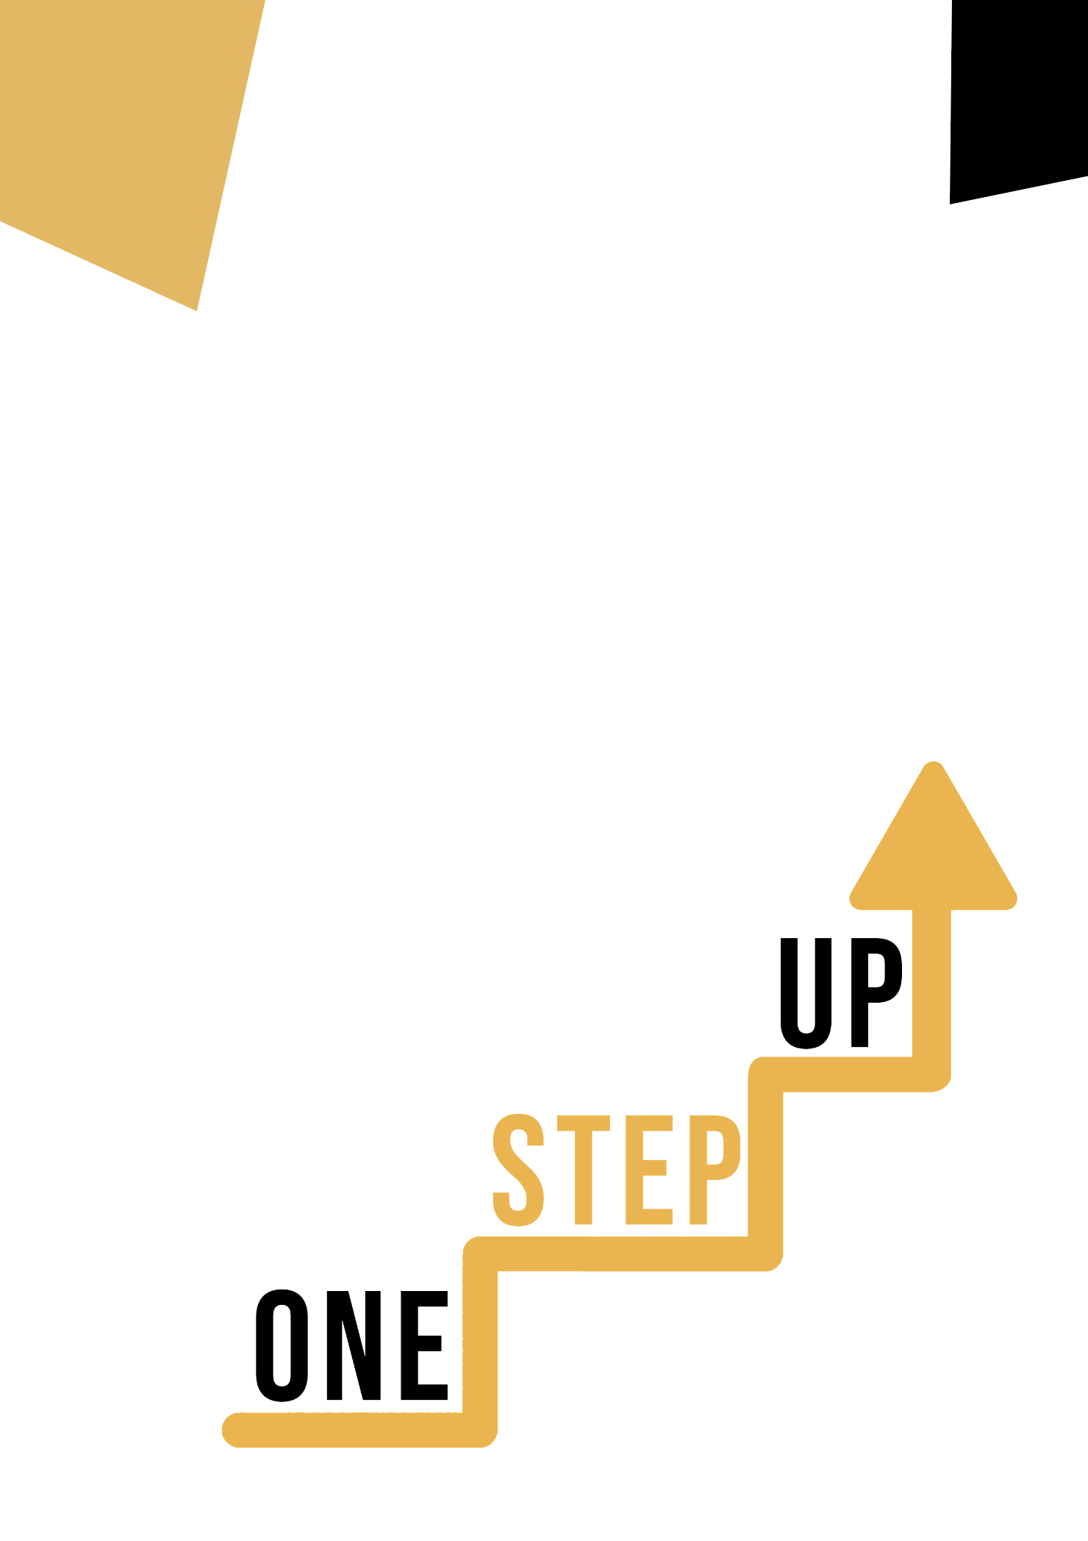
<Competence area and transversal theme>
Adult educator manual

Micro-learning resources to re-engage low-skilled adult learners in education and training

Adult Educator Manual
Lesson Plan
The aim of this short handbook is to support you, as an experienced educator working with low-skilled and marginalised adult learners, with diverse needs, to use the video resources and the activity sheets provided in the Suite of Micro-Learning Resources to Re-Engage Low-Skilled Adult Learners in your centre and in your community. Through this short manual, we will provide you with some background information on the topic being discussed in the video resource and provide some guidance to support you to introduce and implement the accompanying activity with adult learners in your group. The activity that has been developed to accompany the video resources aims to further develop their understanding of the topic outlined in the video resource. Finally, this manual will also present you with some de-briefing questions that you can use in your group of adult learners, to assess the user-friendliness and quality of the activity you have completed with them.
The topic of this manual relates to the video resources Multilingual Competence Through Art.

Introduction to the Topic
Learning a second language can be a challenging experience for most adults, particularly because adults tend to be intimidated by trying new things, afraid of looking ridiculous and making errors. And a great part of language learning is to experiment and make mistakes! But we can change their focus on performance to something more creative that will facilitate their participation and eliminate a certain degree of self-judgment.
Language and art are complementary disciplines and can benefit low-skilled adults in a number of ways. Integrating art into language learning can enhance language acquisition, creativity, and engagement. On the other hand, integrating language skills into art can facilitate new dimensions of expression and communication. In this resource, low-skilled adults can explore how art can positively impact their language skills.

Introduction to the Activity
Using the case study of the Croatian language school Sequoia Center, learners are introduced to a special English language learning program through art - "ESL Through Art" - with the aim of addressing participants' needs and bridging their language barriers using the universal language of visual arts. This provides an example that learners don’t have to go deep into the analyses of artworks and theories but to use visual art as a tool for learning a foreign language. The underlying meaning or message of an artwork is not as crucial as finding interesting ways to utilise artworks for language and vocabulary instruction, especially in programs designed for beginners. Learners also have a chance to try out the “Multilingual Art Collage” which will encourage them to experiment with visually appealing and interesting parts of magazines or newspapers to improve their multilingual skills while playing with their artistic compositions on posters or canvas. This will demonstrate how practicing their languages skills and building their vocabulary can be fun and engaging in combination with working on their own artistic compositions.

Using this Resource with a Group
To use this resource with adult learners in your local group, we recommend that you begin by showing them the video resource to introduce the theme of Multilingual competence through art. This video will help learners to understand the topic before they begin the Learner Handout activity. Once they have gained a general knowledge of the theme, they will be able to begin the handout. For this, we recommend that you print one handout per learner to complete. All learners need for this resource is a pen to complete the learner handout and a computer to view the video. This resource will take one hour in total to complete.

De-Briefing Questions

- What do you think is the key to the success of the Sequoia Centre’s special English language learning program through art - "ESL Through Art"
- What is one key takeaway that you will bring from this case study and activity? How will you apply it to your own life or work?
- How did you find the ‘Multilingual Art Collage”? Did you find it helpful in improving your language skills?
- How do you think the use of art can be incorporated into the traditional educational system or training programme to improve language skills?

