ENTREPRENEURIAL COMPETENCE
Sport AND HOBBIES
Adult educator manual
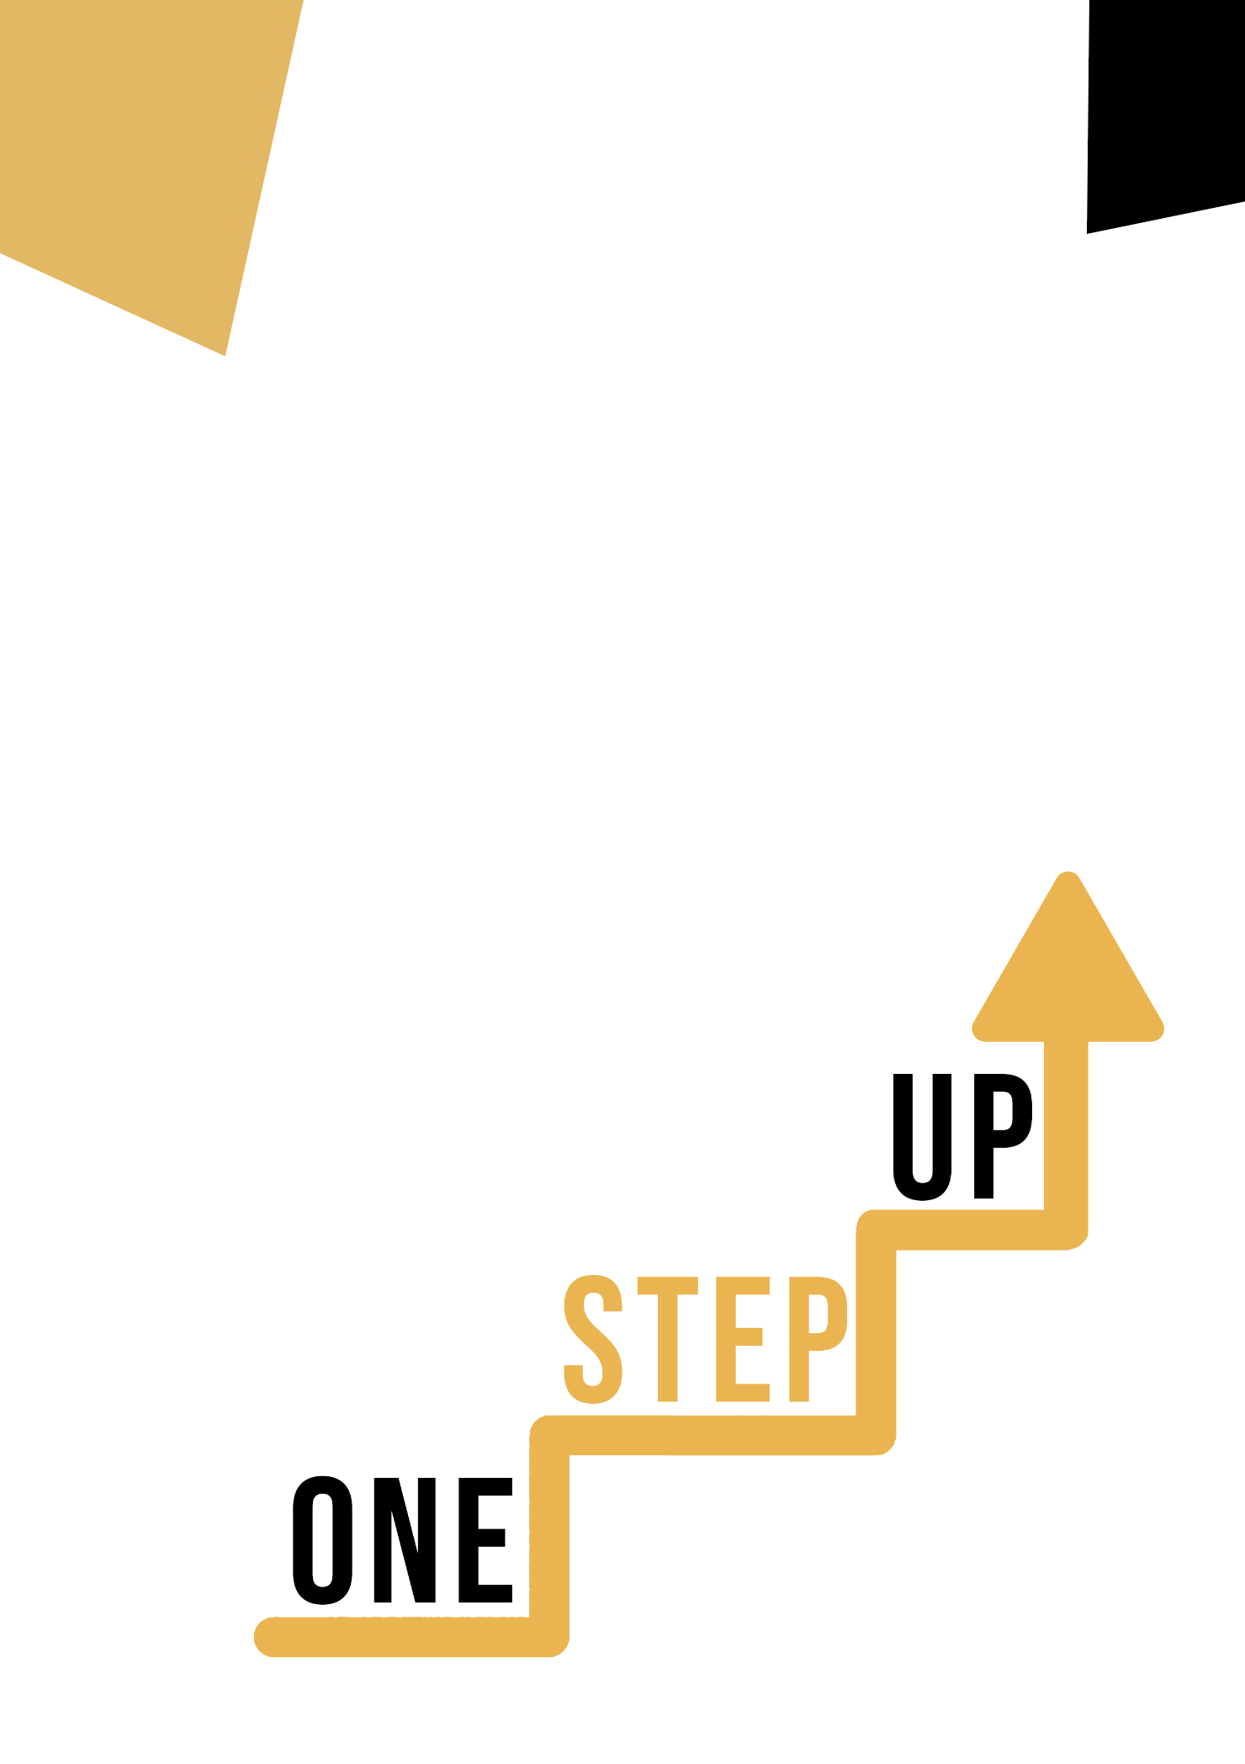

Micro-learning resources to re-engage low-skilled adult learners in education and training

Adult Educator Manual
Lesson Plan
The aim of this short handbook is to support you, as an experienced educator working with low-skilled and marginalised adult learners, with diverse needs, to use the video resources and the activity sheets provided in the Suite of Micro-Learning Resources to Re-Engage Low-Skilled Adult Learners in your centre and in your community. Through this short manual, we will provide you with some background information on the topic being discussed in the video resource and provide some guidance to support you to introduce and implement the accompanying activity with adult learners in your group. The activity that has been developed to accompany the video resources aims to further develop their understanding of the topic outlined in the video resource. Finally, this manual will also present you with some debriefing questions that you can use in your group of adult learners, to assess the user-friendliness and quality of the activity you have completed with them.
The topic of this manual relates to the video resources ENTREPRENEURIAL COMPETENCE, SPORT AND HOBBIES.

Introduction to the Topic

The connection between sport and hobbies and entrepreneurial competence is a captivating synergy that brings together seemingly distinct domains into a harmonious blend of skills, mindset, and success strategies. At first glance, sport and hobbies might appear unrelated to entrepreneurship, but a deeper examination reveals profound parallels and mutual benefits.
The interplay between sport and hobbies and entrepreneurial competence is a symbiotic relationship that enriches both sides. The skills acquired and the mindset cultivated in sport and hobbies can be seamlessly transferred to entrepreneurial pursuits, and vice versa. This dynamic interaction underscores the holistic nature of personal and professional growth, revealing that success in one area can profoundly impact achievements in the other.
The materials in this section will provide a better understanding of what entrepreneurial qualities are and highlight the importance of sport and hobbies.

Introduction to the Activity

The exercise describes a case study of a person who wants to become entrepreneurial, wants to succeed in business. The person loves sport and is a very good tennis player. The learners' task is to write what qualities acquired in sport will help in being entrepreneurial. This will help learners understand the importance of sport and hobbies and learn about the qualities of both an athlete and an entrepreneur.

Using this Resource with a Group

To use this resource with adult learners in your local group, we recommend that you begin by showing them the video resource to introduce the theme of ENTREPRENEURIAL COMPETENCE, SPORT AND HOBBIES. This video will help learners to understand the topic before they begin the Learner Handout activity. Once they have gained a general knowledge of the theme, they will be able to begin the handout. For this, we recommend that you print one handout per learner to complete. All learners need for this resource is a pen to complete the learner handout and a computer to view the video. This resource will take one hour in total to complete.

Debriefing Questions

- What entrepreneurial qualities can you list?
- What are the characteristics of an athlete?
- Did this activity help you understand the connection between sport and hobbies and entrepreneurial qualities?
