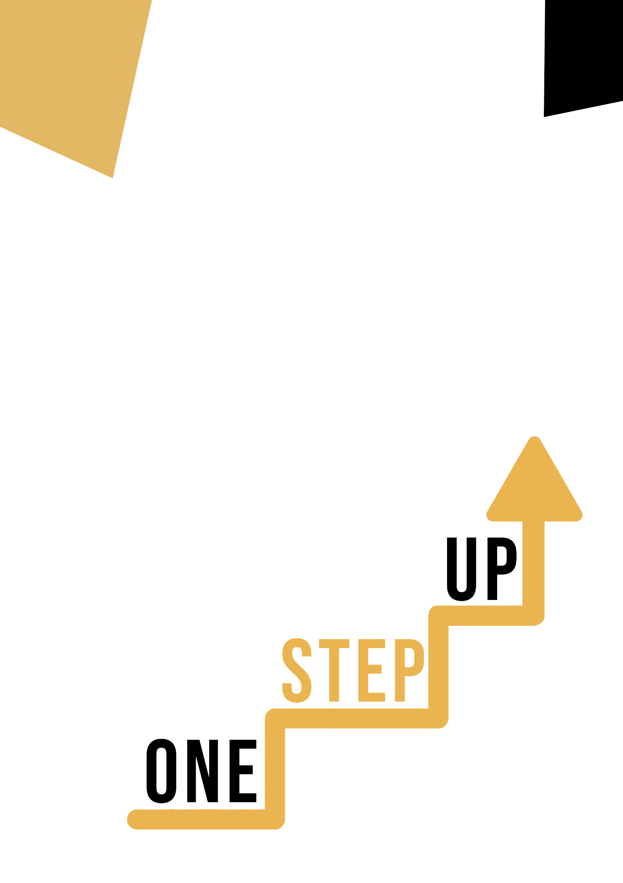
<Competence area and transversal theme>
Adult educator manual

Micro-learning resources to re-engage low-skilled adult learners in education and training

Adult Educator Manual
Lesson Plan
The aim of this short handbook is to support you, as an experienced educator working with low-skilled and marginalised adult learners, with diverse needs, to use the video resources and the activity sheets provided in the Suite of Micro-Learning Resources to Re-Engage Low-Skilled Adult Learners in your centre and in your community. Through this short manual, we will provide you with some background information on the topic being discussed in the video resource and provide some guidance to support you to introduce and implement the accompanying activity with adult learners in your group. The activity that has been developed to accompany the video resources aims to further develop their understanding of the topic outlined in the video resource. Finally, this manual will also present you with some de-briefing questions that you can use in your group of adult learners, to assess the user-friendliness and quality of the activity you have completed with them.

The topic of this manual relates to the video resources Building Citizenship Competence Through Sports and Hobbies.

Introduction to the Topic

Engaging in sports and hobbies offers a fantastic medium to enhance citizenship competences, especially for learners who may lack confidence in this area. Through our resources, learners can explore how sports and hobbies positively impact their civic skills and boost their self-assurance. Whether they enjoy sports, arts, or other leisure activities, they will be guided to discover how these pursuits contribute to teamwork, fair play, and community engagement. These resources aim to empower individuals to embrace citizenship values while pursuing their passions, creating a harmonious and responsible society through the lens of sports and hobbies.

Introduction to the Activity

Using the case study of the association "Sport and Citizenship", learners are introduced to the only European Think tank on sport that aims to analyse sports policy and to study the societal impact of sport. Learners also have the chance to try out the ‘Civic Values Through Sport & Hobbies’ activity which aims to engage learners in self-reflection, analysing how their sport activities and hobbies connect to citizenship principles and contribute to community engagement. This activity will encourage learners to enhance their citizenship skills while engaging in a sport or hobby that interests them the most or that they practice regularly.

Using this Resource with a Group
To use this resource with adult learners in your local group, we recommend that you begin by showing them the video resource to introduce the theme of Building Citizenship Competences Through Sports and Hobbies. This video will help learners to understand the topic before they begin the Learner Handout activity. Once they have gained a general knowledge of the theme, they will be able to begin the handout. For this, we recommend that you print one handout per learner to complete. All learners need for this resource is a pen to complete the learner handout and a computer to view the video. This resource will take one hour in total to complete.

De-Briefing Questions

- What did you learn about the association between "Sport and Citizenship?
- What is one key takeaway that you will bring from this case study and activity? How will you apply it to your own life or work?
- How did you find the ‘Civic Values Through Sport & Hobbies? Did you find it helpful in improving your citizenship skills?
- How do you think the use of sports and hobbies can be incorporated into the traditional educational system or training programme to improve citizenship skills?

