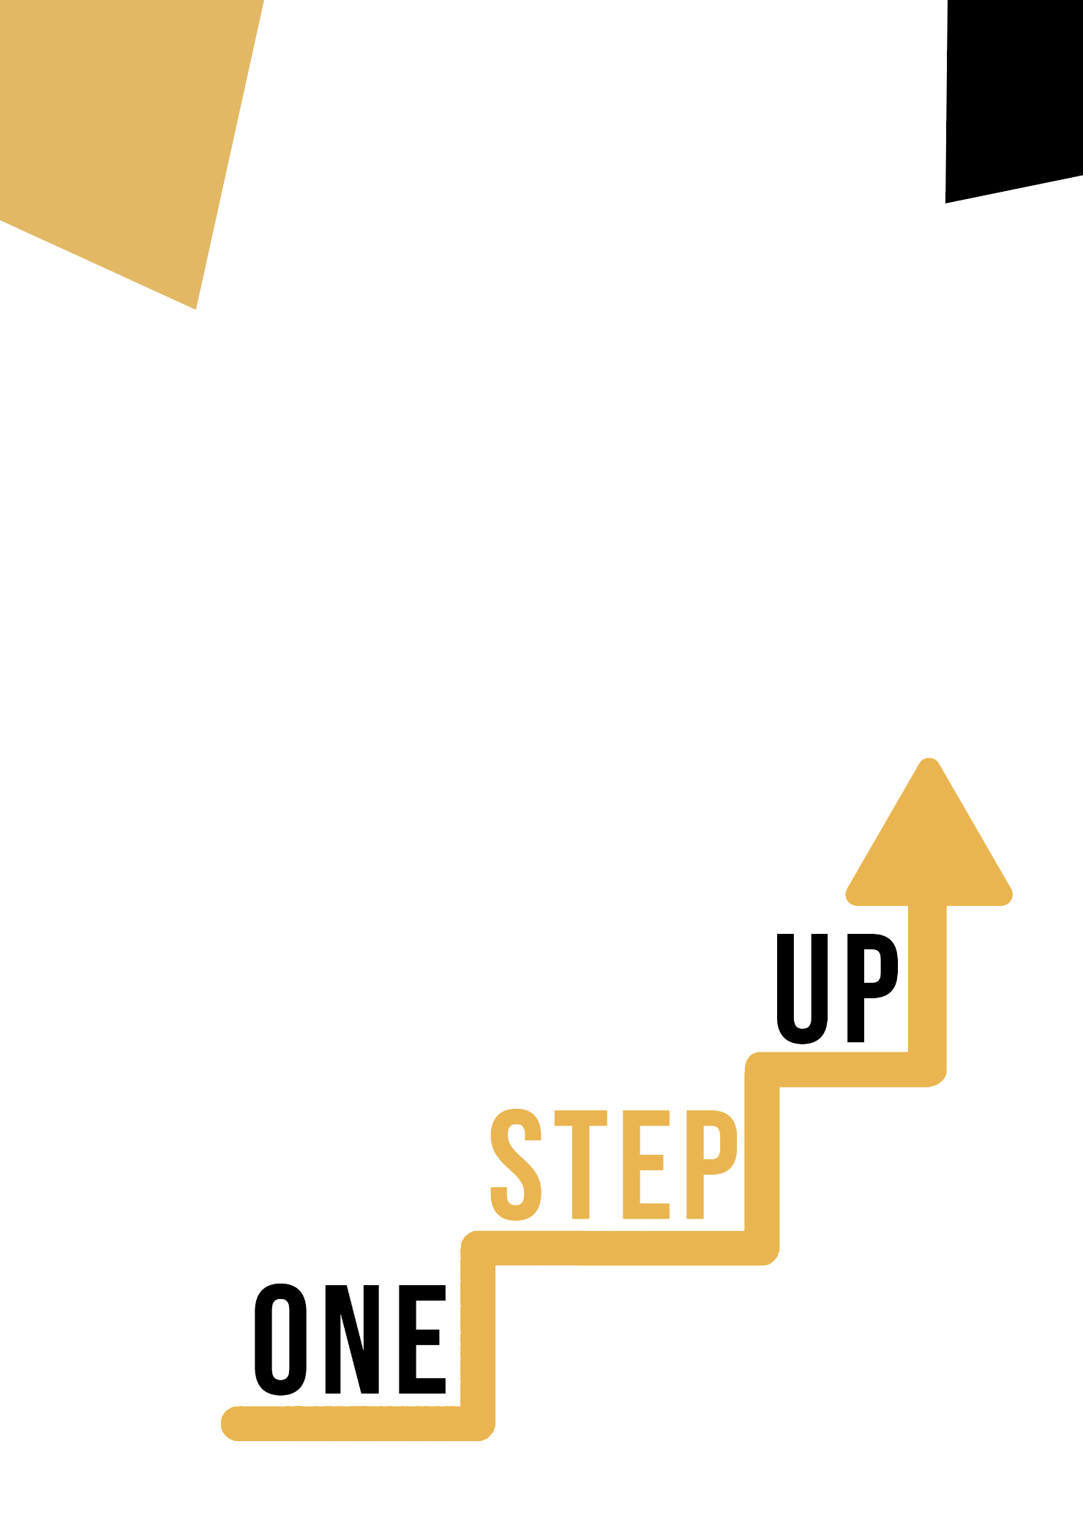
Citizenship Competences through Cultural disciplines
Adult educator manual

Micro-learning resources to re-engage low-skilled adult learners in education and training

Adult Educator Manual
Lesson Plan
The aim of this short handbook is to support you, as an experienced educator working with low-skilled and marginalised adult learners, with diverse needs, to use the video resources and the activity sheets provided in the Suite of Micro-Learning Resources to Re-Engage Low-Skilled Adult Learners in your centre and in your community. Through this short manual, we will provide you with some background information on the topic being discussed in the video resource and provide some guidance to support you to introduce and implement the accompanying activity with adult learners in your group. The activity that has been developed to accompany the video resources aims to further develop their understanding of the topic outlined in the video resource. Finally, this manual will also present you with some de-briefing questions that you can use in your group of adult learners, to assess the user-friendliness and quality of the activity you have completed with them.

The topic of this manual relates to the video resources Citizenship Competences through Cultural Disciplines

Introduction to the Topic
Cultural disciplines provide a valuable context for improving citizenship competences. By engaging with cultural disciplines such as history, sociology, anthropology, and literature, individuals can develop a deeper understanding of the diverse perspectives, values, and experiences that shape society. This knowledge promotes cultural awareness, empathy, and respect for diverse cultures, fostering inclusive citizenship.
Cultural disciplines also enable individuals to critically analyse social issues and reflect on the impact of historical events and societal structures on the present. This critical thinking enhances citizenship competences by empowering individuals to question inequalities, challenge discrimination, and advocate for social justice.
Additionally, cultural disciplines encourage active civic participation. Through the study of cultural heritage, arts, and traditions, individuals gain a sense of belonging and identity, strengthening their connection to their communities and motivating them to engage in civic activities.
By integrating cultural disciplines into citizenship education, individuals can develop the knowledge, skills, attitudes, and values necessary for active citizenship. They learn to appreciate diversity, understand democratic principles, communicate effectively, collaborate with others, and take action for positive social change. In this way, cultural disciplines play a vital role in shaping informed, responsible, and engaged citizens who contribute to building inclusive and democratic societies.

Introduction to the Activity
In the Learner Handout, low-skilled adults have the unique opportunity to delve into the innovative “Integration through Culture” initiative in Ireland and discover how it has helped low-skilled adults develop their citizenship competences through cultural integration. Learners also have the opportunity to engage in a fun and interactive ‘Cultural Artefact Exploration’ activity, where they will discover how a brief exploration of a cultural artefact, reflecting on its cultural significance, and considering its relevance to citizenship can lead to improving their citizenship competences. With this, you can inspire learners to discover how even the most unlikely activities can lead to significant improvements in their cultural awareness and expression skills.

Using this Resource with a Group
To use this resource with adult learners in your local group, we recommend that you begin by showing them the video resource to introduce the theme of Citizenship Competences through Cultural Disciplines. This video will help learners to understand the topic before they begin the Learner Handout activity. Once they have gained a general knowledge of the theme, they will be able to begin the handout. For this, we recommend that you print one handout per learner to complete. All learners need for this resource is a pen to complete the learner handout and a computer to view the video. This resource will take one hour in total to complete.

De-Briefing Questions
Here are some potential debriefing questions for participants to reflect on after completing the case and activity:
- What surprised you the most about the ‘Integration to Culture’ initiative in Ireland?
- What is one key takeaway that you will bring with you from this case study and activity? How will you apply it to your own life or work?
- What was your experience like during the ‘Cultural Artefact Exploration’ activity? Did you find it helpful in improving your citizenship competences?

