citizenship Competence artistic disciplines
Adult educator manual
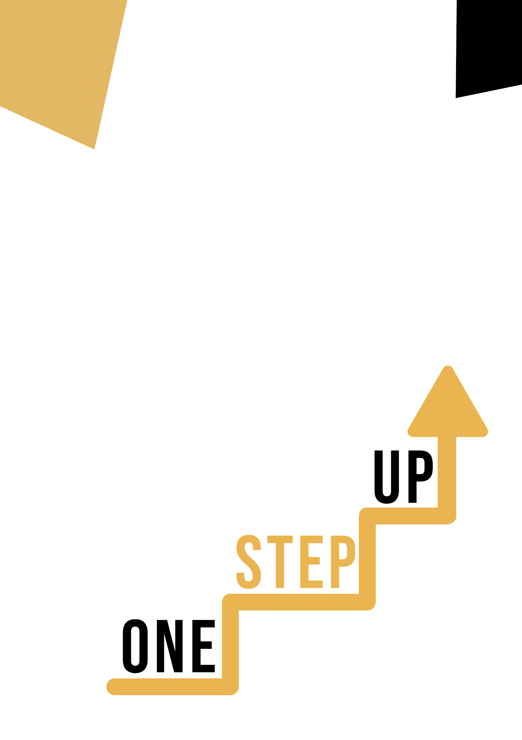

Micro-learning resources to re-engage low-skilled adult learners in education and training

Adult Educator Manual
Lesson Plan
The aim of this short handbook is to support you, as an experienced educator working with low-skilled and marginalised adult learners, with diverse needs, to use the video resources and the activity sheets provided in the Suite of Micro-Learning Resources to Re-Engage Low-Skilled Adult Learners in your centre and in your community. Through this short manual, we will provide you with some background information on the topic being discussed in the video resource and provide some guidance to support you to introduce and implement the accompanying activity with adult learners in your group. The activity that has been developed to accompany the video resources aims to further develop their understanding of the topic outlined in the video resource. Finally, this manual will also present you with some debriefing questions that you can use in your group of adult learners, to assess the user-friendliness and quality of the activity you have completed with them.
The topic of this manual relates to the video resources:
Citizenship Competence – Artistic disciplines

Introduction to the Topic

Navigating the intricate landscape of citizenship competence through the lens of art offers a unique and transformative pathway for individuals, particularly those with lower skill levels, to engage meaningfully with their communities and society at large. The fusion of art and citizenship competence not only empowers individuals to develop a deeper understanding of their rights and responsibilities as citizens but also opens doors to creative expression, personal growth, and active participation. For low-skilled adults, this approach becomes a bridge to a more inclusive and fulfilling citizenship experience, allowing them to contribute, learn, and thrive in ways that resonate with their interests and capabilities.

Introduction to the Activity

The case study describes a person who is not interested in art on a daily basis. She is convinced that no issues of civic competence can be found in the field of art.
We know otherwise, and we want to show her that. The learner's task is to list different art disciplines (e.g. music, dance) and write examples of issues related to civic competence in the arts. This will help adults understand the importance of the area of both art and civic competence and how these areas intersect.

Using this Resource with a Group

To use this resource with adult learners in your local group, we recommend that you begin by showing them the video resource to introduce the theme of Citizenship competence – Artistic disciplines. This video will help learners to understand the topic before they begin the Learner Handout activity. Once they have gained a general knowledge of the theme, they will be able to begin the handout. For this, we recommend that you print one handout per learner to complete. All learners need for this resource is a pen to complete the learner handout and a computer to view the video. This resource will take one hour in total to complete.

Debriefing Questions

- What do you understand about the term " citizenship competence"?
- What is your favourite art form?
- Have you ever wondered what connections art has with citizenship competence?
- Is the task interesting to you?
