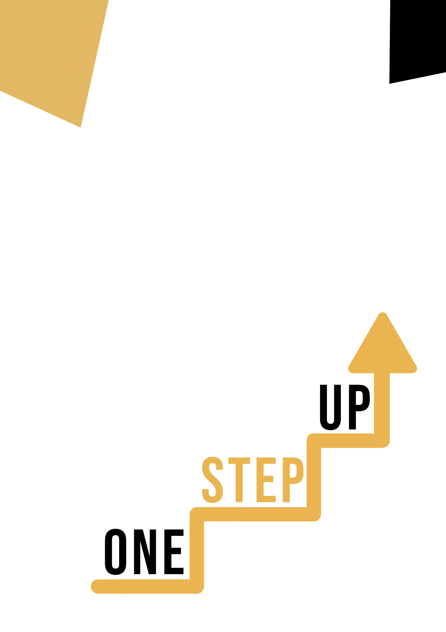
<Competence area and transversal theme>
Adult educator manual

Micro-learning resources to re-engage low-skilled adult learners in education and training

Adult Educator Manual
Lesson Plan
The aim of this short handbook is to support you, as an experienced educator working with low-skilled and marginalised adult learners, with diverse needs, to use the video resources and the activity sheets provided in the Suite of Micro-Learning Resources to Re-Engage Low-Skilled Adult Learners in your centre and in your community. Through this short manual, we will provide you with some background information on the topic being discussed in the video resource and provide some guidance to support you to introduce and implement the accompanying activity with adult learners in your group. The activity that has been developed to accompany the video resources aims to further develop their understanding of the topic outlined in the video resource. Finally, this manual will also present you with some de-briefing questions that you can use in your group of adult learners, to assess the user-friendliness and quality of the activity you have completed with them.

The topic of this manual relates to the resources of Artistic Disciplines (Cultural Awareness and Expression Competence).

Introduction to the Topic
Artistic disciplines encompass a wide range of creative fields, each with its own unique style, techniques, and traditions. These disciplines are not only significant for their aesthetic value but also for their cultural significance. They serve as a means of expression, communication, and reflection, reflecting the diverse experiences, beliefs, and values of societies and individuals.
Cultural awareness and expression competence refer to the ability to understand and appreciate the significance of artistic disciplines in different cultures, as well as the ability to communicate ideas, emotions, and experiences effectively through art. Developing these competences requires an understanding of the historical and cultural context of various artistic disciplines, as well as an appreciation for the diverse perspectives and experiences that shape artistic expression.
In this context, exploring artistic disciplines can help individuals develop a deeper understanding and appreciation of cultural diversity while also fostering their creative abilities and critical thinking skills. From painting and sculpting to music and dance, each artistic discipline offers a unique way of expressing oneself and engaging with the world around us.

Introduction to the Activity
In the Learner Handout, adult learners have the unique opportunity to delve into the innovative “Eadrainn / Between Us” project case study in Ireland and Scotland and discover how it has helped adults to develop their cultural awareness and expression skills through dance. Learners also have the opportunity to engage in a fun and interactive ‘Culture in Collage: Creating a Visual Identity’ activity, where they’ll discover how to create a collage about what they believe represents their cultural identity and become more culturally aware and expressive in the process. With this, you can inspire learners to discover how even the most unlikely activities can lead to significant improvements in their cultural awareness and expression skills.

Using this Resource with a Group
To use this resource with adult learners in your local group, we recommend that you begin by showing them the video resource to introduce the theme of Artistic Disciplines (Cultural Awareness and Expression Competence). This video will help learners to understand the topic before they begin the Learner Handout activity. Once they have gained a general knowledge of the theme, they will be able to begin the handout. For this, we recommend that you print one handout per learner to complete. All learners need for this resource is a pen to complete the learner handout and a computer to view the video. This resource will take one hour in total to complete.

De-Briefing Questions
Here are some potential debriefing questions for participants to reflect on after completing the case and activity:
- What surprised you the most about the “Eadrainn / Between Us” project in Ireland/Scotland?
- In what ways did the “Eadrainn / Between Us” project go beyond just teaching cultural awareness and expression skills?
- What is one key takeaway that will bring with you from this case study and activity? How will you apply it to your own life or work?
- What was your experience like during the “Culture in Collage: Creating a Visual Identity” activity? Did you find it helpful in improving your cultural awareness and expression competence?
- How can artistic disciplines be incorporated into education or training programs for low-skilled adults to improve their cultural awareness and expression skills?

